delwp.vic.gov.au

Metropolitan Partnerships – Inner South-east region

|  |
| --- |
| The 2017 Inner South-east Assembly  Summary Report |

|  |  |
| --- | --- |
|  |  |



|  |  |  |  |
| --- | --- | --- | --- |
|  |  |  |  |

|  |
| --- |
| © The State of Victoria Department of Environment, Land, Water and Planning 2017  LogoThis work is licensed under a Creative Commons Attribution 4.0 International licence. You are free to re-use the work under that licence, on the condition that you credit the State of Victoria as author. The licence does not apply to any images, photographs or branding, including the Victorian Coat of Arms, the Victorian Government logo and the Department of Environment, Land, Water and Planning (DELWP) logo. To view a copy of this licence, visit <http://creativecommons.org/licenses/by/4.0/>  ISBN 978-1-76047-802-5 (Print)  ISBN 978-1-76047-803-2 (pdf/online)  Disclaimer  This publication may be of assistance to you but the State of Victoria and its employees do not guarantee that the publication is without flaw of any kind or is wholly appropriate for your particular purposes and therefore disclaims all liability for any error, loss or other consequence which may arise from you relying on any information in this publication.  Accessibility  If you would like to receive this publication in an alternative format, please telephone the DELWP Customer Service Centre on 136186, email [customer.service@delwp.vic.gov.au](mailto:customer.service@delwp.vic.gov.au), or via the National Relay Service on 133 677 [www.relayservice.com.au](http://www.relayservice.com.au). This document is also available on the internet at [www.delwp.vic.gov.au](http://www.delwp.vic.gov.au). |

**This report has been prepared by Capire and DELWP and is an independent account of the discussions at the assembly.**

Unless otherwise stated, all feedback documented by Capire Consulting Group and any person(s) acting on our behalf is written and/or recorded during our program/consultation activities.

Capire staff and associates take great care while transcribing participant feedback but unfortunately cannot guarantee the accuracy of all notes. We are however confident that we capture the full range of ideas, concerns and views expressed during our consultation activities.

Unless otherwise noted, the views expressed in our work represent those of the participants and not necessarily those of our consultants or our clients.

Executive Summary

An Assembly was held by the Inner South-east Metropolitan Partnership on Wednesday 30 August 2017, bringing together community members, businesses, mayors and councillors to determine the key priorities for the Inner South-east Metropolitan Region.

The outcomes of the Assembly will be used by the Metropolitan Partnership to inform its independent advice to government on priorities for the region.

One hundred and three people participated in the discussion; 88 attendees and 15 table hosts. Attendees included 12 mayors and councillors, one State Minister and a local Member of Parliament.

The focus of the night was to hear feedback and ideas from the community through three activities:

* Review and evaluate the Partnership’s initial thinking on priorities for the Inner South-east region
* Develop and pitch ideas for how these priorities can be achieved
* Evaluate action statements by all participants on the night.

To increase transparency and provide live results, individual handsets were given to every participant to take part in the evaluation polls.

On the night participants agreed that the top priority for the region was to *‘actively seek opportunities to increase the availability of and access to open green space and community infrastructure that supports health and wellbeing’.*

**Hon Lily D’Ambrosio MP, Minister for Suburban Development, with Inner South-east Partnership member Lizzy Kuoth**

Overall participants agreed that the ten priority statements presented by the Partnership were indeed key priorities for the Inner South-east.

Fifteen action statements to address the priorities were developed and evaluated. Participants believed the top two high priority actions were:

* Provide green space and regional sporting facilities on surplus government land, create air rights over rail corridors, schools and the racecourse especially in high growth areas
* The Planning Act is amended to preference the health of communities and neighbourhoods over development and big business.

The results illustrate that infrastructure and social welfare are key intervention points for the region. They were high priority topics and had actions that participants felt were both a high priority and moderately-extremely important. The results also highlighted that, while housing is a key issue for the region, participants remain divided on actions that should be taken.

The Assembly provided the Partnership with a clear message that health and climate change are also important issues for the Inner South-east region. Participants would also like to see more emphasis on affordability throughout the priorities.

Contents

Executive Summary 3

The Metropolitan Partnerships 2

The 2017 Inner South-east Assembly 3

Who took part in the conversation? 4

The Partnership’s priority statements 5

Activity 1 — Reviewing the priorities for the region 6

Activity 2 — How do we achieve the priorities? 7

Activity 3 — Evaluating action statements 10

Key findings 12

Appendix A – List of action statements and votes 13

The Metropolitan Partnerships

The Metropolitan Partnerships are a new and coordinated way for communities to advise government on what matters in their region.

The Victorian Government wants to better understand and respond to the needs of Melbourne’s communities. Six Metropolitan Partnerships across Melbourne have been created because the government recognises that local communities are best placed to advise on issues and priorities for their region.

Each Partnership is made up of eight community and business representatives with varied backgrounds, experiences and networks, the CEO of every local government in that region and a Deputy Secretary from the Victorian State Government.

Working closely with their communities, the Partnerships will identify opportunities for driving improved social, economic and environmental outcomes and advise the government on actions that can make a real difference to the liveability and prosperity of their metropolitan region.

The Partnerships will strengthen relationships and facilitate stronger collaboration across the three tiers of government, businesses and communities. They will also enable the government to respond in a more coordinated and targeted manner to deliver better outcomes for the community.

More information on the six Metropolitan Partnerships can be found at suburbandevelopment.vic.gov.au

## The Inner South-east Partnership

The Inner South-east Partnership members are:

* Alicia Darvall, Chair
* Steve Whittington, Deputy Chair
* Sally Howe, Member
* Simon Stafrace, Member
* Lizzy Kuoth, Member
* Jane Farmer, Member
* 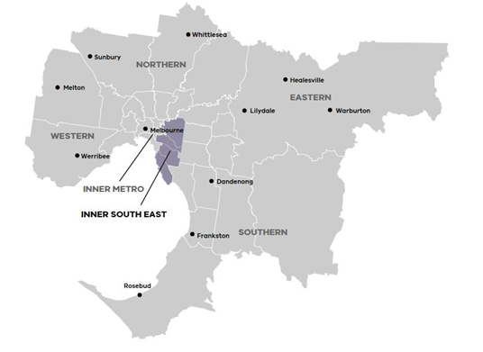Damian Ferrie, Member
* Philip Mallis, Member
* Adrian Robb, CEO, Bayside City Council
* Rebecca McKenzie, CEO, Glen Eira City Council
* Warren Roberts, CEO, Stonnington City Council
* Julia Griffith, Victorian Government representative

Find out more about the Inner South-east Metropolitan Partnership members at: <https://www.suburbandevelopment.vic.gov.au/partnerships/metropolitan-partnerships/inner-south-east-partnership>

Read more about the Inner South-east Metropolitan region at: <https://www.suburbandevelopment.vic.gov.au/regions/inner-south-east-region>

## The Inner South-east Region

Melbourne’s Inner South-east Metropolitan Region extends from Kew in Melbourne's inner east to Brighton on Port Phillip Bay. The area captures high density residential and retail precincts such as South Yarra as well as quieter residential streets through middle suburbs such as Balwyn, Bentleigh and Black Rock. The Inner South-east Metropolitan Region is a desirable residential location with strong retail employment. The Inner South-east is the traditional home to the Wurundjeri people of the Kulin nation.

The 2017 Inner South-east Assembly

On Wednesday 30 August 2017, 103 community members, businesses, councillors and mayors came together to help determine the key priorities for the Inner South-east Metropolitan region.

The Metropolitan Assemblies are part of a commitment to give Victorians the opportunity to influence decisions and shape the future of their communities.

The assemblies have been initiated as an opportunity for the community to come together and have their say on issues that matter to them and the priorities they have for their communities.

There were several ways people could take part in the conversation, including answering pre-engagement questions online at engage.vic.gov.au and attending the Assembly.

## What happened on the night

The focus of the night was to hear feedback and ideas from community members and included three activities.

### Activity 1 – Reviewing the priorities for the region

Informed with the pre-engagement results and other community engagement initiatives conducted by local government, the Partnership members developed ten priority statements for the region.

Participants were split across 15 tables and asked to consider whether the statements highlighted the right priorities for the region and advise what might be missing. The top messages from the conversation were recorded and participants were invited to declare whether they agree or disagree that each statement was a key priority for the region through their individual handsets.

### Activity 2 – Developing action statements

Participants moved to a second table to discuss topics they are passionate about. Topics of interest were indicated by participants when registering for the Assembly, and the number of tables allocated to each topic reflected the volume of interest.

Participants were asked to create an action statement to highlight how the priorities for each topic could be achieved and pitch it to the table for discussion. The table voted for their favourite action statement using sticky dots.

The table then agreed on one action statement to submit to all Assembly participants for evaluation.

### Activity 3 – Voting on action statements

Each table’s action statement was presented to the room. Participants were asked to consider each statement and respond through their handsets to the following questions:

1. *What is the level of priority of this action to achieve better outcomes for the region?*
2. *What is the level of importance of this action for the future of the region?*

## Limitations

As with all community engagement processes, there are limitations associated with the Assembly that should be acknowledged. They include:

* Assembly participants were not necessarily a representative sample of the Inner South-east population. The results from the night are a good indication of sentiment and ideas in the region, but are not a statistically valid reflection of the news of the entire inner south-east community
* Due to multiple registration processes, demographic information was not collected for all participants
* Not all participants chose to take part in all polls. All results have been converted into percentages to reduce the impact of this
* Participants had a varied understanding of the issues in the region and possible solutions
* When evaluating the actions statements participants were unsure what the difference was between priority and importance to the region. This resulted in many giving the same response to both questions
* Table hosts have taken care to record participant feedback. However, we cannot guarantee the accuracy or inclusion of all comments. We are confident that the range of ideas, concerns and views reflect the comments made at the sessions.

Who took part in the conversation?

Between 7 and 30 August 2017, a page dedicated to the Inner South-east region was live on engage.vic.gov.au. The site was visited by 1,369 people with 116 people completing the pre-engagement questions.

Participants’ key demographic attributes are as follows:

* There was an even gender mix among those who participated
* The majority of participants were between 45 and 64 years of age
* Glen Eira Council had the most participants of the four Council areas
* Most participants live in the Inner South-east
* There were 36 participants who own a business in the region.

Figures 1 to 3 show the participants age, suburb they live in and relationship to the region.

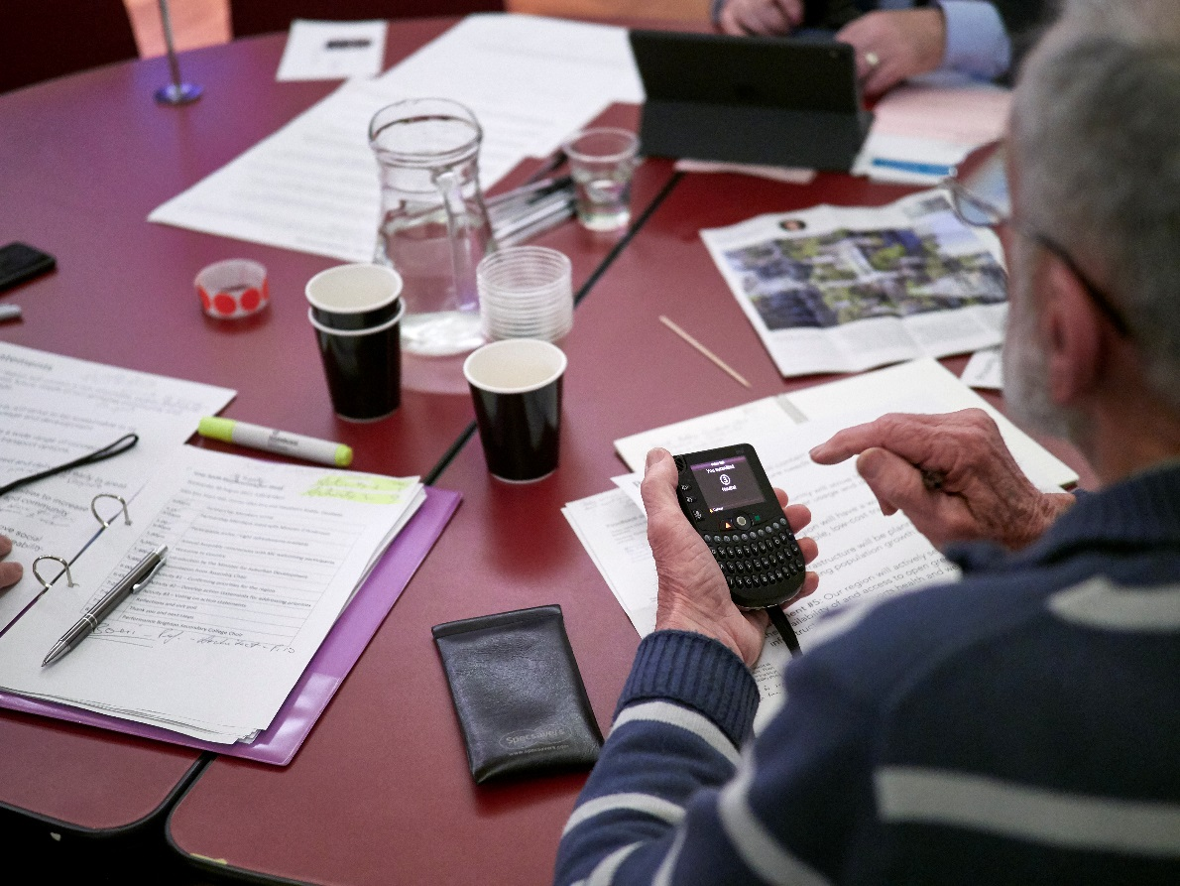

**Figure 3: Age range of Assembly participants (n=77)**

**Figure 2: Participants’ relationship to the region (n=134)**

**Figure 1: Council areas in which participants reside (n=75)**

The Partnership’s priority statements

**Statement #1**: Our region will contain a mix of private, public and social housing that anticipates future needs of our growing community and respects existing heritage.

**Statement #2**: Our community will strive to be sustainable in its management of waste, water usage and development.

**Statement #3**: Our region will have a wide range of connected, sustainable and accessible, low-cost transport options.

**Statement #4**: Infrastructure will be planned and delivered early in areas that are experiencing population growth

**Statement #5:** Our region will actively seek opportunities to increase the availability of and access to open green space and community infrastructure that supports health and wellbeing.

**Statement #6**: Our region will strive to ensure and improve social connectedness and inclusion to achieve quality of life and liveability.

**Statement #7**: Our region will embrace and facilitate innovative business and technologies for the future.

**Statement #8**: Local proximity to shopping districts, schools and services will be central to the liveability of our region.

**Statement #9**: Our region will be a place where people feel safe and secure.

**Statement #10**: Children in the inner south east will have access to world class education regardless of socioeconomic factors and location.

Activity 1 — Reviewing the priorities for the region

Overall participants agreed that the ten priority statements were key priorities for the Inner South-east. Table hosts noted the following key messages from the discussion:

* Community and open space is very important to people in the Inner South-east
* Ensuring the region has adequate infrastructure for a growing population
* The need to prioritise health, particularly for older residents
* The need for more transport options and links, including walking and cycling links
* There is a need to factor the effects of climate change into future planning for the region
* More support for local governments to manage water and waste infrastructure
* The need to ensure the priorities are measurable and leaders are accountable to meeting them.

There were a few specific tweaks to the priority statements requested by tables. One table wanted Statement #1 to focus on diverse housing options rather than on heritage and it was also requested that Statement #6 include ‘equality’ at the end.

The key issues missing in the priorities were health and climate change. Participants would also like to see more emphasis on affordability throughout the priorities.

Table 1 illustrates that participants agreed the key priority in the region was ‘actively seek opportunities to increase the availability of and access to open green space and community infrastructure that supports health and wellbeing’. Overall priorities relating to infrastructure and social welfare were the key priorities.

Table 1: Polling results responding to the statement - This is a key priority for the region.

Legend: 1= Strongly Disagree, 3=Neutral, 5= Strongly Agree.

|  |  |  |  |
| --- | --- | --- | --- |
| Topic | Priority statement | Average score | |
| **Infrastructure** | Our region will actively seek opportunities to increase the availability of and access to open green space and community infrastructure that supports health and wellbeing. | **4.64** |
| **Social Welfare** | Our region will strive to ensure and improve social connectedness and inclusion to achieve quality of life and liveability. | **4.40** |
| **Social Welfare** | Our region will be a place where people feel safe and secure. | **4.35** |
| **Housing** | Our region will contain a mix of private, public and social housing that anticipates future needs of our growing community and respects existing heritage. | **4.34** |
| **Economy, Industry and Jobs** | Local proximity to shopping districts, schools and services will be central to the liveability of our region. | **4.32** |
| **Education and Training** | Children in the inner south east will have access to world class education regardless of socioeconomic factors and location. | **4.31** |
| **Transport** | Our region will have a wide range of connected, sustainable and accessible, low-cost transport options. | **4.31** |
| **Environment** | Our community will strive to be sustainable in its management of waste, water usage and development. | **4.28** |
| **Infrastructure** | Infrastructure will be planned and delivered early in areas that are experiencing population growth. | **4.10** |
| **Economy, Industry and Jobs** | Our region will embrace and facilitate innovative business and technologies for the future. | **3.78** |

Activity 2 — How do we achieve the priorities?

Actions statements pitched by participants on the night and through online engagement are summarised below and organised by topic in Table 2. The most supported ideas are bolded. These ideas were submitted for evaluation. The other ideas have been summarised into a few key statements. All ideas pitched on the night are included in Table 4 in the Appendix.

Table 2: Action statements by topic

|  |
| --- |
| **Housing (discussed at three tables)** |
| * Release Vic Track airspace in inner city areas for a combination of housing options and government public-private partnerships along with open space options. * Enable the planning approach that allows the decoupling of carparks to apartments and other new models for example, the Nightingale Model. * Implement quotas for public and key worker housing in new large scale private developments. * Enable more flexibility in housing types especially for the ageing population for example, allowing independent living units on existing properties. * Dedicate more resources and attention to ensuring high quality housing. * Improve bi-partisan support for housing solutions in the Inner South-east and streamline processes. |
| Pre-engagement suggestion for how government, business and community can work together:   * Enable the community to work with developers and better understand how they can influence planning processes and development. |
| **Social welfare (discussed at three tables)** |
| * The planning act is amended to preference the health of communities and neighbourhoods over development and big business. * Socially disadvantaged families, refugees, CALD and single parents require an integrated approach to assist with social inclusion. * Insist on a minimum requirement for affordable housing and deliver services to these locals driving social inclusion outcomes. * Implement a star rating accreditation for inclusion that would be used in schools, churches, councils, businesses, cafes, etc. This would become part of the value proposition to customers for these organisations. * Support and grow leaders from diverse backgrounds such as leadership incubators. * Provide programs and opportunities for communities to meet up to reduce social isolation and/or break down barriers between cultures. * Set minimum targets for accessible and affordable housing in the region, and develop options for affordable, accessible ageing in place housing options. * Develop and deliver local services to address social inclusion outcomes and for early intervention and treatment of alcohol and drug issues. |
| Pre-engagement suggestions for how government, business and community can work together:   * Educate the broader community on issues such as diversity and the environment. * Provide community programs that encourage social interaction and work towards social cohesion. |
| **Infrastructure (discussed at two tables)** |
| * Provide green space and regional sporting facilities on surplus government land, create air rights over rail corridors, schools and the racecourse especially in high growth areas. * The Caulfield Racecourse parkland should be developed as the central recreation sporting parkland for Melbourne. The management committee should mainly consist of community representatives. * Population growth and infrastructure need to be matched for example develop municipal "threshold capacity indicators” for all infrastructure to model impact of population increases on services future and assist planning. * Convert surplus government land including the racecourse and schools should be utilised to provide more recreation spaces and green open space. * Hard and soft infrastructure to meet all ages including learning spaces and age suitable transport options. |
| Pre-engagement suggestions for how government, business and community can work together:   * Government, business and the community co-designing policies, community spaces and programs. * Provide more community spaces, and consider how social connectedness can be enhanced in the design of new developments. |
| **Education and training (discussed at two tables)** |
| * Educational precincts to cater for all ages and linked into the community and business. * Implement the recommendations of the Gonski report with focus on TAFE. * Using current and predicted data, develop an education provision plan for Inner SE regions focusing on maximising space and catering for local community needs. * Allow education to happen in places others than schools where there is free space. For example, more mixed/shared use of buildings, aged care and school / business. * Provide more opportunities for education and training for older people, and intergenerational learning for example retain the East Village. |
| Pre-engagement suggestion for how government, business and community can work together:   * Deliver volunteer and mentorship programs. |
| **Economy, industry and jobs (discussed at two tables)** |
| * Support a business environment that enables people and businesses to work flexibly in hubs close to home. * Local hubs that support strong local economies by fostering collaboration innovation and education for small businesses. * Creating mechanisms for clusters of business that mutually need each other to succeed to connect at the planning stage. * Encourage greater connection between trader and residents. * The region will actively foster employment precincts that encourage high order employment. |
| Pre-engagement suggestion for how government, business and community can work together:   * Encourage communities to support the local economy. |
| **Environment (discussed at two tables)** |
| * Review and revive our wetlands and watercourses to enhance flood mitigation and bioretention for safer living and healthier bay. * Establish a representative advisory group to ensure environment requirements are underpinned by state laws for sustainable development. * Establish and improve environmental standards in planning including numbers of trees/plants on individual balconies. * Increase engagement and cooperation between council and community groups interested in environmental issues. * Create a common agreement of what sustainable living is. * Regionally significant open spaces (e.g. Elsternwick Park) should have local residents forming a committee of management and become local (climate change adaptation) champions. |
| Pre-engagement suggestion for how government, business and community can work together:   * Collaborate on setting targets for a sustainable community, and provide tools for communities to achieve their goals. |
| **Transport (discussed at one table)** |
| * Develop and prioritise a local public transport plan to cover sustainable low-cost travel for north south coverage. * Provide a comprehensive network of off road bicycle paths and linking key destinations - take existing road space if no other option exists. * Increase frequency of public transport and operating hours to 7 days a week, 6am to 11pm as a minimum. * Prioritise personal and public transport on the road network over cars and trucks on key corridors linking activity centres. * Change access and availability of commuter parking to enable more people to use trains. |

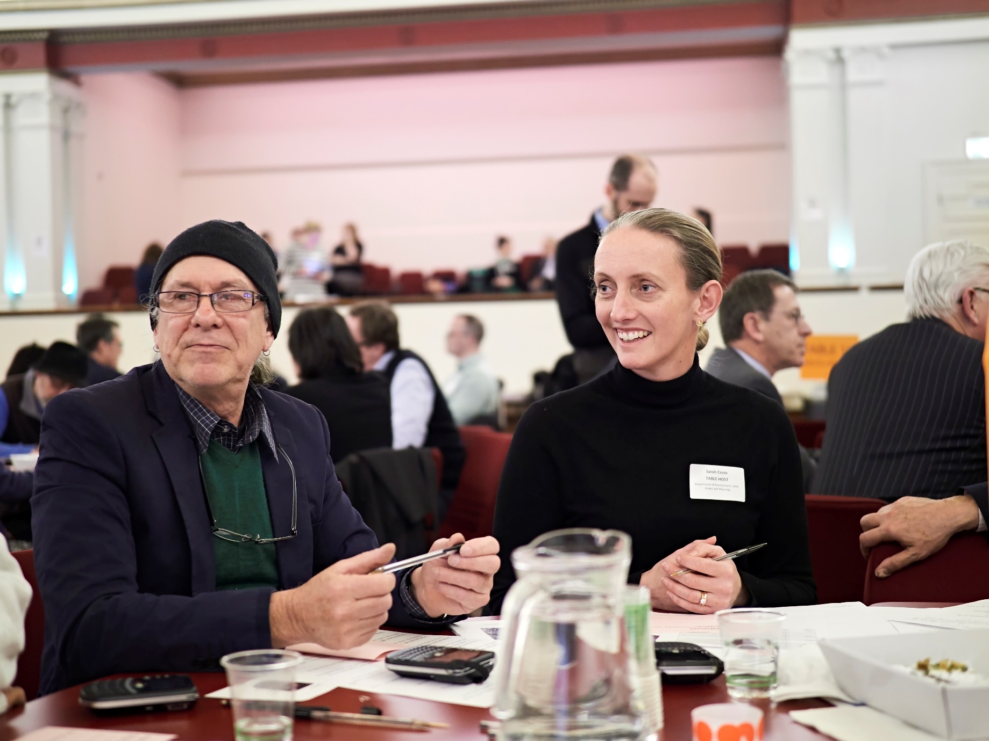

Activity 3 — Evaluating action statements

Participants’ evaluations of the action statements are illustrated in Table 3. Participants believed the top two priority and important actions were:

* Provide green space and regional sporting facilities on surplus government land, create air rights over rail corridors, schools and the racecourse especially in high growth areas
* The planning act is amended to preference the health of communities and neighbourhoods over development and big business.

Action statements regarding Infrastructure and Social Welfare were voted highest priority, matching the top two key priority topics. In contrast, the actions responding to housing, another key topic, received mixed responses from participants.

Participants largely agreed on the priority and importance of the action statements.

There were however three actions that split participants more than others. They were:

* Release Vic Track airspace in inner city areas for a combination of housing options and government public-private partnerships along with open space options
* Implement quotas for public and key worker housing in new large scale private developments
* Socially disadvantaged families, refugees, CALD and single parents require an integrated approach to promote social inclusion.

When reviewing participant voting patterns several demographic factors were observed, including:

* Younger age groups were more likely to agree that the two housing actions were priorities for the region
* Older age groups were less likely to believe releasing Vic Track airspace in inner city areas is a priority
* Older age groups were more likely to think the integrated approach to assisting more participation from socially disadvantaged and CALD groups was a priority
* People who lived or worked in Glen Eira, Stonnington and Boroondara were more likely to agree the social welfare action is a priority for the region
* The council areas were split on releasing Vic Track airspace. People who live/work in Bayside and Stonnington were more likely to believe this was a priority, however it was the opposite with people who live/work in Boroondara and Glen Eira
* Local government councillors, mayors and CEO’s thought the integrated approach to assist more participation from under-represented groups was a priority for the Inner South-east region.

|  |  |  |  |
| --- | --- | --- | --- |
| Topic | Action statement | Average priority | Average importance |
| **Infrastructure** | Provide green space and regional sporting facilities on surplus government land, create air rights over rail corridors, schools and the racecourse especially in high growth areas. | **4.00** | **4.07** |
| **Social Welfare** | The planning act is amended to preference the health of communities and neighbourhoods over development and big business. | **3.99** | **4.10** |
| **Transport** | Develop and prioritise a local public transport plan to cover sustainable low-cost travel for north south coverage. | **3.78** | **4.06** |
| **Environment** | Establish a representative advisory group to ensure environment requirements are underpinned by state laws for sustainable development. | **3.78** | **3.83** |
| **Environment** | Review and revive our wetlands and watercourses to enhance flood mitigation and bioretention for safer living and healthier bay. | **3.73** | **3.74** |
| **Education and Training** | Educational precincts to cater for all ages and linked into the community and business. | **3.61** | **3.47** |
| **Economy, Industry and Jobs** | Local hubs that support strong local economies by fostering collaboration innovation and education for small businesses. | **3.59** | **3.51** |
| **Infrastructure** | The Caulfield Racecourse parkland should be developed as the central recreation sporting parkland for Melbourne. The management committee should mainly consist of community representatives. | **3.54** | **3.53** |
| **Social Welfare** | Insist on a minimum requirement for affordable housing and deliver services to these locals driving social inclusion outcomes. | **3.54** | **3.71** |
| **Education and Training** | Implement the recommendations of the Gonski report with focus on TAFE. | **3.52** | **3.58** |
| **Housing** | Implement quotas for public and key worker housing in new large scale private developments. | **3.45** | **3.52** |
| **Economy, Industry and Jobs** | Support a business environment that enables people and businesses to work flexibly in hubs close to home. | **3.44** | **3.47** |
| **Social Welfare** | Socially disadvantaged families, refugees, CALD and single parents require an integrated approach to promote social inclusion. | **3.38** | **3.43** |
| **Housing** | Release Vic Track airspace in inner city areas for a combination of housing options and government public-private partnerships along with open space options. | **3.26** | **2.99** |
| **Housing** | Enable the planning approach that allows the decoupling of carparks to apartments and other new models for example, the Nightingale Model. | **2.53** | **2.49** |

Table 3: Polling results for the action statements.   
Legend: 1= Not a priority, 3= Medium priority, 5= Essential.

Key findings

The Assembly participants’ contributions and ideas provide Partnership members with a good insight to the key priorities for the region.

The Partnership’s key take-aways are:

* The priorities presented on the night are almost right. Health and climate change need to be included in the current ten priority statements
* Infrastructure and social welfare are key intervention points for the region. These themes surfaced in discussions and in the action statements presented by participants
* Access to public open space is important for the community. Railway airspace, the Caulfield racecourse and underutilised land could provide opportunities for increasing open and community space in the Inner South-east. This would be beneficial across the whole region
* Housing is a key issue for the region, however, participants remain divided on actions that should be taken.

The Partnership will take on board the ideas from the Assembly whilst it formulates its independent advice that will be submitted to Government later this year.

**Inner South-east Partnership Chair, Alicia Darvall**

Appendix A – List of action statements and votes

Table 4: All action statements put forward by participants, their votes and themes.

| **Action statement** | **Votes** | **Theme** |
| --- | --- | --- |
| Provide green space regional sporting facilities on surplus Government land, air rights, over rail corridors, schools, racecourse, especially in high growth areas | 8 | Infrastructure |
| Release Vic Rail airspace in inner city areas for a combination of housing options and gov't Private/Public/Partnerships along with open space options | 7 | Housing |
| Decouple car parking and apartments to enable developments and new models such as 'nightingale Housing'! | 6 | Housing |
| The planning act is amended to preference the health of communities and neighbourhoods over development and big business | 6 | Social welfare |
| Educational precincts to cater for all ages and linked into the community and business | 5 | Education |
| Education and innovation precinct. A new State government school in East village co-located with business to provide innovation and employment opportunities | 5 | Education |
| That community is incentivised/rewarded/encouraged to invest in young people's education through participation, work experience, etc and create connections. Community involvement in education across all years is facilitated. | 5 | Education |
| The Caulfield racecourse parkland should be developed as the central sensation sporting parkland for Melbourne. The managing committee should mainly consist of community representation | 5 | Infrastructure |
| Establish community leadership incubators that 'grow leaders' from diverse backgrounds to build capacity of community members to participate in groups and decisions | 5 | Social welfare |
| More resources directed toward independent quality control in building developments | 4 | Housing |
| Reform property taxes with a broad based CIV Tax to secure government revenue and reduce the disincentive for people to right size | 4 | Housing |
| Implement the recommendations of the Gonski report i.e. Needs based funding to address current inequalities between schools and students. Support TAFE institutions | 4 | Education |
| Representative advisory group established to ensure environmental requirements are underpinned by state legislation to sustainable for development | 4 | Environment |
| Socially disadvantaged families from refugee, CALD, single parent require an integrated approach to promote social inclusion and hence a productive community - babies of today adults of future | 4 | Social Welfare |
| Set a minimum requirement for affordable housing within the area - and deliver services to these locals to drive social inclusion outcomes | 4 | Social Welfare |
| Enable air space above facilities such as local public pool to be used for housing and/or the roof to be used as a public park | 3 | Housing |
| Implement quotas for public and key worker housing in new large-scale developments in private development | 3 | Housing |
| That a bi-partisan approach is taken with future planning for the inner south east and greater Melbourne | 3 | Housing |
| Using current and predicted data, develop an education provision plan for Inner SE regions focusing on maximising space and catering for local community needs | 3 | Education |
| Develop stormwater and sewerage infrastructure to alleviate their current stressed condition to achieve a level of safety and sustainability in the light on increasing urbanisation and climate change factors such as flooding and raw sewage releases - renew and revive our natural wetlands and watercourses to enhance flood mitigation and bio-retention for safer living and healthier bay | 3 | Environment |
| Retain the "village" and promote inter-generational learning situations | 3 | Education |
| Population vs. infrastructure needs more balance. Commute congestion in all travel means is already frustrating. Public transport needs a commuter’s touch. Roads needs a driver’s touch. | 3 | Infrastructure |
| Local transport - suitable infrastructure to allow small buses to better travel opportunities for older, poorer people to access their daily needs (shopping, doctor, dentist etc.) | 3 | Infrastructure |
| To effectively utilise the open space opportunities provided by land underneath sky rail, and to ensure the Caulfield Racecourse, is managed to provide opportunities for public access for both sporting recreational use | 3 | Infrastructure |
| As a prevention measure the number of safety hubs needed to increase and be established asap along with infrastructure 'before' population growth gets worse | 3 | Social welfare |
| Ensure services exist and continue to develop to support and connect those in our community who live alone and/or feel isolated. | 3 | Social Welfare |
| Establish a set of key priorities (KPI) that groups/business that plans to develop in the community from housing, shopping other industry have to fulfil for the community. I.e. Reduction in carbon footprints, green spaces, health hubs, cultural imperatives, sporting facilities. | 3 | Infrastructure |
| Develop and prioritise a local public transport plan to cover sustainable low-cost travel for north-south coverage | 3 | Transport |
| Our region will embrace alternative styled dwelling to meet the need of changing population like multifamily dwellings, aging accommodation that allows pets. | 2 | Housing |
| Can education happen in places others than schools where there is free space? E.g. More mixed use of buildings, shared use buildings - eg. Aged care and school / business and school. This is because there is so much unused space in education buildings, example on holidays. | 2 | Education |
| To bring together the environment groups in the community for discussion with councils | 2 | Environment |
| De-centralise Melbourne by increasing employment opportunities within our region | 2 | Environment |
| Implement a star rating accreditation for inclusion - schools, churches, councils, businesses, cafes, etc. part of the value proposition to customers, etc. | 2 | Social Welfare |
| Design an affordable and accessible ageing in place framework that responds to 'right sizing' as encourages intergenerational inclusion | 2 | Social Welfare |
| Regionally significant open spaces (e.g. Elsternwick Park) should have local residents forming a committee of management and become local (climate change adaptation) champions | 2 | Environment |
| Facilitate community groups which enable those concerned about environmental issues to hold businesses and government departments accountable for their waste management | 2 | Environment |
| Engage 55+ with education and training in the local secondary TAFE Colleges | 2 | Education |
| Infrastructure will keep population change - state and local government working together | 2 | Infrastructure |
| Develop municipal "threshold capacity indicators" for all infrastructure to model impact of population increases on services future and assist planning | 2 | Infrastructure |
| Increase frequency of public transport and operating hours to 7 days a week, 6am to 11pm as a minimum | 2 | Transport |
| Allow the rezoning of Business districts to residential districts to allow the increase in mixed use housing without the need for high density | 1 | Housing |
| We need better integrated planning across government agencies to ensure infrastructure alignment | 1 | Housing |
| Support greater uses such as affordable housing and ageing in place in and around transport hubs. State support in streamlining urban renewal opportunities | 1 | Housing |
| Allow dependant persons units to stay in backyards after the dependant person has moved on. Great form of affordable housing and provides income for landowner. Makes use of ex infrastructure. | 1 | Housing |
| Primary schools should be funded specifically to provide for their library to be staffed by a library professional and to be open each day. (Currently schools determine the priority which may mean closure at recess/lunch depriving students of relaxing and safe place.) | 1 | Education |
| New housing development to have trees and plants on each individual balcony - provide funding opportunities for owner’s corporations to beautify their multi-unit dwelling | 1 | Environment |
| improve natural environment to mitigate population growth, care use etc. | 1 | Environment |
| How do we change planning laws to make more affordable and appropriate housing | 1 | Social Welfare |
| Align our measurable environmental targets to achieve regional goals e.g. Carbon neutral by 2040 | 1 | Environment |
| Facilitation of sharing community knowledge through intergenerational play groups | 1 | Education |
| World leader in providing dynamic soft and hard infrastructure to meet needs of all ages, culture and abilities i.e. Access employment and services, opportunities to learn and engage, affordable essential services - power, water, telecoms, transport. access to open space, arts, culture, environment | 1 | Infrastructure |
| improve infrastructure in older suburbs. Keep up with the increase of population. Better transport to shopping centres. More parking | 1 | Infrastructure |
| Local suburban government should organise programs where multi-cultural people can meet. Lack of police-staff in the region | 1 | Social welfare |
| state government land on rail lines that is not required is opened for linear parks. Councils can help develop | 1 | Social welfare |
| Provide a comprehensive network of off road bicycle paths and linking key destinations - take existing road space if no other option exists. | 1 | Transport |
| Prioritise personal and public transport on the road network over cars and trucks on key corridors linking activity centres | 1 | Transport |
| Change access and availability to commuter parking to remove 1st in best dressed to enable more people to use trains | 1 | Transport |
| Ensure sufficient infrastructure is provided in order to develop housing to allow residents to move within the region and not to leave it when their circumstances change. | 0 | Housing |
| Our region recognises its diversity and associated specific housing needs and means to deliver in each location | 0 | Housing |
| Develop a strategy that seeks to, the culture to promote active modes of transport | 0 | Housing |
| Adoption of a regional priority to promote. | 0 | Housing |
| Make sure all housing development is high quality (good quality material) and energy efficient to facility affordability. | 0 | Housing |
| Planning to focus on the changing need of commuters (e.g. Working hours, catering for people dropping children off at school) so they can access PT better (eg. Planned commuter parking). | 0 | Education |
| Have common agreement of what sustainable living is | 0 | Environment |
| Maintain our current bio-diversity | 0 | Environment |
| regulate and enforce higher environmental standards in planning | 0 | Environment |
| We need to provide training for older people to do volunteering or different types of work. | 0 | Education |
| Ensure the Caulfield racecourse and its environs are preserved as a useable community asset | 0 | Infrastructure |
| Safety and security - drugs and alcohol issues are a source of crime and community issue. Develop well resourced, connected service that allow for early intervention and treatment and meet demand. | 0 | Social welfare |
| Once a year free picnic to celebrate live music | 0 | Social welfare |
| The region will actively foster employment precincts that encourage high order employment | 0 | Economy |
| Creating mechanisms for clusters of business that mutually need each other to succeed to connect at the planning stage. I.e. 1 boutique alone won’t attract enough customers but 4 creates a destination. I.e. Maternal health and childcare centre - economies of people at local level. | 0 | Economy |
| co-working spaces that support occasional flexible work - based on main streets with co-located childcare (clustering) | 0 | Economy |
| That meet the majority of our weekly needs are accessible to all at times we need. | 0 | Economy |
| Analysis, development, encourage, facilitate innovative business and tech develop clusters of innovative bus. Encourage/facilitate low risk experimentation of tech | 0 | Economy |
| Encourage greater connection between trader and residents | 0 | Economy |
| That support the ability to work close to home. That supports the ability to work at home or close to home | 0 | Economy |
| Land and air rights owned by the state government needs to be made available to the community for green space | 0 | Infrastructure |
| Establish a framework to fund and develop regional sporting facilities | 0 | Infrastructure |
| Vic government surplus land should give it to local council to put into open green space. Local council know where community short of green space. | 0 | Infrastructure |
| open space controlled by state government such as schools and racecourse should be more available for community and sporting use | 0 | Infrastructure |
| Establish a practical development centre button scheme to found infrastructure needs prior to development | 0 | Infrastructure |
| commit to planning usable adequate green space around population dense areas. | 0 | Infrastructure |
| Drive everyone to be involved more regularly in decisions that affect their local community, i.e. neighbourhood/suburb | 0 | Infrastructure |
| Consider double decker trains to carry a higher volume of passengers to/from CBD and other areas of interest | 0 | Transport |
| Insist on a minimum requirement for affordable housing and deliver services to these locals driving social inclusion outcomes. | 0 | Social welfare |