Revitalising Melton: Our Vision

Melton Revitalisation Board
Our role is to develop a shared vision for revitalisation in our suburb with a view to supporting the immediate economic recovery of Melton and identifying opportunities to refresh our suburban environment. We’re taking a place-based approach with initiatives designed around the specific circumstances of Melton with input from local people and organisations with lived experiences and community knowledge.
Steve McGhie, Member for Melton District and Chair, Melton Revitalisation Board
Cr. Kathy Majdlik, Mayor, Melton City Council
Kel Tori, CEO, Melton City Council
Michael Lim, Senior Manager, YLab
Neal Morgan, Managing Director, Morgan’s Supermarkets
Belinda Scott, Health Sector Professional
Trish Heffernan, CEO, Djerriwarrh Community and Education Services
John Garang Kon, Founder & Director, African Australian Legal Service

A Message from the Melton Revitalisation Board Chair
I’m pleased to be Chairing the inaugural Melton Revitalisation Board.
Melton is a diverse community that is experiencing rapid growth. The City of Melton’s population is forecast to grow to over 485,000 people by 2051, presenting opportunities for residents and businesses, but also challenges to our infrastructure and our services.
Melton residents are young in age – 30% of our population is under 25 years old. It is also wonderfully multicultural in its make-up – almost 30% of our population was born overseas. This means Melton enjoys a great diversity of skills, knowledge, capabilities and cultures.
In light of Melton’s remarkable growth, and to ensure the suburb’s full potential is realised, the Victorian Government has identified Melton as a key revitalisation site and appointed this board to work closely with local communities to understand and deliver upon the issues and opportunities for Melton.
Board members represent a cross-section of government, business and community leaders. Together we’ve developed a vision for Melton that will guide the delivery of local projects.
I would like to thank the Board for their great work so far. I look forward to working closely with Members over the coming year to develop, support and implement revitalisation projects that will contribute to long lasting change in Melton and reporting back on these in the Board’s End of Term Report.
Steve McGhie, MP for Melton

Why Melton?
Melton is an urban area within metropolitan Melbourne, located 35km to the west of the CBD. With a diverse and young community, the City of Melton is experiencing rapid growth with estimates suggesting that the population is expected to grow to over 485,000 people by 2051.
Breathtaking history and heritage trails, homesteads and drystone walls and an abundance of open, green spaces make Melton a welcoming place to live and to visit.
The Victorian Government is committed to strengthening the liveability of Melton by driving economic opportunities and the delivery of local projects. This is why Melton has been identified as a priority suburb to revitalise. Investment in Melton will seek to:
- Offer a place of economic and social opportunities for people from across the region. Build a reputation for
being prosperous
- Create a community where all our residents feel safe and secure
- Build a compassionate and inclusive community, which welcomes people from multicultural and diverse backgrounds

Melton statistics
- 56,495 - population (2016)*
- +22.13% - estimated population forecast (2016 - 2026): 56,495 (2016) – 68,999 (2026) This will be subject to change given the impact of COVID-19 on international and interstate migration
- 49.2% are households with children which is higher than the average for Greater Melbourne (43.5%)
- Hospitals - A new hospital is in planning for Melton
- Melton Railway Station, connecting Melton to the Melbourne CBD and Ballarat, is located 2.6km south of the Melton Town Centre.
*Australian Bureau of Statistics, 2016

About Suburban Revitalisation
The Victorian Government’s Suburban Revitalisation program identifies and supports the delivery of local projects in activity centres across metropolitan Melbourne. This work strengthens the liveability of our suburbs by driving economic opportunities and jobs growth closer to where Melburnians live.
Melton’s Revitalisation Board provides a local voice to the program, working with local communities to identify opportunities for locally-led projects to make Melton thrive.

Our vision for Melton
Over the next two years we will focus our efforts on creating a community where our residents feel proud to live and creating an attractive environment that people want to visit.
More specifically, we have a vision of:
- A place which offers economic and social opportunities for people from across the region and has a reputation for being prosperous
- A compassionate and inclusive community, which welcomes people from multicultural and diverse backgrounds
- A community where residents feel safe and secure

Our objectives
- Apply the diversity lens to all work, initiatives and investments we make to reflect the diverse nature of the people in our community
- Leverage our existing assets and open spaces to remind people of the value of living in Melton
- Prioritise the safety, trust and sense of community of all of our residents
- Create an environment in our commercial hubs that encourage both the growth of local business and attracts people to the area
We also recognise that there are limitations to what we can influence as a board and are therefore committed to work with other groups to achieve change together. We have set three objectives to guide how we leverage partnerships to support women and multicultural communities:
- Advocate for social procurement practices in construction and maintenance, appropriate support services in the community, and inclusive employment practices
- Enable organisations to provide sufficient and quality access to educational and skills-building opportunities and pathways
- Advocate for relevant and ongoing support services for vulnerable groups, particularly those experiencing homelessness

To deliver upon our vision, we’ve identified a series of changes that we plan to make in order to create a safe, vibrant and accessible community.
We believe that these changes, illustrated below, are complementary and interrelated. By driving these changes, we can create a liveable and compassionate community.
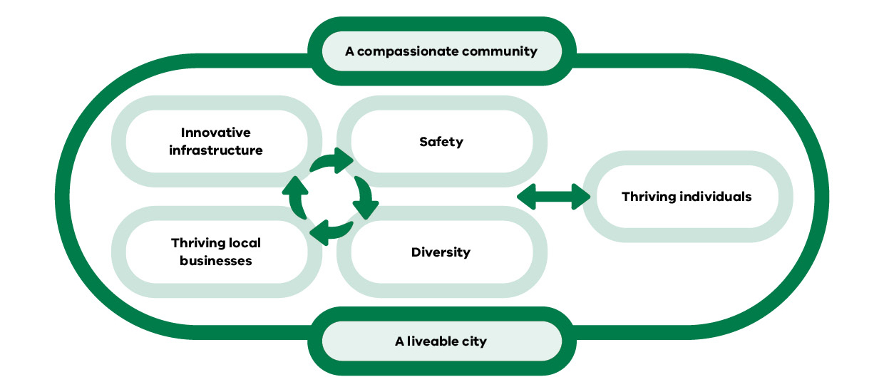
First and foremost, we want all Melton residents to thrive, regardless of their background, culture, identity or social circumstance.

Thriving individuals
- All individuals treat each other with compassion and respect
- People feel physically and emotionally safe in public spaces
- Melton residents are able to access a community ‘experience’
- Residents have easy access to the services they need
- Residents are proud of, and celebrate, the diversity in their communities
We are setting out to create a city that delivers all of the services you need.
We want to create a city where you feel safe, where we celebrate the diversity of our communities and where everyone is treated with compassion and respect.
Secondly, we will pull upon a range of levers to:
- Create an environment that is conducive to the establishment and growth of small businesses across different sectors
- Make investment decisions that also take into account their potential to grow our environmental footprint
- Apply a ‘diversity’ lens to everything we do and ensuring the safety of our residents is front-of-mind

Diversity
- Services and public spaces in Melton are culturally appropriate
- Greater recognition of First Nations People

Innovative infrastructure
- Sustainable living (renewable energy, waste) with savings reinvested in the community
- Natural features of Melton: wide spaces, parks and garden fully utilised
- Melton is known for investment in innovative infrastructure eg. cycle tracks

Safety
Melton has an improved perception of safety among the wider Melbourne community
Anti-social behaviour is reduced

Thriving local businesses
- Individuals looking to start new businesses are better supported
- Local businesses become more diversified
- Businesses are supported to take greater ownership of their role in the community including focusing on driving social change and employing more young people
- Businesses supported to provide inclusive services and leisure opportunities in the High street, or in designated ‘hubs’
In the longer-term, we believe that by focusing on striving to meet the needs of the community, and ensuring we are pulling the levers around growing local business, preserving the environment and investing in infrastructure, we can:
- Create a compassionate community where people from different backgrounds interact and share stories
- Create a liveable city which makes you proud and where people visit to enjoy themselves and have fun
Published by the Office for Suburban Development, (Level 8, 1 Spring Street) Melbourne, Victoria, Australia 3000. Telephone 1300 366 356
Authorised by the Victorian Government, Melbourne.
© Copyright State of Victoria, Department of Jobs, Precincts and Regions, October 2021. Except for any logos, emblems, trademarks, artwork and photography this document is made available under the terms of the Creative Commons Attribution 3.0 Australia license.
Disclaimer
This publication may be of assistance to you but the State of Victoria and its employees do not guarantee that the publication is without flaw of any kind or is wholly appropriate for your particular purposes and therefore disclaims all liability for any error, loss or other consequence which may arise from you relying on any information in this publication. While every effort has been made to ensure the currency, accuracy or completeness of the content we endeavour to keep the content relevant and up to date and reserve the right to make changes as require. The Victorian Government, authors and presenters do not accept any liability to any person for the information (or the use of the information) which is provided or referred to in the report.

