delwp.vic.gov.au

Metropolitan Partnerships – Southern region

|  |
| --- |
| The 2018 Southern Assembly  Summary Report |

|  |  |
| --- | --- |
|  |  |

**Privacy**

This report has been prepared by Capire and Department of Environment, Land, Water and Planning and is an independent account of the discussions at the assembly.

Capire Consulting Group and any person(s) acting on their behalf is committed to protecting privacy and personally identifiable information by meeting its responsibilities under the Victorian Privacy Act 1988 and the Australian Privacy Principles 2014 as well as relevant industry codes of ethics and conduct.

For the purpose of program delivery, and on behalf of its clients, Capire collects personal information from individuals, such as e-mail addresses, contact details, demographic data and program feedback to enable it to facilitate participation in consultation activities. Capire follows a strict procedure for the collection, use, disclosure, storage and destruction of personal information. Any information its collects is stored securely on its server for the duration of the program and only disclosed to its client or the program team. Written notes from consultation activities are manually transferred to our server and disposed of securely.

Comments recorded during any consultation activities are faithfully transcribed however not attributed to individuals. Diligence is taken to ensure that any comments or sensitive information does not become personally identifiable in our reporting, or at any stage of the program.

Capire operates an in-office server with security measures that include, but are not limited to, password protected access, restrictions to sensitive data and the encrypted transfer of data.

For more information about the way Capire collect information, how it is used, stored and disclosed and Capire’s complaints procedure, please see www.capire.com.au or telephone (03) 9285 9000.

Consultation

Unless otherwise stated, all feedback documented by Capire Consulting Group and any person(s) acting on its behalf is written and/or recorded during program/consultation activities.

Capire staff and associates take great care while transcribing participant feedback but unfortunately cannot guarantee the accuracy of all notes. Capire is however confident that it captured the full range of ideas, concerns and views expressed during consultation activities.

Unless otherwise noted, the views expressed in Capire’s work represent those of the participants and not necessarily those of Capire’s consultants or clients.

|  |
| --- |
| © The State of Victoria Department of Environment, Land, Water and Planning 2018  LogoThis work is licensed under a Creative Commons Attribution 4.0 International licence. You are free to re-use the work under that licence, on the condition that you credit the State of Victoria as author. The licence does not apply to any images, photographs or branding, including the Victorian Coat of Arms, the Victorian Government logo and the Department of Environment, Land, Water and Planning (DELWP) logo. To view a copy of this licence, visit <http://creativecommons.org/licenses/by/4.0/>  ISBN 978-1-76077-246-8 (print)  ISBN 978-1-76077-247-5 (pdf)  Disclaimer  This publication may be of assistance to you but the State of Victoria and its employees do not guarantee that the publication is without flaw of any kind or is wholly appropriate for your particular purposes and therefore disclaims all liability for any error, loss or other consequence which may arise from you relying on any information in this publication.  Accessibility  If you would like to receive this publication in an alternative format, please telephone the DELWP Customer Service Centre on 136186, email [customer.service@delwp.vic.gov.au](mailto:customer.service@delwp.vic.gov.au), or via the National Relay Service on 133 677 [www.relayservice.com.au](http://www.relayservice.com.au). This document is also available on the internet at [www.delwp.vic.gov.au](http://www.delwp.vic.gov.au). |

Contents

Executive Summary 1

The Metropolitan Partnerships 3

The 2018 Southern Assembly 4

Who took part in the conversation? 6

What we heard… 7

The top priorities for 2018 8

Exploring the priority outcomes in more detail 9

Evaluation 15

Executive Summary

The Southern Metropolitan Partnership (the Partnership) held its second annual Assembly on Wednesday 1 August 2018. The Assembly brought together 107 community members, businesses, councillors and MPs to continue the conversation for the Southern Metropolitan region.

The Metropolitan Assemblies are part of a commitment to give Victorians the opportunity to influence decisions and shape the future of their communities.

In its second year, the Southern Assembly provided the opportunity for the Partnership to report back to the community on how their input shaped the 2017 advice and how the Victorian Government has responded. It was also an opportunity to further explore the priorities for the region and how community, business and government can work collaboratively to address common challenges.

The night was divided into three activities: reviewing the 2017 priorities, choosing top priorities for 2018, and exploring the priority outcomes in more detail. These activities were preceded by three presentations from:

1. the Chair of the Southern Partnership, Elizabeth Deveny, who shared the process the Partnership had being going through over the last year;
2. the Minister for Suburban Development, Lily D’Ambrosio, who discussed the government’s response to the 2017 advice; and
3. two young people who attended the Youth Forum, Callum Johnstone and Georgia Newman from Patterson River Secondary College, shared their experience and the top priorities for young people in the Southern region.

## Activity 1 results - Reviewing the 2017 priority outcomes

In the first activity, participants were presented with the Partnership’s priority outcomes in 2017 and any related responses in the 2018-19 Victorian Budget. At tables of six to eight people, participants were asked to share their initial reactions to the priority outcomes and the Victorian Government’s response and were given the opportunity to suggest any additional priorities.

Overall the participants supported the 2017 priority outcomes and said that they were still relevant in 2018. People were especially interested in seeing further progress on the main themes of ‘employment’ and ‘infrastructure for transport and health’.

## Activity 2 results - The Assembly’s top priority outcomes for 2018

In the second activity participants were given a list of priorities to review and asked to ‘*Choose the top three priority outcomes you think the Partnership should consider for their 2018 advice to government*?’. The list included the Partnership’s 2017 priority outcomes, the top priorities at the Youth Forum and four new priorities which emerged during the discussion on the night.

The top four priorities chosen by participants were: ‘Transport’, ‘Youth (life skills, engagement, jobs)’, ‘Housing and Affordability’, and ‘Mental Health’.

## Activity 3 results - Exploring the priority outcomes in more detail

For the final activity participants each chose a priority outcome to discuss in more detail. This included exploring the real issues that can be impacted, what opportunities exist, and how we will know we have successfully improved the outcome.

The key messages from the activity were:

Connected Public Transport: increase connectivity, access and frequency of current public transport networks, including the bus networks to support efficient mobilisation in the region.

Youth Engagement: facilitate greater engagement with youth, providing access to employment, health services and recreational activity.

Housing and Affordability: provide increased access to affordable housing options, increasing the housing mix to satisfy the needs of current and future users in the region.

Access to Mental Health Services: support and connect community members with mental health services, as well as promoting mental health programs in schools and the workplace.

Support for Health and Wellbeing: provide better support for community members to engage and access health services.

Family and Community: continue to support local communities by encouraging fair, equitable and collective community engagement and service provision.

Access to Local Jobs: better access to employment opportunities, particularly supporting vulnerable workers in attaining appropriate skills, training and employment.

Environmental Preservation and Awareness: increased community engagement and awareness of environmental sustainability, resulting in collective action.

Education: improve youth engagement and increase links between schools and the workforce.

Celebrating Indigenous Culture and Sense of Place: promote the adoption of a treaty for true cultural recognition and community engagement.

Alternative Water Resources: encourage and facilitate the utilisation of alternative water resources.

Community Safety: improve public safety mechanisms to enhance perceptions of safety and safety in the region.

More detail on each of these discussions and suggestions for addressing these challenges can be found on page 9.

Summary of overall findings

Participants at the 2018 Southern Partnership Assembly shared their desire for an inclusive, vibrant community.

Several priorities raised at the first Southern Assembly in 2017 were discussed and reinforced as priorities in 2018. For example, priorities such as the need for greater housing affordability and public transport infrastructure were reinforced. This is because participants felt a focus on affordable housing and public transport will improve liveability and accessibility in the South and therefore the development of the region. Assembly participants were eager to see further action on these issues to a accommodate current and future residents in the Southern Region.

In May 2018 the experiences of young people in the region were considered through the Youth Forum. Priorities, such as ‘mental health’, raised at the Youth Forum were discussed and given a high priority at the Assembly. Participants also focussed on the significance of youth engagement, the need for better public transport to employment opportunities, and the barriers impacting a young person’s ability to progress from educational institutions to the workplace. It was felt that stronger collaboration between industries and educational bodies was needed to support employment links and attainment.

Participants were concerned with the lack of health services to support young people and reflected upon the need for greater funding and support for young people to access mental health services.

More broadly, participants advocated for increased access to health services in the region. The need for services to support community members, such as new arrival and refugees, to access employment opportunities was also recognised. Assembly participants commented on the need for greater support for vulnerable workers to attain the appropriate skills, training and employment they need.

Whilst acknowledging the diverse communities residing in the Southern Region, Assembly participants recommended greater investment in diverse workplace environments, accessible services for new migrants, and enhancing community safety. Further consideration was given to the diversity of community groups, and ‘Celebrating indigenous culture and sense of place’ emerged as a new outcome for 2018.

The Metropolitan Partnerships

**The Metropolitan Partnerships are a new and coordinated way for communities to advise government on what matters in their region.**

The Victorian Government wants to better understand and respond to the needs of Melbourne’s communities. In May 2017, six Metropolitan Partnerships across Melbourne were established because the government recognises that local communities are best placed to advise on issues and priorities for their region.

Each Partnership is made up of eight community and business representatives with varied backgrounds, experiences and networks, the CEO of every local government in that region and a Deputy Secretary from the Victorian State Government.

Working closely with their communities, the Partnerships will identify opportunities for driving improved social, economic and environmental outcomes and advise the government on actions that can make a real difference to the liveability and prosperity of their metropolitan region.

The Partnerships will strengthen relationships and facilitate stronger collaboration across the three tiers of government, businesses and communities. They will also enable the government to respond in a more coordinated and targeted manner to deliver better outcomes for the community.

More information on the six Metropolitan Partnerships can be found at suburbandevelopment.vic.gov.au.

## The Southern Metropolitan Partnership

The Southern Metropolitan Partnership members are:

* Elizabeth Deveny, Chair
* Andrew Simmons, Deputy Chair
* Andrew Cornwall, Member
* Vicki MacDermid, Member
* 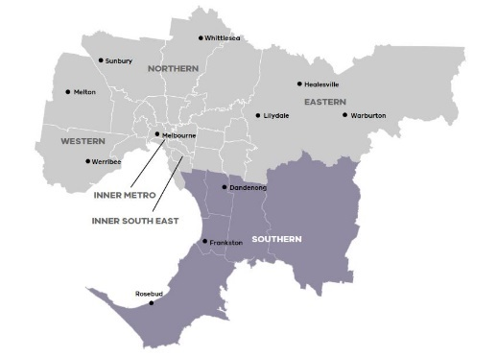 Shabnam Safa, Member
* Jillian Walsh, Member
* Andrew Gardiner, Member
* Jacqueline Galloway, Member
* Gary McQuillan, CEO, Cardinia Shire Council
* Steve Dalton, A/CEO, Casey City Council
* John Nevins, CEO, Kingston City Council
* Dennis Hovenden, CEO, Frankston City Council
* John Bennie, CEO, Greater Dandenong City Council
* Carl Cowie, CEO, Mornington Peninsula Shire Council

**Figure 1: The Southern Region**

* Jenny Atta, Victorian Government representative

## The Southern Region

Read more about the Southern Metropolitan Region at: <https://www.suburbandevelopment.vic.gov.au/regions/southern-region>

Find out more about the Southern Metropolitan Partnership members at: <https://www.suburbandevelopment.vic.gov.au/partnerships/metropolitan-partnerships/southern-partnership>

The Southern metropolitan region is a diverse and vibrant area that includes the coastal local government areas of Kingston, Frankston, and Mornington Peninsula. It also includes the inland regional economic centre of Greater Dandenong, and the outer suburban growth areas of Cardinia and Casey. It has the largest population of the six Melbourne regions at over 1 million people, or about 22 per cent of Melbourne’s total population.

The 2018 Southern Assembly

On Wednesday August 1, 2018, 107 community members, businesses, councillors and MPs came together to continue the conversation for the Southern Metropolitan region.

In its second year, the Southern Assembly was a chance to report back to the community how the Partnership and Government have responded to their input of 2017. It was also an opportunity to further explore the priorities for the region and what advice the Partnership can give government about improving the Southern region.

The ways in which people could contribute to the conversation in 2018 included online pre‑engagement, attending the Assembly in person, or online through live‑streaming and answering questions on the Engage Victoria web-page. The Assembly also took into account the views of young people who attended the Metropolitan Partnerships Youth Forum on 7 May 2018.

## The 2017 Priority Outcomes

Housing – Provide greater access to affordable housing options across the region.

Transport – Improve connectivity and access to employment, education, services and recreational activities.

**Education and Youth Engagement** – Increase education and retention for children and young people.

**Water** – Develop a regional approach to water usage to provide for long term economic growth and environmental benefit.

## What happened on the night

The night was divided into three activities that were preceded by three presentations from:

1. the Chair of the Southern Partnership, Elizabeth Deveny, who shared the process the Partnership had being going through over the last year.
2. the Honourable Lily D’Ambrosio, Minister for Suburban Development, who discussed the government’s response to the 2017 advice.
3. Callum Johnstone and Georgia Newman from Patterson River Secondary College attended the Metropolitan Partnerships Youth Forum on 7 May 2018, shared their experience and the top priorities for young people in the Southern region.

### Activity 1 – Reviewing the 2017 priority outcomes

Following presentations from the Partnership Chair and the Minister for Suburban Development, participants reviewed the Partnership’s 2017 priority outcomes and the government’s response.

At tables of six to eight people, participants were asked to share their initial reactions to the priority outcomes for the region. They also discussed whether anything had been missed and what priority they would add to the advice for 2018. Their discussions were facilitated by a senior government member and recorded by a scribe.

### Activity 2 – The Assembly’s top priority outcomes for 2018

To understand what remains the most important priorities for the Southern region for 2018, participants were asked to choose their top three priorities using polling technology. They were able to choose from the 2017 priority outcomes, priorities raised by young people and any additional priorities raised on the night. The results of this poll were displayed instantly.

### Activity 3 – Exploring the priority outcomes in more detail

Participants moved during the break onto tables according to the priority outcomes they wanted to discuss. Three questions were posed to participants, who discussed them in relation to the priority outcomes they were focussing on at their table. The questions were:

* *What is the real issue we can impact?*
* *What are the opportunities?*
* *How will we know we are successful?*

The table participants were then asked to design a vision board representing their responses to the questions.

The night concluded with evaluation questions, asking participants how satisfied participants were with the opportunities provided on the night to share and discuss the region’s priorities. The results of this poll were displayed instantly, increasing transparency.

## Limitations

There are limitations associated with the Assembly that should be acknowledged. They include:

* Assembly participants were not necessarily a representative sample of the   
  Southern population. The results from the night are a good indication of the sentiment and ideas in the region but are not a statistically valid reflection of the views of the entire Southern community. The Assembly engagement will be complimented with other engagement, which will inform the Partnership’s advice to Government.
* Due to multiple registration processes, demographic information was not collected for all participants.
* Participants had a varied understanding of the issues in the region and possible solutions.
* Table hosts have taken care to record participant’s feedback. However, we cannot guarantee the accuracy or inclusion of all comments. We are confident that the range of ideas, concerns and views reflect the comments made at the sessions.

Who took part in the conversation?

In total, 107 people attended the Assembly, including 88 community members, Mayors and councillors, MPs and Ministers, and 12 Partnership members. Between 28 May and 18 July 2018, a Southern region website was live on engage.vic.gov.au. The site was visited by 880 people and over 100 people completed the pre-engagement questions through the registration form.

The key Assembly participant demographic attributes are as follows:

* The largest age group was 45-54 years of age, but the Assembly had a good percentage of people under 35 (20 %).
* 63 participants live in the region and 39 work there.
* The cities of Kingston, Frankston and Casey had the most participants.
* Quite a few participants indicated they came from a non-English speaking background (15 attendees).

**Figure 2: Age breakdown of the Assembly community member participants[1].**

Figure 3: Assembly participants’ relationship to the region[2].

Figure 4: Municipality that Assembly participants live in[3].

**Figure 5: Numbers of participants with a disability, Aboriginal or Torres Strait Islander heritage, or a non-English speaking background**.

What we heard…

## Reviewing the 2017 priority outcomes

At each table, participants could review the Partnership’s priority outcomes in their 2017 advice to government, as well as the government’s response. The participants were asked to discuss what their reflections were on the 2017 advice and discuss whether they believed the priority outcomes captured everything that was important to the region, and what further action was required.

In the online registration form, people were also shown the priority outcomes from 2017 and asked whether they were still relevant to the region in 2018 and what would be their top priority, if they could add one.

This section presents the findings from both the online and the face‑to‑face engagement.

### Participant’s reflections on the 2017 advice?

Overall, the participants endorsed the 2017 priority outcomes, which were still considered to be highly relevant in 2018 and were likely to remain so because of the high regional population growth rate. There was a strong reinforcement of the 2017 priority outcomes, particularly echoing the need for greater affordable housing options and increased connectivity. Some participants identified areas that were not addressed in the 2017 advice, articulating concerns about ‘youth disengagement’, ‘mental health’, ‘employment opportunities’ and ‘access to local services’. During the reflective discussions, some participants highlighted that the 2017 priority outcomes were too broad in scope. Some participants saw the value in articulating more localised and context specific priority outcomes.

### What do the Partnerships need to do more work on in 2018?

Participants were asked what other areas required attention in 2018 and provided many ideas for additional priorities and work to be progressed by the Partnership. The participants readdressed the need for greater ‘housing affordability’ and ‘adequate access to transport’, ‘employment’ and ‘education’.

Whilst examining access to transport, participants were eager to see further investment into bus networks and public transport options. Comments reflected a common desire for enhanced connectivity, permeability and access. When evaluating the 2017 advice, participants identified the need for greater employment opportunities. Participants also identified how the current public transport services impact access to employment opportunities and local services.

‘Mental health’ was a common topic raised. Participants were particularly concerned with young people’s mental health and wellbeing in the Southern Metropolitan region. The assembly participants discussed the need for greater funding and service provision, connecting community members with mental health services and programs. Furthermore, participants advocated for community member’s increased engagement and better access to local health services.

The top priorities for 2018

After a tea break, participants were given a list of priorities to review and asked to ‘*choose the top three priority outcomes you think the Partnership should consider for their 2018 advice to government’*. These included the Partnership’s 2017 priority outcomes, the young people’s priorities and two new priorities which emerged on the night.

### Partnerships priority outcomes from 2017:

1. Housing
2. Transport
3. Education and youth engagement
4. Water
5. Family and community
6. Environment
7. Access to local jobs

### Priorities from the Youth Forum:

1. Mental health services and awareness.
2. Life skills in the education.
3. Housing affordability

Additional priorities submitted at the Assembly:

1. Community Safety
2. Celebrating Indigenous culture and sense of place.

The results, displayed in Figure 5, show that the top four priorities chosen by participants were Transport, Youth (life skills, engagement, jobs), Housing and Affordability, and Mental Health.

Figure 6: Results of the poll 'choose the top three priority outcomes you think the Partnership should consider for their 2018 advice to government’

Exploring the priority outcomes in more detail

In the third activity participants sat at theme-based tables, and explored four questions:

1. *What is the real issue we can impact?*
2. *What are the opportunities?*
3. *How will we know we are successful?*

Their responses have been summarised under each theme in the following section. The themes are not presented in order of weighting or priority.

## Transport

**The real issue that can be impacted:**

* Communication of delays and changes to public transport users.
* Frequency of public transport.
* The lack of interconnected public transport in the region.
* The limited number of car parking spaces at train stations.
* Limited public transport options for young people.
* Safety when waiting for public transport services.
* Some streets in the region are not serviced with footpaths.
* Cycling and walking is unsafe on high speed roads.
* Current public transport provision is limiting access to employment, local services and social opportunities.

**The opportunities are:**

* Increase the frequency of bus services for more direct and regular services.
* Extend the bus network’s operation hours.
* Provide better road infrastructure to accommodate bus networks.
* Provide additional footpaths and cycling paths to facilitate active transport.
* Install bicycle storage spaces at public transport nodes.
* Provide bike racks on buses.
* Undertake greater analysis and assessment of public transport routes within the region to better accommodate routes for inhabitants in the South.
* Embrace innovative forms of public transport e.g. on-demand bus services.

**We will know we are successful when:**

* Active public transport connects the community to their desired destinations.
* Cycling is a safe, viable and frequent choice of transportation.
* Air pollution is reduced.
* Traffic congestion is minimised.
* Buses are a preferable, reliable, comfortable and a safe public transport option.
* There are more opportunities for young people to use public transport.
* More flexible and on-demand transport options exist.

## Youth (life skills, engagement, jobs)

**The real issue that can be impacted:**

* Minimal partnerships between schools and health services.
* Recognising the economic climate for young people in 2018 is challenging.
* Infrequent and ineffective bus services.
* Unaffordable rent and bills for young students.

**The opportunities are:**

* Improve pathways from schooling to work environments.
* Equip young people with the appropriate skills to enter the workforce.
* Facilitate career guidance programs for young people.
* The establishment of local placements.
* Provide sporting hubs for young people to be engaged.
* Support the partnership between young people and youth mental health services.

*Participants did not complete the question ‘What will success look like?’.*

## Mental Health

**The real issue that can be impacted:**

* Lack of prevention and early intervention services.
* Limited access to mental health services.
* The stigma around mental illnesses.

**The opportunities are:**

* Supporting the role of schools in improving mental health outcomes.
* Connecting the community with prevention programs in early childhood and middle years.
* Funding mental health first aid programs across the community.
* Mental Health first aid training for community.
* Strengthen preexisting mental health programs for maximum effect and access.

**We will know we are successful when:**

* There is a decrease in the rates of self-harm and suicide.
* There has been an increase in higher education attainment.
* Mental health services have consistent engagement with community members.
* Treatment is accessible and affordable.
* Negative attitudes and stigma of mental health have diminished.

## Housing

**The real issue that can be impacted:**

* There is a lack of housing diversity in the Southern Region.
* The current funding cannot support the demand for housing infrastructure.
* Visa requirements present barriers for non-Australian born community members to gain housing.
* Increasing rental prices are unaffordable.

**The opportunities are:**

* Create local employment to support financial security.
* Increase housing diversity to ensure housing is accessible and affordable for current and future community members.
* Encourage localised employment opportunities.
* Establish services to support residents when attaining new accommodation.
* Provide rental and mortgage assistance.
* Develop contributions to affordable housing: make it enforceable through planning regulations.

**We will know we are successful when:**

* There are sustainable economic models for affordable housing across all areas of government.
* There is a greater percentage of affordable housing.
* There are adequate housing opportunities for the elderly, single people and young people.
* Local and state governments are providing adequate financial support and housing projects for the community.
* There is a decrease in stigma surrounding public, social and affordable housing.

## Health and Wellbeing

**The real issue that can be impacted:**

* Connecting people with health services.
* Online services are difficult for some members of the community to access.
* Mental health management, and support in schools and the workplace.
* Communication between health services and non-English speaking community members.
* The waitlist for health services.
* Hospital congestion.

**The opportunities are:**

* Alert employers of local health and wellbeing services available.
* Communicate health and wellbeing messages through public advertising and marketing.
* Utilise volunteers to assist in the provision of services.
* Develop a waiting list management program at the hospital.
* Greater engagement by services with local communities.
* Support community services to prevent increased hospital admission.
* Healthy food choices in food vendors and local shops.
* Promote physical exercise and outdoor experiences.

**We will know we are successful when:**

* Health and wellbeing services are accessible, available and utilised.
* Health services have access to a large volunteer base.
* Incidents of self-harm have been reduced.
* The region sees a reduction in people re-offending.
* There is a reduction in hospital and health service waitlists.
* The prevalence of disease is reduced in the region.
* Physical activity amongst community members has increased.
* 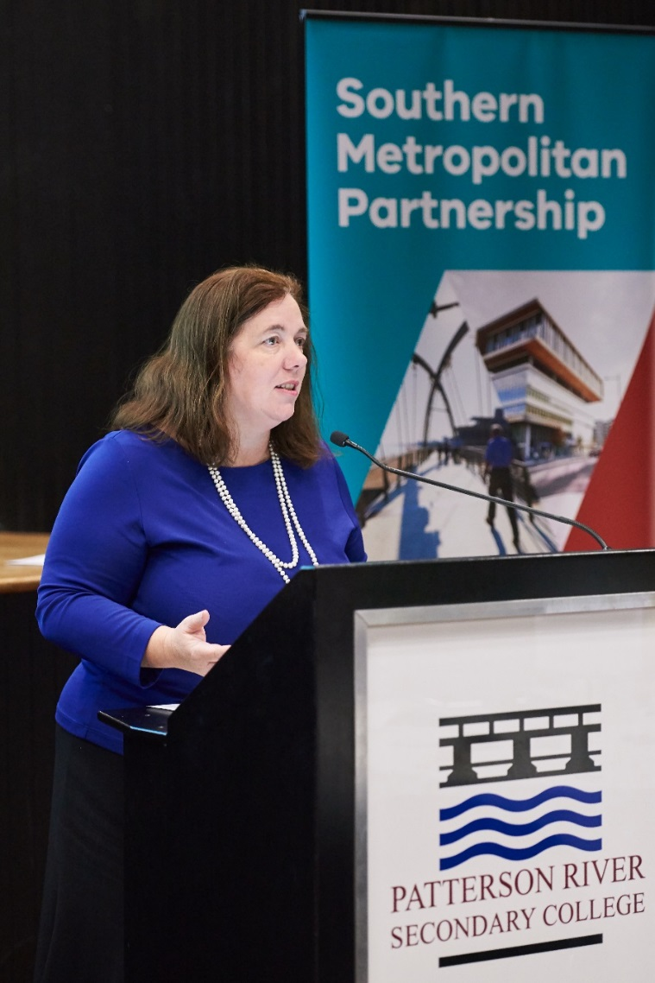Community health and wellbeing strategies have been formed and implemented.

## Family and Community

**The real issue that can be impacted:**

* Gender inequity and inequality.
* The presence of domestic violence.
* Discrimination and disadvantage due to socio-economic factors.

**The opportunities are:**

* Develop volunteer programs to give youth experience and skills for their resumes.
* Provide affordable English classes for refugees and newly arrived migrants.
* Foster and develop respect for self and community and build resilience.
* Support the integration of services and initiatives working across LGAs.
* Provide the local community with adequate tools to empower themselves.

**We will know we are successful when:**

* There are increased rates of school attendance.
* Community based and identified performance metrics are established and used to measure community empowerment and strength.
* Training programs are facilitating greater community engagement and employment.
* The employment rates in the Southern region have increased.

## Employment/Access to Local jobs

**The real issue that can be impacted:**

* Prejudice and discrimination limit people’s ability to work.
* Work opportunities and occupational training is limited in the region.
* Overseas qualifications and experiences are not recognised in Australia.
* Workplace bullying forces people to leave their work.
* Government employment agencies do not adequately connect workers with full time employment.

**The opportunities are:**

* Expand diversity recruitment programs to ensure there are inclusive workplace opportunities.
* Enhance protection in the workforce for vulnerable workers.
* Increase apprenticeship opportunities and training for residents.
* Facilitate stronger collaboration with industry to support employment attainment.
* Provide investment into key programs for jobs and training addressing employment needs.
* Stronger collaboration with industry and private sector to address training and skills needs.
* Change perception of career options and industries.

**We will know we are successful when:**

* People are receiving adequate training and can work in industries selected by the individual.
* Unemployment rates have decreased in the region.
* People in the South have the choice to participate and contribute to the local and wider economy.

## Environment

**The real issue that can be impacted:**

* Unsustainable development.
* Disengaged community attitudes surrounding environmental action.
* The prioritisation of economic benefits over environmental preservation.
* Environmental threats disregarded in decision making processes.

**The opportunities are:**

* Increase community engagement and awareness of environmental sustainability.
* Establish community reference groups to provide advice on all environmental statutory authority decisions.
* Create a regional/local database of environmental sites of significance.
* Increase signage promoting local produce.
* Detail strategic documents to govern use of the green wedge zone.
* Increase environmentally sensible development.
* Acknowledge and preserve Western Port Bay.
* Protect the Mornington Peninsula as an important environmental asset.

**We will know we are successful when:**

* The urban growth boundary is defined and continuously assessed to ensure environmental preservation.
* There is an increase in public awareness of environmental concerns.
* There has been an increase to the Southern region’s livability rating.
* Local food production is maintained and serving the community.

## Education

**The real issue that can be impacted:**

* Youth disengagement from studies.
* Barriers inhibiting young people’s ability to move from educational institutions to the workplace.
* Skills gained through extra-curricular and informal settings are not recognised by employers.
* Limited services supporting people who have recently migrated.
* Mainstream schooling does not tailor education to the individual.
* Insufficient educational facilities/infrastructure.
* There is an inadequate amount of schools serving the population.
* Drug addictions and family violence impacting productivity and wellbeing of students.
* The absence of age appropriate sexual health education.
* The limited presence of allied health workers in schools.

**The opportunities are:**

* Create links between educational institutions and various support services.
* Provide subsidised breakfast programs to students.
* Encourage suicide prevention and mental health services in educational institutions.
* Provide further voluntary opportunities to community members.
* Improve connections between schools and work experience/employment.
* Ensure young children are engaged socially and recreationally.
* Increase professional capabilities to respond to domestic conflicts within a school setting.
* The emergence of a community hub enabling informal educational engagement.
* Train primary school teachers and parents to support earlier intervention.

**We will know we are successful when:**

* There is adequate support for those seeking employment.
* Employment rates have increased.
* More people are participating in work experience and job placements.
* There has been a reduction in early leavers from school.
* There has been a reduction in hospital admissions.
* There has been a reduction in youth suicide.

## Celebrating Indigenous culture and sense of place

## The real issue that can be impacted:

* The absence of a treaty prevents Aboriginal and Torres Strait Islander people from true cultural recognition and national engagement.
* The lack of funding towards Aboriginal and Torres Strait Islander people and the relevant services.
* Management of water and the environment.
* Aboriginal and Torres Strait Islander employment rates.
* Aboriginal and Torres Strait Islander school attendance rates.
* Mental health amongst Aboriginal and Torres Strait Islander people.

**The opportunities are:**

* The presence of a Treaty:
  + to increase sense of place
  + to educate on traditional waters and lands
  + to harness positive relationships between first peoples and the rest of the Australian population
  + to improve service delivery
  + to promote equal and fair negotiations
  + to support mental health in the community
  + to drive housing solutions for the community.
* Implement statues, signage, languages and stories in public spaces to share Aboriginal and Torres Strait Islander histories and presence with local communities.
* Create new jobs within the education sector, to educate and engage youth with Aboriginal and Torres Strait Islander teachings.

**We will know we are successful when:**

* Non-indigenous communities engage with Aboriginal and Torres Strait Islander communities, collectively celebrating Indigenous culture, history and place.
* The Aboriginal and Torres Strait Islander communities have greater engagement, empowerment and authority over their lives.
* The mainstream school curriculum changes to include the languages, histories and stories of Aboriginal and Torres Strait Islander peoples.
* A treaty is adopted.

## Water

**The real issue that can be impacted:**

* Community's preparedness to pay for recycled or alternative water.
* The over consumption and waste of limited drinking water.
* Trading allocations for water is low in 2018/19 budget.
* The cost of water.
* Recycled and storm water are underutilized resources.

**The opportunities are:**

* Promote economic growth through an increase in alternative water resources.
* Improve the efficiency of residential water use.
* Improve livability and public green spaces.

**We will know we are successful when:**

* There has been a reduction to the amount of waste discharged into the bay.
* Jobs have been created due to the demand of alternative water resources.
* Green spaces are thriving and healthy.
* Property values have improved.

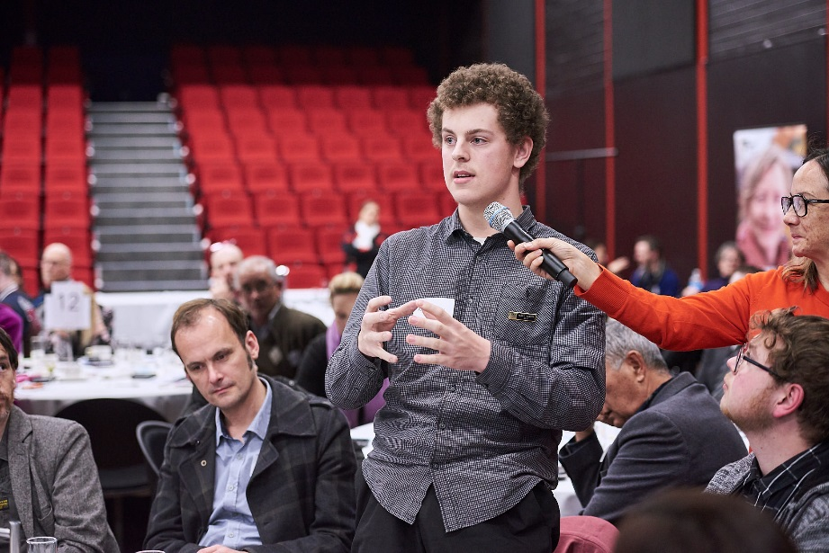

## Community Safety

**The real issue that can be impacted:**

* The presence of domestic violence.
* The presence of chronic stress.
* The presence of social isolation.
* Unsafe public environments.

**The opportunities are:**

* Addressing the issue of social isolation through building community connections and public events.
* Provide ongoing funding to support Neighbourhood/Safety Housing.
* Create opportunities for communities within the region to engage and build relationships.
* 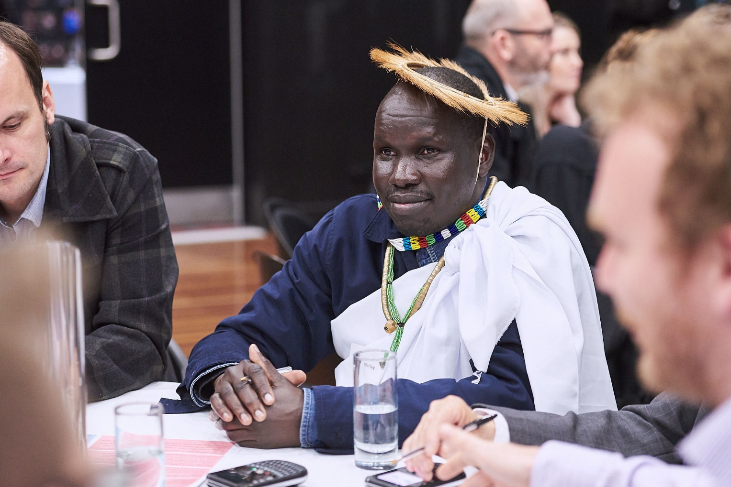Harness community input and building resilience to community safety threats.

**We will know we are successful when:**

* People's perception of feeling safe in their community has increased.
* There has been a reduction in domestic violence.
* Community members are aware of and have access to relevant services.

Evaluation

Participants were asked to evaluate the success of the Assembly by answering the question: ‘*How satisfied are you with the opportunities provided tonight to share and discuss the priorities for your region?*’, with possible responses ranging from ‘very dissatisfied’ to ‘very satisfied’.

The overall feedback for the assembly was very positive, with 88 per cent of respondents stating that they were either satisfied or very satisfied with the opportunities provided at the assembly.

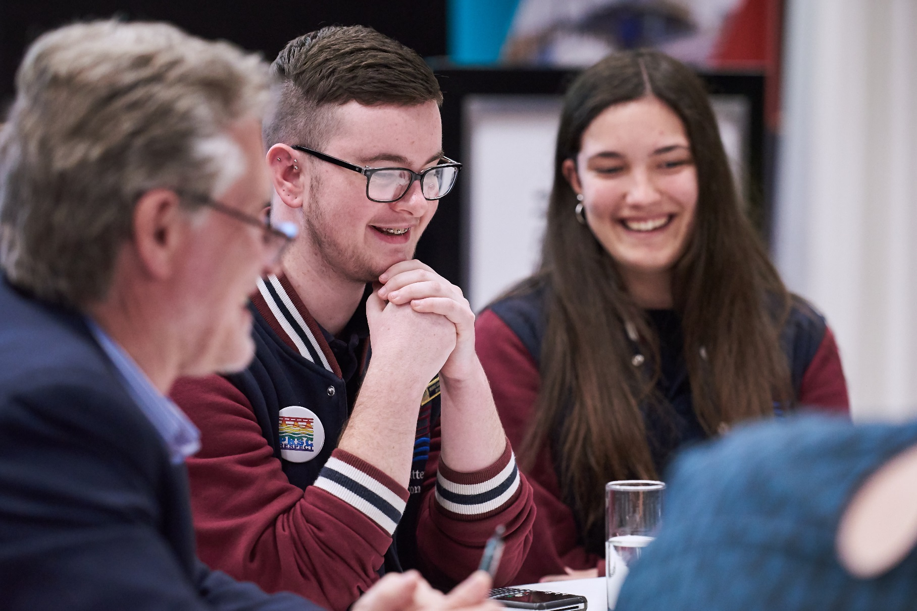Figure 6: Participant’s responses to the question: 'How satisfied are you with the opportunities provided tonight to share and discuss the priorities for your region?

1. Graphs have been calculated for the people who attended the Assembly and do not include demographics of people who completed questions in the registration form but did not attend the Assembly.
2. Participants could choose more than one option.
3. Many participants did not provide their suburb.