delwp.vic.gov.au

Metropolitan Partnerships – Western region

|  |
| --- |
| The 2018 Western Assembly  Summary Report |

|  |  |
| --- | --- |
|  |  |

**Privacy**

This report has been prepared by Capire and Department of Environment, Land, Water and Planning and is an independent account of the discussions at the assembly.

Capire Consulting Group and any person(s) acting on our behalf is committed to protecting privacy and personally identifiable information by meeting our responsibilities under the *Victorian* *Privacy Act 1988* and the *Australian Privacy Principles 2014* as well as relevant industry codes of ethics and conduct.

For the purpose of program delivery, and on behalf of our clients, we collect personal information from individuals, such as e-mail addresses, contact details, demographic data and program feedback to enable us to facilitate participation in consultation activities. We follow a strict procedure for the collection, use, disclosure, storage and destruction of personal information. Any information we collect is stored securely on our server for the duration of the program and only disclosed to our client or the program team. Written notes from consultation activities are manually transferred to our server and disposed of securely.

Comments recorded during any consultation activities are faithfully transcribed however not attributed to individuals. Diligence is taken to ensure that any comments or sensitive information does not become personally identifiable in our reporting, or at any stage of the program.

Capire operates an in-office server with security measures that include, but are not limited to, password protected access, restrictions to sensitive data and the encrypted transfer of data.

For more information about the way we collect information, how we use, store and disclose information as well as our complaints procedure, please see www.capire.com.au or telephone (03) 9285 9000.

Consultation

Unless otherwise stated, all feedback documented by Capire Consulting Group and any person(s) acting on our behalf is written and/or recorded during our program/consultation activities.

Capire staff and associates take great care while transcribing participant feedback but unfortunately cannot guarantee the accuracy of all notes. We are however confident that we capture the full range of ideas, concerns and views expressed during our consultation activities.

Unless otherwise noted, the views expressed in our work represent those of the participants and not necessarily those of our consultants or our clients.

|  |
| --- |
| © The State of Victoria Department of Environment, Land, Water and Planning 2018  LogoThis work is licensed under a Creative Commons Attribution 4.0 International licence. You are free to re-use the work under that licence, on the condition that you credit the State of Victoria as author. The licence does not apply to any images, photographs or branding, including the Victorian Coat of Arms, the Victorian Government logo and the Department of Environment, Land, Water and Planning (DELWP) logo. To view a copy of this licence, visit <http://creativecommons.org/licenses/by/4.0/>  ISBN 978-1-76077-244-4 (print)  ISBN 978-1-76077-245-1 (pdf)  Disclaimer  This publication may be of assistance to you but the State of Victoria and its employees do not guarantee that the publication is without flaw of any kind or is wholly appropriate for your particular purposes and therefore disclaims all liability for any error, loss or other consequence which may arise from you relying on any information in this publication.  Accessibility  If you would like to receive this publication in an alternative format, please telephone the DELWP Customer Service Centre on 136186, email [customer.service@delwp.vic.gov.au](mailto:customer.service@delwp.vic.gov.au), or via the National Relay Service on 133 677 [www.relayservice.com.au](http://www.relayservice.com.au). This document is also available on the internet at [www.delwp.vic.gov.au](http://www.delwp.vic.gov.au). |

Contents

Executive Summary 1

The Metropolitan Partnerships 3

The 2018 Western Assembly 4

Who took part in the conversation? 6

What we heard… 7

The top priorities for 2018 9

Exploring the priority outcomes in more detail 10

Evaluation 14

Executive Summary

The Western Metropolitan Partnership (the Partnership) held its second annual Assembly on Wednesday 18 July 2018. The Assembly brought together 103 community members, businesses, councillors and mayors to continue the conversation for the Western Metropolitan region.

The Metropolitan Assemblies are part of a commitment to give Victorians the opportunity to influence decisions and shape the future of their communities.

In its second year, the Western Assembly provided the opportunity for the Partnership to report back to the community on how their input shaped the 2017 advice and how the government has responded. It was also an opportunity to further explore the priorities for the region and how community, business and government can work collaboratively to address the challenges in the region.

The event was divided into three activities: reviewing the 2017 priorities, choosing top priorities for 2018, and exploring the priority outcomes in more detail. These activities were preceded by three presentations from:

1. the Chair of the Western Metropolitan Partnership, Alex Cockram, who shared the process the Partnership had being going through over the last year;
2. the Honourable Lily D’Ambrosio, Minister for Suburban Development and Minister for Energy, Environment and Climate Change, and the Honourable Jill Hennessy, Minister for Health and Minister for Ambulance Services, who discussed the government’s response to the 2017 advice; and
3. a young person who attended the Metropolitan Partnerships Youth Forum, Asende Singehebhuye, who shared their experience and the top priorities for young people in the Western region.

## Activity 1- Reviewing the 2017 priority outcomes

In the first activity, participants were presented with the Partnership’s priority outcomes for 2017 and the related responses in the 2018 Victorian Government Budget. At tables of six to eight people, participants were asked to share their initial reactions to the priority outcomes and the government’s response.

Overall the participants supported the 2017 priority outcomes, confirming that they were still relevant in 2018. People were especially interested in seeing further progress on the main themes of ‘employment’ and ‘infrastructure for transport and health’.

## Activity 2 results - The Assembly’s top priority outcomes for 2018

In the second activity, participants were given a list of priorities to review and asked to ‘*Choose the top three priority outcomes you think the Partnership should consider for their 2018 advice to government*?’. The list included the Partnership’s 2017 priority outcomes, the top priorities at the Youth Forum and three new priorities which emerged during the first discussion on the night.

The top three priorities chosen by participants were: ‘Jobs, Skills and Entrepreneurship’; ‘Public Transport, Road Congestion and Freight’; and ‘Reducing Entrenched Disadvantage Through Better Health and Education Services’.

## Activity 3 results - Exploring the priority outcomes in more detail

For the final activity, participants each chose a priority outcome to discuss in more detail. This included exploring the real issues that can be impacted, what opportunities exist, and how we will know we have successfully improved the outcome.

The key messages from the activity were:

Jobs, Skills and Entrepreneurship: continue to support local small businesses by improving the opportunities for local procurement and employment.

Public Transport, Road Congestion and Freight: improve access to and parking at train stations, as well as integrated transport options, including bike infrastructure.

Reduce Entrenched Disadvantage through Better Health and Education Services: better services to support families and prepare them for the demands of post-natal and early years, particularly providing accessible services and reducing the isolation of young mothers.

A Greener Region (Parks and Open Space): increase funding for open spaces, as well as providing education about the importance of parks and open space for the region.

Waste and Recycling Centre of Excellence: continued support for initiatives to educate the public about the environment and awareness of the opportunities for the region in recycling.

Support for Homeless People: support diverse and affordable housing measures, including inclusionary zoning, to better assist the disadvantaged and people experiencing hardship.

Intercultural Development: support migrants to overcome segregation and improve intercultural exchanges and education.

Connected Communities: improve attitudes towards women and youth across all cultures and age-groups.

Marketing and Promotion of The West: improve the region’s negative image by building community awareness of its multicultural heritage, and capitalising on the West’s natural resources and heritage.

More detail on each of these discussions and suggestions for addressing these challenges can be found on page 10.

Summary of overall findings

Participants at this year’s Assembly highlighted many of the same issues that were raised last year. A lack of jobs, and transport infrastructure and connectivity remained the two consistent themes identified amongst the western region’s barriers to long-term success, along with issues relating to health and education. Participants were keen to see further action on all these issues in order to keep pace with the growth being experienced across the entire region.

At the same time, participants provided optimistic feedback reflecting a high level of pride, drawn from the region’s sense of community and diverse cultural identity. A key aspect of this year’s reflections was the need to grow this sense of pride throughout the community and to better manage the West’s reputation across metropolitan Melbourne. Participants considered that even though the West was an area brimming with human capital and innovative ideas, this was often overlooked in media narratives, which have tended to focus on negative portrayals of youth culture. Recognising, developing and promoting the positive stories of the West was put forward as an important step to take to encourage people to come to the West to live, work and travel.

The physical assets of the region were also identified as being under-utilised or recognised, with opportunities to turn around peoples’ opinions of these assets. Some examples of this included the area’s waste recycling potential and the renewal of industrial heritage and architecture. Recycling initiatives were considered excellent opportunities to make the West a leading centre for innovation and reinvention. The region’s creative hubs were also viewed as being essential to not only bring people together and educate them, but also help to address the region’s employment challenges into the future.

The west’s remarkable cultural diversity underpinning its physical assets was what people considered the primary strength for the West. While continuing to improve services to currently underserviced elements of society, including immigrants, it was seen as equally important to increase public education in order to broaden the view that diverse populations are vital assets in both community building and job creation.

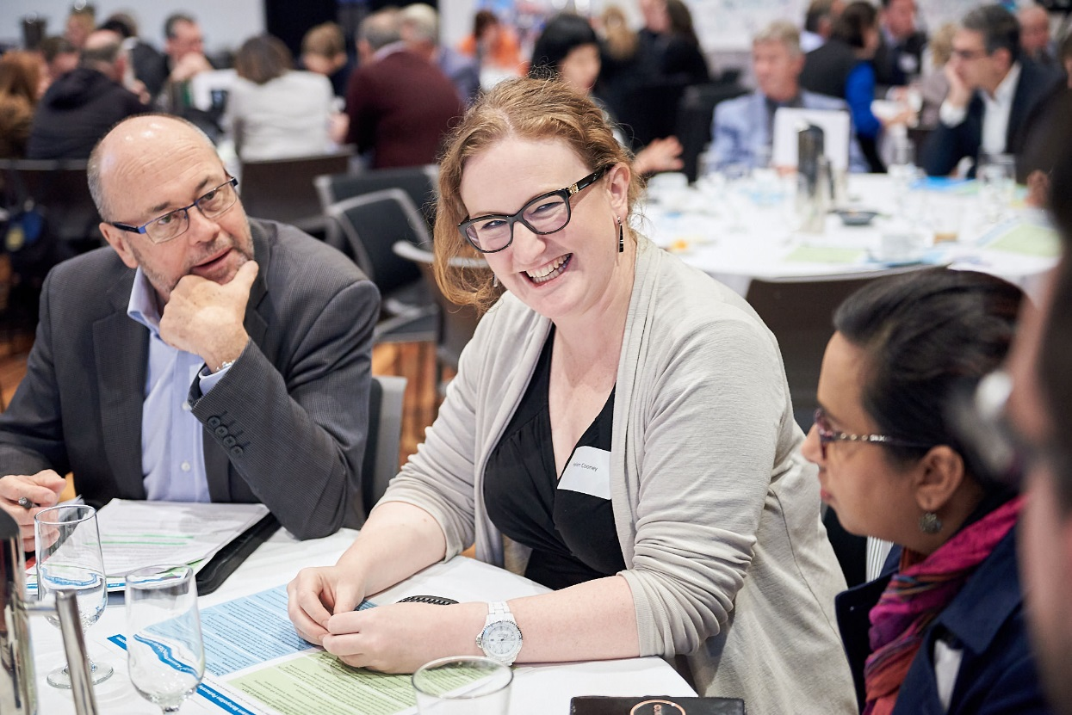

The Metropolitan Partnerships

**The Metropolitan Partnerships are a new and coordinated way for communities to advise government on what matters in their region.**

The Victorian Government wants to better understand and respond to the needs of Melbourne’s communities. In May 2017, six Metropolitan Partnerships across Melbourne were established because the government recognises that local communities are best placed to advise on issues and priorities for their region.

Each Partnership is made up of eight community and business representatives with varied backgrounds, experiences and networks, the CEO of every local government in that region and a Deputy Secretary from the Victorian State Government.

Working closely with their communities, the Partnerships will identify opportunities for driving improved social, economic and environmental outcomes and advise the government on actions that can make a real difference to the liveability and prosperity of their metropolitan region.

The Partnerships will strengthen relationships and facilitate stronger collaboration across the three tiers of government, businesses and communities. They will also enable the government to respond in a more coordinated and targeted manner to deliver better outcomes for the community.

More information on the six Metropolitan Partnerships can be found at suburbandevelopment.vic.gov.au

## The Western Metropolitan Partnership

The Western Metropolitan Partnership members are:

* Alex Cockram, Chair
* Peter Dawkins, Deputy Chair
* James Fitzgerald, Member
* Anna Reid, Member
* Rhyll Dorrington, Member
* Christopher Campbell, Member
* Elleni Bereded-Samuel, Member
* Stephen Wall, CEO, Maribyrnong City Council
* Helen Morrissey, CEO, Brimbank City Council
* Kelvin Tori, CEO, Melton City Council
* Aaron van Egmond, CEO, Hobsons Bay City Council
* Bryan Lancaster, CEO, Moonee Valley City Council
* Kelly Grigsby, CEO, Wyndham City Council

**Figure 1: The Western Region**

* Luke Wilson, Victorian Government representative

## The Western Region

Read more about the Western Metropolitan Region at: <https://www.suburbandevelopment.vic.gov.au/regions/western-region>

Find out more about the Western Metropolitan Partnership members at: <https://www.suburbandevelopment.vic.gov.au/partnerships/metropolitan-partnerships/western-partnership>

The Western region extends from the inner suburban local government areas (LGAs) of [Moonee Valley](http://www.mvcc.vic.gov.au/) and [Hobsons Bay](http://www.hobsonsbay.vic.gov.au/) through to the middle-ring areas of [Maribyrnong](https://www.maribyrnong.vic.gov.au/Home) and [Brimbank](https://www.brimbank.vic.gov.au/?_ga=2.37398818.388927310.1510529530-1982647733.1478492236), and to the growth areas of [Melton](http://www.melton.vic.gov.au/Home) and [Wyndham](https://www.wyndham.vic.gov.au/)[.](https://www.wyndham.vic.gov.au/?_ga=2.34784547.388927310.1510529530-1982647733.1478492236) The region has a population of around 900,000, or about 19 per cent of metropolitan Melbourne’s total population.

The 2018 Western Assembly

On Wednesday 18 July 2018, 103 community members, businesses, councillors and mayors came together to continue the conversation for the Western Metropolitan region.

In its second year, the Western Assembly was an opportunity to report back to the community on how the Partnership and Government have responded to their input of 2017. It was also an opportunity to further explore the priorities for the region and what advice the Partnership can give government about improving the Western region.

The ways in which people could contribute to the conversation in 2018 included online pre‑engagement, attending the Assembly in person, or participating online through live‑streaming and answering questions on the Engage Victoria web-page. The Assembly also took into account the views of young people who attended the Metropolitan Partnerships Youth Forum on 7 May 2018.

## The 2017 Priority Outcomes

Jobs and Skills – a diverse offering of jobs close to where people live

Public Transport, Road Congestion and Freight – increase the reach and strength of the network, and consolidate the West as a central hub for freight and logistics

Reduce Entrenched Disadvantage through Better Health and Education Services – improve social connectivity and wellbeing

Connected Communities – an inclusive and creative western region that embraces cultural, social and economic diversity

A Greener Region – liveable and well-planned suburbs with open space, trees and appealing streetscapes

A Waste and Recycling Centre of Excellence – showcase best practice approaches to waste management and recycling through a western centre of excellence.

## What happened on the night

The event was divided into three activities that were preceded by three presentations from:

1. the Chair of the Western Metropolitan Partnership, Alex Cockram, who shared the process the Partnership had being going through over the last year.
2. the Honourable Lily D’Ambrosio, Minister for Suburban Development and Minister for Energy, Environment and Climate Change, and the Honourable Jill Hennessy, Minister for Health and Minister for Ambulance Services, who discussed the government’s response to the 2017 advice.
3. a young person who attended the Metropolitan Partnerships Youth Forum on 7 May 2018, Asende Singehebhuye, who shared their experience and the top priorities for young people in the Western region.

### Activity 1 – Reviewing the 2017 priority outcomes

Following the presentations, participants reviewed the Partnership’s 2017 priority outcomes and the government’s response.

At tables of six to eight people, participants were asked to share their initial reactions to the priority outcomes for the region. They also discussed whether anything had been missed. Their discussions were facilitated by a senior government member and recorded by a scribe.

### Activity 2 – The Assembly’s top priority outcomes for 2018

To understand what remains the most important priorities for the Western region for 2018, participants were asked to choose their top three priorities using polling technology. They were able to choose from the 2017 priority outcomes, priorities from young people and any additional priorities raised on the night. The results of this poll were displayed instantly.

### Activity 3 – Exploring the priority outcomes in more detail

Participants moved during the break onto tables according to the priority outcomes they wanted to discuss. Three questions were posed in relation to the priority outcomes they were focused on at each table. The questions were:

* *What is the real issue we can impact?*
* *What are the opportunities?*
* *How will we know we are successful?*

The table participants were then asked to create a vision board representing their responses to the questions.

The night concluded with evaluation questions, asking participants how satisfied they were with the opportunities provided on the night to share and discuss the region’s priorities. The results of this poll were displayed instantly, increasing transparency.

## Limitations

There are limitations associated with the Assembly that should be acknowledged. They include:

* Assembly participants were not necessarily a representative sample of the Western Region’s population. The results from the night are a good indication of the sentiment and ideas in the region but are not a statistically valid reflection of the views of the entire Western community. The Assembly engagement will be complemented with other engagement, which will inform the Partnership’s advice to Government.
* Due to multiple registration processes, demographic information was not collected for all participants.
* Participants had a varied understanding of the issues in the region and possible solutions.
* Table scribes have taken care to record participant’s feedback. However, we cannot guarantee the accuracy or inclusion of all comments. We are confident that the range of ideas, concerns and views reflect the comments made at the sessions.

Who took part in the conversation?

In total, 103 people attended the Assembly, including 69 community members, 13 councillors, seven MPs and Ministers, and 14 Partnership members. Between 28 May and 18 July 2018, a Western region website was live on engage.vic.gov.au. The site was visited by 1,422 people and 158 people completed the pre-engagement questions through the registration form.

The key Assembly participant demographic attributes are as follows.

* Most participants (86 per cent) were between 25 and 64 years of age.
* Notably, 24 per cent of participants were between 15 and 34 years of age, with 35 to 44-year-old people constituting the largest age bracket (26 per cent).
* 59 participants live in the region and 63 work there.
* The cities of Maribyrnong (21 attendees), Hobsons Bay (20 attendees) and Wyndham (18 attendees) had the most participants.
* A small number of participants indicated they had a disability (six attendees) or a non-English speaking background (17 attendees).
* Two participants identified as being of Aboriginal or Torres Strait Islander heritage.

**Figure 2: Age breakdown of the Assembly community member participants[1].**

**Figure 3: Assembly participants’ relationship to the region[2].**

Figure 4: Municipality that Assembly participants live in[3].

**Figure 5: Numbers of participants with a disability, Aboriginal or Torres Strait Islander heritage, or a non-English speaking background.**

What we heard…

## Reviewing the 2017 priority outcomes

At each table, participants could review the Partnership’s priority outcomes in their 2017 advice to government, as well as the government’s response. The participants were asked to reflect on the 2017 advice and discuss whether they believed the priority outcomes captured everything that was important to the region, and what further action was required.

In the online registration form, people were also shown the 2017 priority outcomes and asked whether they were still relevant to the region in 2018 and what would be their top priority, if they could add one.

This section presents the findings from both the online and the face‑to‑face engagement.

### Participants’ reflections on the 2017 advice?

Overall, the participants endorsed the 2017 priority outcomes, which were still considered to be highly relevant in 2018 and were likely to remain so because of the high regional population growth rate. There were positive comments about specific initiatives relating to multicultural young people, as well as the waste and recycling centre, which some participants viewed as an area that the West could take the lead on. However, overall comments continued to centre around leading the priorities of ‘employment and infrastructure’, with several suggestions relating to youth unemployment, congestion around train stations and insufficient access to transport, health and education infrastructure to match demand.

### What do the Partnerships need to do more work on in 2018?

Participants were asked what other areas required attention in 2018 and provided many ideas for additional priorities and work to be progressed by the Partnership. They underlined ‘greater access to jobs, transport and health infrastructure’. Participants were keen to see further evidence of investment and coordination of action across the entire western region, not only in Footscray, Sunshine, and Werribee, where some people felt most of the investment was being concentrated.

Participants highlighted the opportunity for the West to use its natural assets (e.g. rivers and shoreline) more effectively to promote the area, and to raise the need for environmental education and further greening.

Participants also reflected that a continual focus on disadvantage could eventually lead to adverse outcomes linked with the negative stereotypes occasionally associated with the West. Instead, a more positive framing of challenges was suggested as an alternative approach, one that could promote the region’s multicultural strengths and educational, environmental and employment opportunities, beyond the traditional manufacturing sectors. Within the health sector, mental health was a common topic raised, and support for young people and families was seen as an urgent issue to address, alongside increased support for primary health, early childhood staff and aged care workers.

Three additional questions were added to this year’s online survey that addressed people’s perceptions of the region and what their future-shaping ideas were. The questions and key responses are included below:

**What game changing ideas do you have that you believe could shape the future of Melbourne’s West?**

* Develop a regional plan regarding creative employment and learning precincts.
* Make the West greener.
* Invest in tourism infrastructure.
* Redevelop heritage areas.
* Embrace technology to reuse waste.

**What do you love about living in Melbourne’s West?**

* Diversity and multiculturalism
* Having open space
* Community
* Affordability
* Proximity to arts, live music, culture and food, both locally and in the CBD
* Industrial architecture
* Local flora and fauna.

**What do you find frustrating or what needs improvement in Melbourne’s West?**

* Lack of integrated transport infrastructure
* Traffic
* Destruction of the environment
* Being seemingly ignored and maligned in politics and the media.

Some key ideas regarding shaping the region’s future related to further developing types of employment that were non-traditional in the West, such as tourism, and creating more opportunities for small businesses that employ locals. This also aligned with ideas expressed elsewhere during the Assembly, related to changing the portrayal of the West in the media. The theme of employment precincts emerged as one that could more effectively enable the sharing of ideas and creativity in the community. People viewed the restoration and use of heritage areas as being possibly linked to this, with the Darling Mill area around Albion Station being viewed as one area with potential in this regard. People were also enthusiastic to see more aspects of the green economy being developed in the region. Once again, the idea of embracing technology to reuse waste while creating employment emerged as a cross-cutting theme, with solutions that address employment and improve regional reputation and identity.

The main points of frustration expressed about the region echoed the advice given through feedback on Partnership priorities, namely the problems associated with heavy traffic and the lack of transport infrastructure, along with the challenge of mitigating the destruction of the environment with the region’s rapid development.

Residents were very aware of the varied cultural and natural assets in the West and, besides continuing to call for better transport infrastructure to connect these assets and communities, they also called for better active transport infrastructure to alleviate mobility and access issues. Such ‘greener’ solutions were considered as potentially forming a base to promote tourism in the West and better capitalise on the region’s natural assets.

Open space and natural resources contributed to favourable opinions about living in the West. People loved the culture evident in the region, expressed through the arts, live music, multicultural festivals and food. Being close to local cultural venues, along with those in regional Victoria and the CBD was a major positive aspect to living in the West. The built environment was also a strong point. Affordability was viewed as being important to businesses as well as residents. In this respect, industrial architecture provided creative businesses with attractive venues and development opportunities.

Another theme in participants’ responses was the need to better coordinate strategies that linked these various ideas across the councils in the West. A ‘Greater Western Regional Commission’ was put forward as one idea that could help link policy and action in the region.

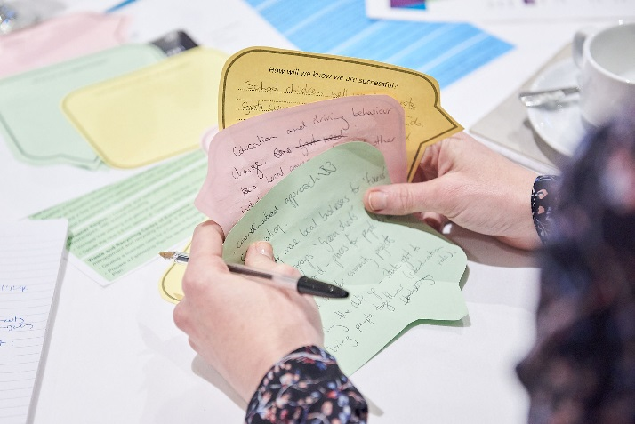

The top priorities for 2018

After a tea break, participants were given a list of priorities to review and asked to ‘*choose the top three priority outcomes you think the Partnership should consider for their 2018 advice to government’*. These included the Partnership’s 2017 priority outcomes, the young people’s priorities and three new priorities which emerged on the night.

**The Partnership’s priority outcomes from 2017:**

1. **Jobs and Skills**
2. **Public Transport, Road Congestion and Freight**
3. **Reduce Entrenched Disadvantage through better health and education services**
4. Connected Communities
5. A Greener Region
6. A Waste and Recycling Centre of Excellence

**Priorities from the Youth Forum:**

1. Violence and bullying awareness
2. Reduce drug and alcohol prevalence
3. Support for homeless people

**Additional priorities submitted at the Assembly:**

1. Intercultural development
2. Marketing and promotion of the West
3. Affordable and social housing

The results, displayed in Figure 6, show that the top three priorities chosen by participants were Jobs, Skills and Entrepreneurship; Public Transport, Road Congestion and Freight; and Reduce Entrenched Disadvantage through Better Health and Education Services’.

Figure 6: Results of the poll 'choose the top three priority outcomes you think the Partnership should consider for their 2018 advice to government’

Exploring the priority outcomes in more detail

In the third activity participants sat at theme-based tables, and explored three questions:

1. *What is the real issue we can impact?*
2. *What are the opportunities?*
3. *How will we know we are successful?*

Their responses have been summarised under each theme in the following section. The themes are not presented in order of weighting or priority.

## Health and wellbeing

**The real issue that can be impacted:**

* Child health in the first three years.
* The isolation of young mothers, especially in the outer west.
* Greater focus on preventive health with culturally appropriate responses.
* Relieving pressure on the current Western health hubs in Footscray, Sunshine and Werribee.
* Participation rates in sport and recreation, which can reduce stress while increasing resilience and a sense of community.

**The opportunities are:**

* Developing a sense of community in the West based on organic connections and better links to education, local service organisations and police etc.
* Valuing and better promoting our diversity.
* A more systematic approach to pre- and post- natal services in the areas of demand.
* Culturally appropriate parenting support.

**We will know we are successful when:**

* Fewer parents feel socially isolated.
* Every family has access to services.
* An additional hospital is established.
* There are fewer hospital admissions.
* There are reduced levels of chronic disease.
* Fewer children are removed from families.
* People are proud of where they come from and have the opportunity to tell their story.

## Education

**The real issue that can be impacted:**

* Schools and students to develop aspiration and success.
* Pathways between school and work or further education.

**The opportunities are:**

* Supporting teachers to develop skills to address trauma spectrum and learning disorders.
* Increasing teacher numbers and improving the image and status of teachers.
* Alternative education settings and models to re-engage students.
* Investment in the Navigator Program and increased leverage of existing industries – particularly the knowledge sector, to improve youth outcomes through this program.
* Providing support and investment for early childhood education.

**We will know we are successful when:**

* Attendance rates increase.
* NAPLAN scores meet and exceed the national average.
* There is less attrition in teacher numbers.
* Post-school education rates increase.

## Jobs and skills

**The real issue that can be impacted:**

* Workers transitioning out of manufacturing jobs.
* Lower number of jobs than required.
* Small businesses that are struggling to survive.
* Opportunities for local procurement and local businesses.
* Addressing the negative image of the West for business and overall safety.
* Improving business infrastructure.

**The opportunities are:**

* Small business development offices at local levels to assist enterprises to remain in and succeed in the region through better networking, co-working, innovation and other business practices.
* Attracting outside business by promoting the West’s land affordability, multicultural, sustainability and innovation assets.
* Redevelopment and renewal opportunities of brown fill sites. Increasing opportunities for local procurement.
* Connecting western businesses with broader supply opportunities, through more integrated procurement planning processes.
* The West’s current infrastructure advantage, as well as future assets that could be developed, such as the Western Interstate Freight Terminal (WIFT).
* Exploiting untapped regional potential in other industries not commonly associated strongly with the region, such as health and education. This could be achieved through better preparing and promoting the region’s workforce preparedness for industries of the future.
* Increased funding for internships and support services to prevent youth crime.

**We will know we are successful when:**

* The number of entrepreneurs increases.
* There are more jobs that target locals.
* There is reduced youth unemployment.
* There are increased opportunities for people to work in the West.
* Business failures reduce and there are greater connections across business networks.

## Public transport, road congestion and freight

**The real issue that can be impacted:**

* Frequency of transport services.
* Integration of transport services and strategies, including integration between local council transport strategies.
* Too many points of contact for community to resolve transport issues.
* The general increase in road traffic.
* Crowded access routes to and parking at train stations.
* Low level of active transport.

**The opportunities are:**

* Embrace new and innovative transport forms, such as electric and mini-buses.
* Airport link and connected public transport services.
* Better long-term planning for integrated transport in precincts.
* Provide amenities and car and bike parking at train stations.

**We will know we are successful when:**

* There is more choice and use of public transport options.
* There are fewer accidents.
* Accessibility to stations improves.
* More children cycle to school.
* There are more opportunities for youth to participate in activities without needing to be driven there.
* More flexible and on-demand transport options exist.

## Housing

**The real issue that can be impacted:**

* Lack of affordable housing for disadvantaged people from the region.
* Lack of diverse housing stock closer to people’s workplaces.

**The opportunities are:**

* More inclusionary zoning that caters for key workers and the disadvantaged.
* Using technology to change and broaden the conversation about urban form, density and housing, as well as including community participation in planning.

**We will know we are successful when:**

* No one is homeless and there is access to secure and stable affordable housing across the region. There is a better housing mix of family apartments and one- to two-bedroom units, which allows people more choice.

## Environmental sustainability and waste

**The real issue that can be impacted:**

* Lack of education regarding the environment and waste, and people recycling incorrectly.
* Making sure that green spaces are connected and that there are enduring outcomes for the natural environment.

**The opportunities are:**

* Providing better supporting infrastructure, such as repair shops and community-run resource centres that capitalise on grassroots interest and enthusiasm.
* Shaping local thinking about the environment to consider the region’s entire ecosystem as being connected.
* Reviewing the ‘Greening the West’ policy and building on it to maximise outcomes.
* Further education that teaches locals about the need to treat the environment as a key resource that requires input from the public.
* Linking the environment with health and wellness through active transport and activity.
* Better government coordination of the key players.
* Better regulation of problem products and tougher enforcement of approaches such as bin audits and litter fines.

**We will know we are successful when:**

* Public behaviour towards the environment improves.
* There is a reduced regional reliance on landfill.
* School children are well versed in waste management and schools have access to the environmental education and waste management resources that they need.
* People are more aware of important wildlife areas and are more willing to take action to preserve these.
* There is more community pride and understanding of waste and consumption issues and of government policy settings and programs.

## Parks and open space

**The real issue that can be impacted:**

* The lack of education around the benefits and necessity of green and open spaces.
* The current inadequacy of house ratings, which does not address the importance of gardens. Many are barren and could be improved through better education.

**The opportunities are:**

* Community gardens as a means of providing public education and local produce.
* Ranger talks in informal settings using gathering points and markers, and employing elements of indigenous history and knowledge.

**We will know we are successful when:**

* There is increased funding for open space and both passive and active recreation in these areas.
* There is more publicly available research and data on the benefits of green and open space.

## Community and personal safety

**The real issue that can be impacted:**

* Attitudes and violence towards women and youth.
* The broader narrative regarding community safety. Facts still need to be separated from perception.
* Youth-related drug use and petty crime, some of which could be linked to boredom, exclusion and bullying.

**The opportunities are:**

* Better multilingual advice and resources regarding family violence.
* Better training for police regarding other services.
* Advocacy for more after-hours services.
* Emergency housing for those affected by family violence.
* Increased funding for early intervention initiatives and support services to prevent crime.

**We will know we are successful when:**

* There is improved access to adequate services which are multi-faceted, provide after-hours access, and recognise different needs of people (CALD etc.).

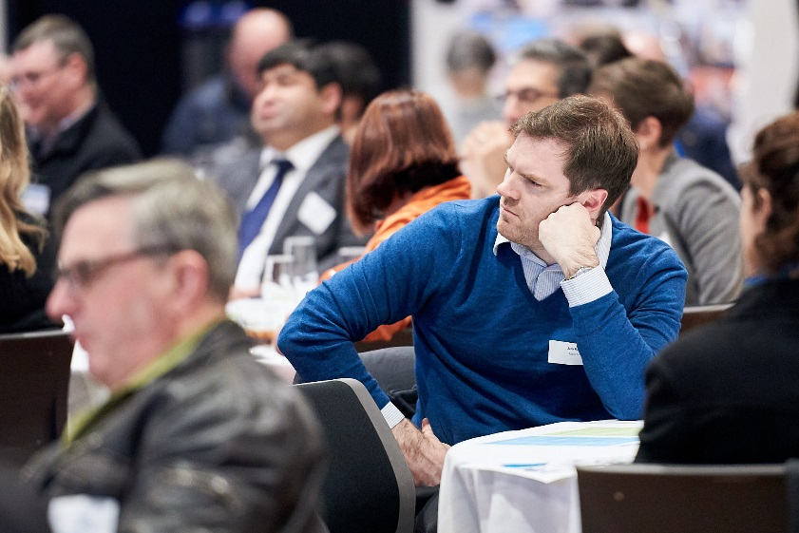

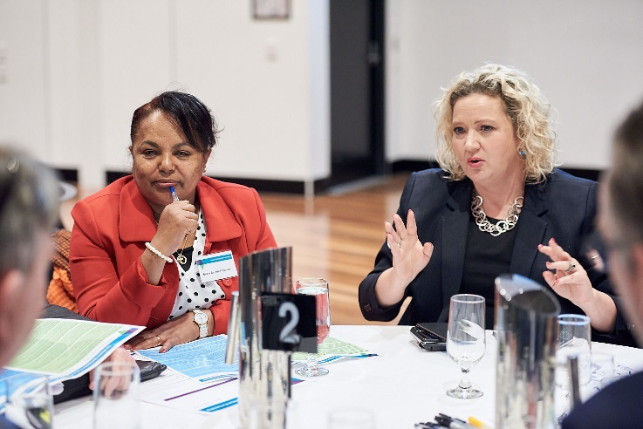

## Marketing and promoting the west

**The real issue that can be impacted:**

* The West’s negative image.

**The opportunities are:**

* Building a positive narrative that can counter negative perceptions about the West.
* Promoting the region’s assets, such as being a centre for creativity and innovation.
* Using waste and recycling as an opportunity to promote science and sustainability.
* Nurturing and promoting the ideas of young people.
* Harnessing the assets of the West in terms of multiculturalism, affordability and connectivity: rail, freight and airport.
* Supporting centres of excellence at our higher education institutions.

**We will know we are successful when:**

* People travel to the West not just for work, but also for fun, play and recreation.
* Communities and community members market the region on their own.
* Residents and visitors speak positively about the West.
* The West becomes a leader in innovation and new industries.
* Young people are better supported by industries and education and stay in the region.

## Intercultural development

**The real issue that can be impacted:**

* Overcome cultural segregation.
* The lack of a consistent and positive narrative regarding the West and its multicultural character.
* Ongoing language barriers that form a barrier to engagement.
* Lack of recognition for migrant qualifications.

**The opportunities are:**

* Better community and government leadership to counteract the negative press about the region by creating a united and positive narrative.
* Increased intercultural exchanges between the younger and older generations.
* More interfaith programs that build trust.
* More public services and facilities, such as libraries, that provide information and intercultural interaction and education.

**We will know we are successful when:**

* There is a greater cultural mix at next year’s Assembly.
* There are more mixed cultural events in the region.
* Our region’s leadership cohort and broader workforce becomes more culturally diverse.
* There is less bias and judgement in the media regarding the West.

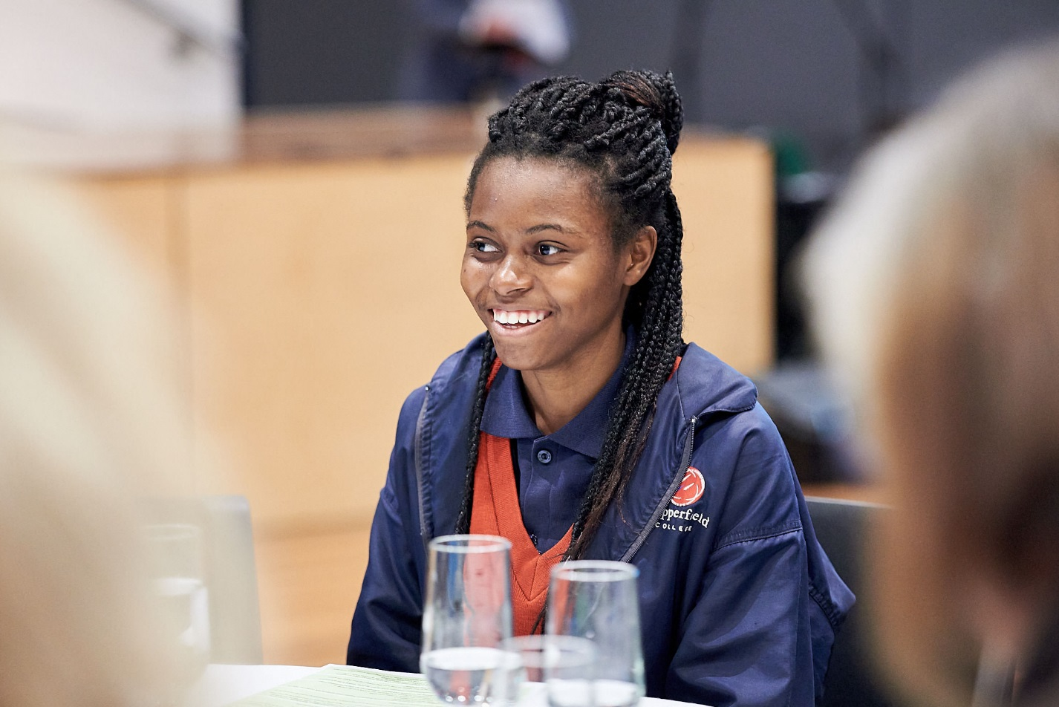

Evaluation

Participants were asked to evaluate the success of the Assembly by answering the question: ‘*How satisfied are you with the opportunities provided tonight to share and discuss the priorities for your region?*’, with possible responses ranging from ‘very dissatisfied’ to ‘very satisfied’.

The overall feedback for the assembly was very positive, with 92 per cent of respondents stating that they were either satisfied or very satisfied with the opportunities provided at the assembly.

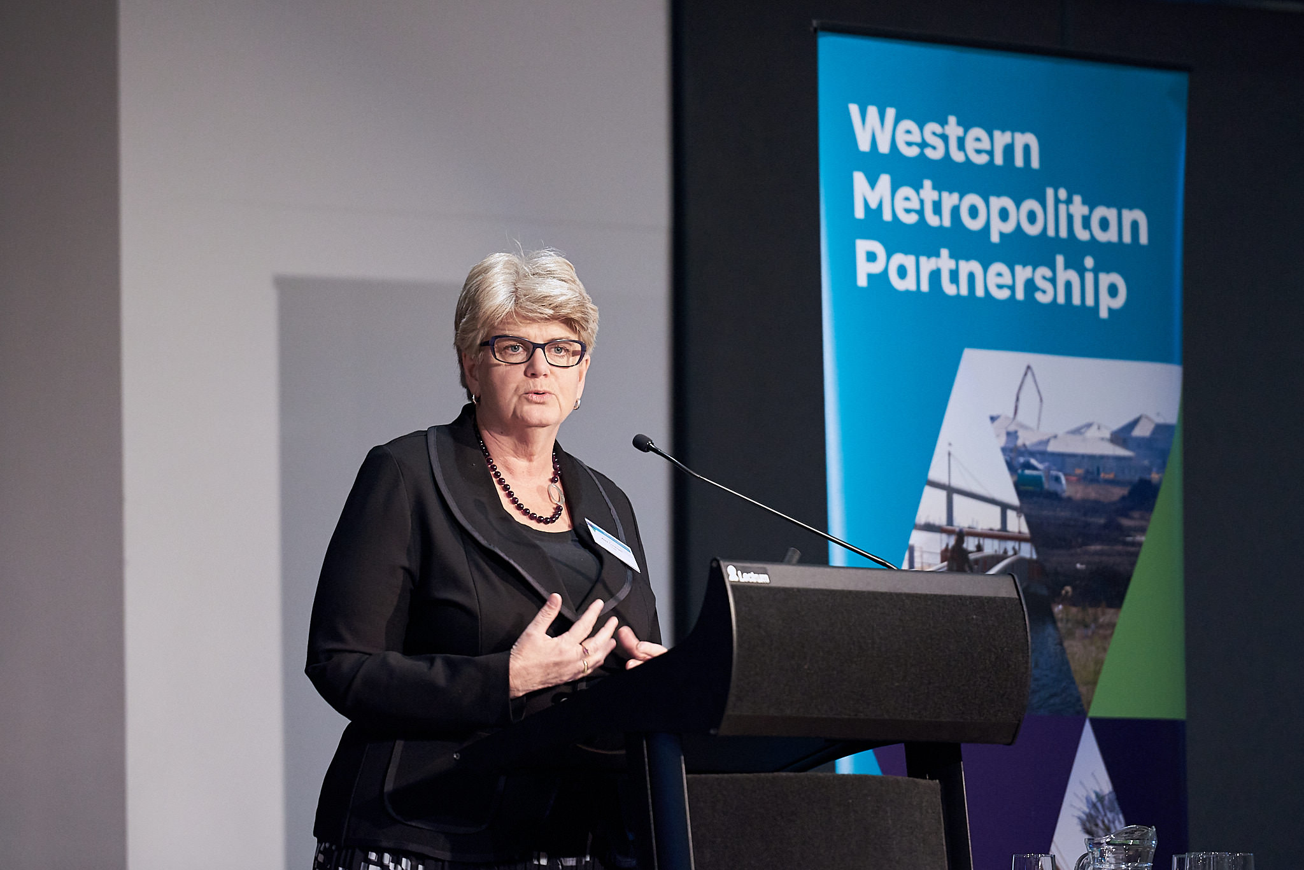Figure 7: Participant’s responses to the question: 'How satisfied are you with the opportunities provided tonight to share and discuss the priorities for your region

1. Graphs have been calculated for the people who attended the Assembly and do not include demographics of people who completed questions in the registration form but did not attend the Assembly.
2. Participants could choose more than one option.
3. Many participants did not provide their suburb.