delwp.vic.gov.au

Metropolitan Partnerships – Inner South-east region

|  |
| --- |
| The 2018 Inner South-east Assembly  Summary Report |

|  |  |
| --- | --- |
|  |  |

Privacy

This report has been prepared by Capire and Department of Environment, Land, Water and Planning and is an independent account of the discussions at the assembly.

Capire Consulting Group and any person(s) acting on their behalf is committed to protecting privacy and personally identifiable information by meeting its responsibilities under the Victorian Privacy Act 1988 and the Australian Privacy Principles 2014 as well as relevant industry codes of ethics and conduct.

For the purpose of program delivery, and on behalf of its clients, Capire collects personal information from individuals, such as e-mail addresses, contact details, demographic data and program feedback to enable it to facilitate participation in consultation activities. Capire follows a strict procedure for the collection, use, disclosure, storage and destruction of personal information. Any information its collects is stored securely on its server for the duration of the program and only disclosed to its client or the program team. Written notes from consultation activities are manually transferred to our server and disposed of securely.

Comments recorded during any consultation activities are faithfully transcribed however not attributed to individuals. Diligence is taken to ensure that any comments or sensitive information does not become personally identifiable in our reporting, or at any stage of the program.

Capire operates an in-office server with security measures that include, but are not limited to, password protected access, restrictions to sensitive data and the encrypted transfer of data.

For more information about the way Capire collect information, how it is used, stored and disclosed and Capire’s complaints procedure, please see www.capire.com.au or telephone (03) 9285 9000.

Consultation

Unless otherwise stated, all feedback documented by Capire Consulting Group and any person(s) acting on its behalf is written and/or recorded during program/consultation activities.

Capire staff and associates take great care while transcribing participant feedback but unfortunately cannot guarantee the accuracy of all notes. Capire is however confident that it captured the full range of ideas, concerns and views expressed during consultation activities.

Unless otherwise noted, the views expressed in Capire’s work represent those of the participants and not necessarily those of Capire’s consultants or clients.

|  |
| --- |
| © The State of Victoria Department of Environment, Land, Water and Planning 2018  LogoThis work is licensed under a Creative Commons Attribution 4.0 International licence. You are free to re-use the work under that licence, on the condition that you credit the State of Victoria as author. The licence does not apply to any images, photographs or branding, including the Victorian Coat of Arms, the Victorian Government logo and the Department of Environment, Land, Water and Planning (DELWP) logo. To view a copy of this licence, visit <http://creativecommons.org/licenses/by/4.0/>  ISBN ISBN 978-1-76077-134-8 (print)  ISBN ISBN 978-1-76077-135-5 (pdf)  Disclaimer  This publication may be of assistance to you but the State of Victoria and its employees do not guarantee that the publication is without flaw of any kind or is wholly appropriate for your particular purposes and therefore disclaims all liability for any error, loss or other consequence which may arise from you relying on any information in this publication.  Accessibility  If you would like to receive this publication in an alternative format, please telephone the DELWP Customer Service Centre on 136186, email [customer.service@delwp.vic.gov.au](mailto:customer.service@delwp.vic.gov.au), or via the National Relay Service on 133 677 [www.relayservice.com.au](http://www.relayservice.com.au). This document is also available on the internet at [www.delwp.vic.gov.au](http://www.delwp.vic.gov.au). |

Contents

Contents 1

Executive summary 1

The Metropolitan Partnerships 3

The 2018 Inner South-east Assembly 4

Who took part in the conversation? 6

What we heard 7

Exploring equity within priority outcomes 8

Transport Connectivity 8

Economy, industry and jobs 8

Access to education 9

Open space and environment 10

Health and wellbeing – social isolation 11

Health and wellbeing 11

Affordable and Social Housing 12

Creating a vision for the Inner South-east as a region with opportunity for all 13

Transport connectivity 13

Affordable and social housing 13

Community cohesion and inclusion 14

Community health and wellbeing 14

Open space and environment 14

Economy, industry and jobs 15

Access to education 15

Evaluation 16

Executive summary

The Inner South-east Metropolitan Partnership’s second annual Assembly was held on Wednesday 30 May 2018. The Assembly brought together 91 community members, businesses, councillors and mayors to continue the conversation for the Inner South-east metropolitan region.

The metropolitan Assemblies are part of the Government’s commitment to give Victorians the opportunity to influence decisions and shape the future of their communities.

The 2018 Inner South-east Assembly was an opportunity to further explore the priorities for the region and how community, business and government can work together to make the Inner South-east a region of opportunity for all.

The overarching theme of the night was exploring the inequalities in the Inner South-east and identifying ways to address them. There were presentations and activities to close the loop with the community regarding the Partnership’s advice in 2017.

## Reviewing the 2017 priority outcomes

Overall, participants supported the 2017 priority outcomes. They felt the Partnership’s advice covered the needs of the region and that the priorities are still relevant in 2018. In particular, participants supported having Environment and Open Space and Transport Connectivity as priority outcomes.

When asked what additional priorities people would like to see in 2018, the top themes were community connectedness, opening up spaces for sporting and recreational activities, and managing development.

## Exploring equity within the priority outcomes

The scene was set for the second activity of the night with two presentations exploring equity within the region. The first was a report back on targeted youth engagement that was undertaken to increase youth participation and better inform the Partnership’s advice. Following this was a presentation on ‘perceptions versus realities’ which provided some key data relating to areas of isolation and inequality in the Inner South-east.

Participants chose a priority outcome to provide deeper insights into, and shared what people are currently experiencing, what inequalities exist and what needs to change.

Highlights from the themed table discussions include:

* Transport connectivity: improve public and active transport connections beyond current routes, particularly connecting people to local services and open spaces within neighbourhoods.
* Economy, industry and jobs: provide more options for flexible working arrangements to reduce the need for people to travel out of the region for work. Also provide greater support for young people to identify the skills and professions best suited to them and the modern economy.
* Access to education: ensure everyone in the Inner South-east has access to good quality government schools regardless of the private schools available.
* Open space and environment: increase the availability and access to open and recreational spaces (existing and new), particularly for women and older people.
* Health and wellbeing – social isolation: improve access to social opportunities such as sporting clubs and community programs. Current barriers for people include the cost, knowing how to find the opportunities, cultural barriers and local transport connections.
* Health and wellbeing: address issues of cost, accessibility and stigma with health and wellbeing services (particularly mental health services).
* Affordable and social housing: a desire for legislation to be changed to facilitate more affordable and social housing in the region.

More detail on each of these discussions and suggestions for addressing these challenges can be found on page 10.

## Creating a vision for the Inner South-east as a region of opportunity for all

Assembly participants recorded their individual vision for the region by completing the sentence: *‘In 2030, everyone in the Inner South-east will be able to…*’

Participants visions were varied and touched on all the themes explored by the Partnership in their priority outcomes. However, ***access*** was continuously mentioned across all themes as this was seen as pivotal to ensuring the region is inclusive for everyone.

## Summary of overall findings

In addition to the existing priority outcomes, there was a strong message throughout the Assembly discussions about increasing community connectedness. Participants said this could be achieved through improving access to open space, providing more volunteering opportunities or co-located work spaces so that people can work close to home but not alone. In many cases improving community connectedness was suggested as a way to help people who are isolated or have reduced access to services, such as young and old people, migrants and people with low incomes.

Throughout the discussions there were two issues that were revealed as having cross cutting impacts; a lack of transport connectivity and affordable housing. The impacts of poor transport connectivity include: older people not being able to access local services; long commuting times reducing health and wellbeing; and poor walkability stopping people from accessing open space. In relation to affordable housing, the impact of mortgage stress and high rent can have a flow-on effect to other issues such as health and wellbeing. While priorities in their own right, transport connectivity and affordable housing are also key to delivering on other priority outcomes.

Throughout the discussions there were two issues that were revealed as having cross cutting impacts; a lack of transport connectivity and affordable housing.

The Metropolitan Partnerships

## 

## The Metropolitan Partnerships are a new and coordinated way for communities to advise government on what matters in their region.

The Victorian Government wants to better understand and respond to the needs of Melbourne’s communities. In May 2017, six Metropolitan Partnerships across Melbourne were established because the government recognises that local communities are best placed to advise on issues and priorities for their region.

Each Partnership is made up of community and business representatives with varied backgrounds, experiences and networks, the CEO of every local government in that region and a Deputy Secretary from the Victorian State Government.

Working closely with their communities, the Partnerships will identify opportunities for driving improved social, economic and environmental outcomes, and advise the government on actions that can make a real difference to the liveability and prosperity of their metropolitan region.

The Partnerships will strengthen relationships and facilitate stronger collaboration across the three tiers of government, businesses and communities. They will also enable the government to respond in a more coordinated and targeted manner to deliver better outcomes for the community.

More information on the six Metropolitan Partnerships can be found at suburbandevelopment.vic.gov.au

## The Inner South-east Partnership

The Inner South-east Partnership members are:

* Alicia Darvall, Chair
* Steve Whittington, Deputy Chair
* Sally Howe, Member
* Simon Stafrace, Member
* Lizzy Kuoth, Member
* Jane Farmer, Member
* 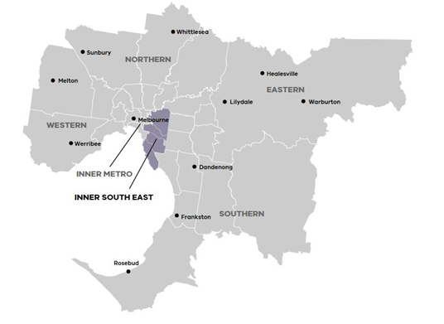Damian Ferrie, Member
* Philip Mallis, Member
* Mick Cummins, Acting CEO, Bayside City Council
* Rebecca McKenzie, CEO, City of Glen Eira Warren Roberts, CEO, Stonnington City Council
* Phil Storer, CEO Boroondara City Council
* Julia Griffith, Victorian Government representative

Find out more about the Inner South-east Metropolitan Partnership members at: <https://www.suburbandevelopment.vic.gov.au/partnerships/metropolitan-partnerships/inner-south-east-partnership>

Read more about the Inner South-east Metropolitan region at: <https://www.suburbandevelopment.vic.gov.au/regions/inner-south-east-region>

## The Inner South-east Region

Melbourne’s Inner South-east Metropolitan Region extends from Kew in Melbourne's inner east to Brighton on Port Phillip Bay. The area captures high density residential and retail precincts such as South Yarra as well as quieter residential streets through middle suburbs such as Balwyn, Bentleigh and Black Rock. The Inner South-east Metropolitan Region is a desirable residential location with strong retail employment. The Inner South-east is the traditional home to the Wurundjeri people of the Kulin nation.

The 2018 Inner South-east Assembly

On Wednesday 30 May 2018, 91 community members, businesses, councillors and mayors came together to continue the conversation for the Inner South-east Metropolitan region.

The second annual Assembly was a chance for the Inner South-east Partnership to report back to the community about their work over the past 12 months and for the Government to provide an overview of its response to the Partnerships 2017 advice. It was also an opportunity to further explore the priorities for the region and what the Partnership can advise in 2018 to make the Inner South-east a region of opportunity for all.

The ways people could contribute to the conversation in 2018 included pre-engagement online, attending the Assembly in person or participating online through livestreaming and answering questions on the Engage Victoria web-page. Young people also had the opportunity to participate by attending a dedicated youth forum that was held on 7 May 2018.

## The 2017 priority outcomes

**Environment and Open Space** – Promote healthy neighbourhoods by developing an increased network of active open space.

**Economy, Industry and Jobs** – Encourage local employment hubs and flexible, co-working spaces to support strong, local economies.

**Affordable and Social Housing** – Create the right mix of private, public and social housing to anticipate future needs of growing communities.

**Transport Connectivity** – Improve connectivity of transport modes to cover sustainable, low-cost travel across the region (including north-south travel), promote active transport options and reduce car usage.

## What happened on the night

The overarching theme of the night was exploring the inequalities in the Inner South-east and identifying ways to address them. The first activity was focussed on sharing with the community the Partnership’s 2017 advice to Government.

### Activity 1 – Close the loop on the 2017 advice

Following presentations from the Partnership Chair and the Minister for Suburban Development, participants reviewed the Partnership’s 2017 priority outcomes and the Government’s response.

At tables of six to eight people, participants were asked to share their initial reactions to the priority outcomes for the region. They also discussed whether anything had been missed. Their discussions were facilitated by a senior government member and recorded by a scribe.

### Scene setting presentations

The Partnership asked participants to think about issues of inequity and exclusion in their discussions about the priority outcomes. To set the scene for this discussion, several ‘perceptions versus realities’ of living in the Inner South-east were presented. These facts were designed to increase participants awareness of some of the hidden issues in the region.

Young people also presented on the additional engagement activities that had been undertaken to increase their participation in the Assembly conversation; the Youth Forum and an *InstaWorkshop* undertaken as a joint initiative with Swinburne University. The feedback from these engagements was shared with participants to ensure young people’s views were also considered at table discussions.

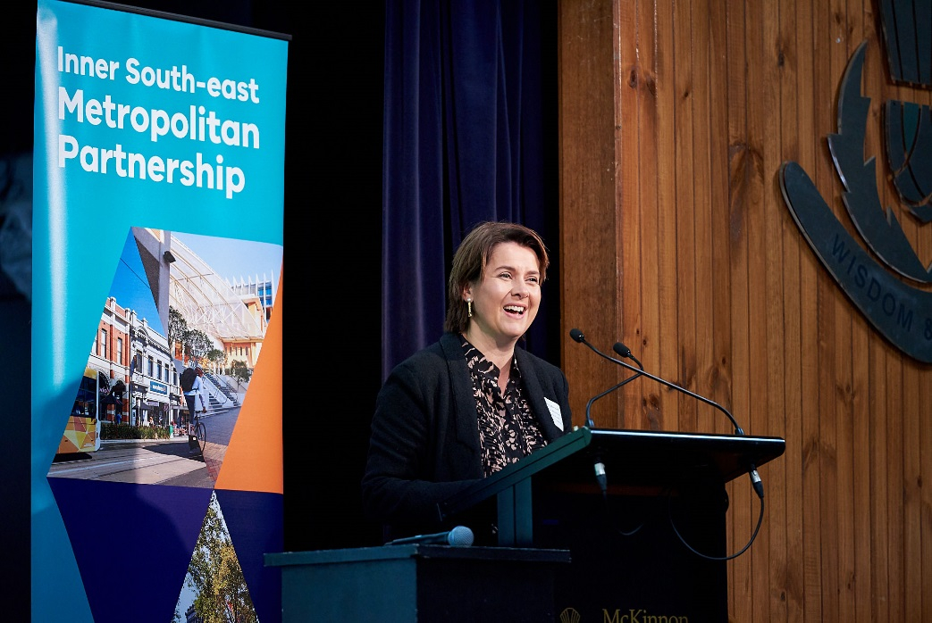

### Activity 2 – Deeper dive into the priority outcomes

Participants moved during the break onto tables according to the priority outcomes they wanted to discuss. Three questions were posed to participants, which they discussed in relation to the priority outcomes they were focussing on at their table. The questions were:

* ‘What are people currently experiencing in the Inner South-East?’
* ‘Where are the inequalities in our region?‘
* ‘How can we ensure everyone has equitable access to (theme)?’

### Activity 3 – Creating a vision for the Inner South-east region

To conclude the nights activities each participant individually completed a vision card. On the vision card they completed the following sentences:

* ‘In 2030, everyone in the Inner South-east will be able to….’
* ‘The first step for this to happen would be….’

## Limitations

There are limitations associated with the Assembly that should be acknowledged. They include:

* Assembly participants were not necessarily a representative sample of the Inner South-east population. The results from the night are a good indication of the sentiment and ideas in the region, but are not a statistically valid reflection of the news of the entire inner south-east community.
* Due to multiple registration processes, demographic information was not collected for all participants.
* Participants had a varied understanding of the issues in the region and possible solutions.
* Table hosts have taken care to record participant’s feedback. However, we cannot guarantee the accuracy or inclusion of all comments. We are confident that the range of ideas, concerns and views reflect the comments made at the sessions.

Who took part in the conversation?

In total 91 people attended the Assembly including 70 community members, five councillors, four MP’s and Ministers, and twelve Partnership members. Between 30 March and 30 May 2018, an Inner South-East region website was live on engage.vic.gov.au. The site was visited by 1,370 people and 136 people completed the pre-engagement questions through the registration form.

There were 13 young people from the Inner South-east region that took part in the Youth Forum on May 7, 2018.

The key Assembly participant demographic attributes are as follows:

* Attendance was evenly spread between females and males, compared to 2017.
* Two-thirds of participants were between 45 and 74 years of age. This compares similarly to 2017.
* Three-quarters of the participants live in the region, and over a third (40 per cent) work in the region.
* The cities of Glen Eira (50) and Boroondara (25) had the most participants.

Figure 1: Age breakdown of the Assembly community member participants[1].

Figure 2: Assembly participants relationship to the region[2].

Figure 3: Municipality that Assembly participants live in[3].

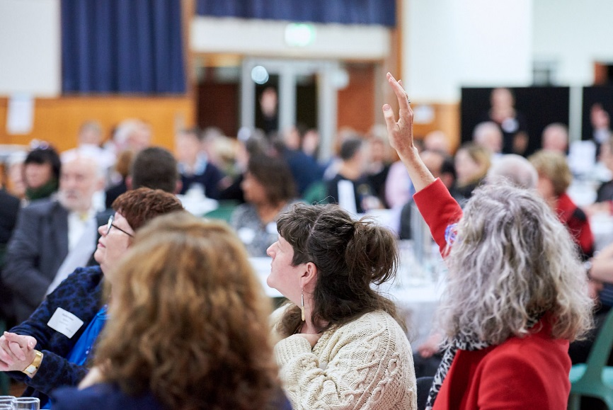

What we heard

**Reviewing the 2017 priority outcomes**

On each table, participants could review the Partnership’s priority outcomes in their 2017 advice to government, and the Government’s response. The participants were asked to discuss what their reflections were on the advice, whether they believed the priority outcomes captured everything that was important to the region and what they need to do more of.

In the online registration form, people were also shown the priority outcomes and asked whether they were still relevant to the region in 2018 and if they could add one priority, what would it be.

This section presents the findings from both the online and the face to face engagement.

## 

## Participant’s reflections on the 2017 advice?

Overall the participants supported the 2017 priority outcomes. They felt the Partnership’s advice to government covered the needs of the region and that they are still relevant in 2018. In particular, participants supported having Environment and Open Space and Transport Connectivity as priority outcomes. Many tables wanted to see more details about the priority outcomes and the Government’s response such as more information about what the Partnership are recommending for cycling corridors and where the funding is going to within the region (e.g. distribution of investment more equally across the region).

Several tables were concerned that the priority outcomes did not include reference to managing development, including ensuring good quality development and having adequate transport infrastructure to support the growing population. Some participants also wanted to see a greater focus on community connectedness, including how new open space would bring people together.

Lastly, several tables noted the lack of the youth voice and issues in the 2017 priority outcomes.

## What do the Partnerships need to do more work on in 2018?

Participants on tables at the Assembly and online provided many ideas for additional priorities and work to be progressed by the Partnership. These have been consolidated into themes, with specific suggestions summarised where possible. They are presented in the order and frequency they were mentioned, for example Community connectedness was mentioned most.

Community connectedness: People spoke about reating opportunities and spaces for community members to meet and socialise, particularly intergenerational connectivity between older and younger generations. This was highlighted as important to address the social isolation of older people. Several participants recommended increasing community participation and volunteering opportunities for older and migrant community members, particularly women.

Opening up spaces for sporting and recreational activities: Participants acknowledged the strong emphasis on open space in the priority outcomes, however they would also like to see inclusion of sporting activities in these spaces. They highlighted the need to open more clubs and sporting venues to other groups. They also suggested sharing school recreational spaces with community groups after hours.

Managing Development: It was discussed that as the Inner South-east region grows, and housing density increases it is important that developments are managed to ensure they; have a mixture of types, protect the neighbourhood character, align with old architecture, are environmentally sustainable and have adequate space for car parking and cycling infrastructure.

Intermodal Transport connectivity: The importance of active transport modes (bicycles and walking) was emphasised at the Assembly. People would like safety when using these modes to be addressed especially as road congestion increases and pressure on footpaths and car parks increases. Participants want to see safe cycling options for young people travelling to school.

**Access to education:** Participants were concerned that population growth is putting pressure on school capacity and that high quality education needs to be available to everyone in the region

Waste management: Participants wanted to see more action on waste management particularly recycling and waste reduction strategies.

Exploring equity within priority outcomes

In the second activity participants sat at theme based tables, and explored three questions:

1. ‘What are people currently experiencing in the Inner South-East?’
2. ‘Where are the inequalities in our region?’
3. ‘How can we ensure everyone has equitable access to (theme)?’

Their responses have been summarised under each theme in the following section. The themes are not presented in order of weighting or priority.

## Transport Connectivity (two tables discussed this topic)

**Inner South-east Assembly participants are experiencing or concerned about:**

* Limited public transport options for elderly people to access services within their neighbourhood such as the doctors. More bus routes were suggested.
* Traffic congestion increasing, because public transport coverage does not allow people to move around the region.
* Frustration with connections between different modes when using public transport.
* Commuting times increasing, and more time being spent on the road, decreasing people’s quality of life.
* Growth in apartment development is placing pressure on the transport system.
* Pedestrians not being able to cross roads in time for the pedestrian crossing signals, this makes them feel unsafe.

### The inequalities in the region are:

* Families who need to transport young children to kinder and school on public transport. The transport facilities are inadequate for this group.
* The transport system is not very safe for cyclists.
* Services are poor for young people, people with a disability and people who have a vision impairment.
* Some pockets of the region have very poor public transport options.

### Their ideas for the region are:

* More shuttle/mini buses to increase access around neighbourhoods to places such as shopping. centres. Perhaps this could be organised by Councils.
* Subsidise transport services for people in need.
* Make some roads one way so more space can be given to cyclists.
* Increase the pedestrian crossing times for older people in areas with a higher proportion of elderly people.
* Reduce car speed limits in inner metro areas.

## Economy, industry and jobs (two tables discussed his topic)

**Inner South-east Assembly participants are experiencing or concerned about:**

* High inequality in wealth, with high earners located next to public housing estates.
* Increasingly needing to travel (out of the region) to find work. In some cases, this is because important work opportunities are moving to the growth areas.
* Few public transport options for travelling to jobs not in the city.
* Shifting to a part-time economy.
* Young people not being prepared for the future economy, for example they are not being told that entrepreneurship is a viable profession.
* The gap between poor and rich is affecting the fabric of society.

### The inequalities in the region are:

* Manufacturing jobs are leaving but speciality high skilled jobs, such as design, are increasing. Many young people do not know how to get into these areas.
* Parents and carers often cannot work if they must travel far from home.
* Many young people are getting into university then re-training into trades where they have lower incomes**.**
* Not enough options for people to work from home.

### Their ideas for the region are:

* Improve the continuity of support, employment and training for apprentices to match the growing need for trades.
* Link solo older houses with younger renters and encourage car share options.
* Encourage work opportunities in areas of the inner city so not everyone has to travel in the same direction.
* Acknowledge and address that working from home creates social isolation and mental health issues. For example, facilitate and create more co-working spaces close to home.
* Improve connections between industries and schools to encourage employees engaging with young people.

## Access to education (three tables discussed this topic)

**Inner South-east Assembly participants are experiencing or concerned about:**

* Good access to private schools and selective government secondary schools, but many of the private schools are expensive with few scholarship options.
* Finding good quality government schools that are not selective. Tight zoning means there is a lack of choice for government schools.
* Prevailing negative stigma on some schools for past results and history, this is no longer accurate.
* There is too much academic pressure on students, other skills are not being recognised.

### The inequalities in the region are:

* There are areas with high numbers of private schools and therefore limited access to government schools. For example, Stonnington has no secondary government school.
* High need families not being able to access the education services they need.
* Lack of diversity in students and families in some schools.
* Some families in public housing are struggling to get their children to schools.
* High achievers are not catered for in public schools.

### Their ideas for the region are:

* Improve the perception and performance of government schools in the region.
* Make sure government schools are accessible in less affluent areas.
* Integrate services at schools such as maternal child health, this will encourage parents to get involved in the educational institutions.
* Improve transport infrastructure to schools.
* Encourage other school pathways, not always year 12 exams. Also have conversations about career options earlier.
* Explore other ways to measure success not just test results. Build students’ resilience.

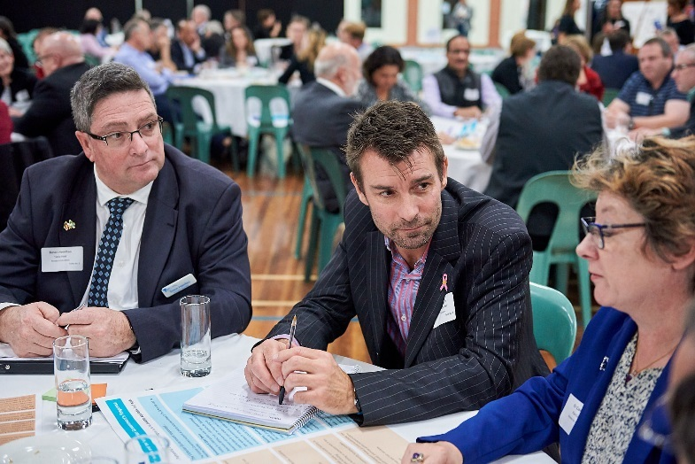

## Open space and environment (two tables discussed his topic)

**Inner South-east Assembly participants are experiencing or concerned about:**

* Diversity in open space; passive and active.
* Barriers to using current open space such as flood ways. Also, lack of active transport connections to open space so people can walk and ride there.
* Poor planning decisions in the past for example, high rise development with no way to dispose of waste.
* Lack of facilities that are appropriate for females and older people.
* Too much traffic which creates noise and air pollution.
* Tree canopy is reducing, currently limited and fragmented.

### The inequalities in the region are:

* Glen Eira has good quality open space but relatively low use. This could be due to poor walkability.
* Female sports teams are missing out on premium sporting opportunities.
* Participation of older people in sport is lacking, because of the difficulties of travelling around.
* Open spaces are not always safe after dark.
* Low availability of current facilities and open space.
* Water ways are polluted especially with rubbish.

### Their ideas for the region are:

* Utilise schools after hours to improve access to open space. The recently announced new school campus at the East Village is a good example of where this could happen.
* Council needs to leverage more developer contributions to help fund open space.
* Value capture for non-financial purposes such as social and environmental outcomes.
* Increase green infrastructure such as green walls and roofs.
* Use air rights over railway corridors for playing fields and indoor facilities.
* Increase opportunities for communities to lead initiatives such as Love our Streets.

## Health and wellbeing – social isolation (two tables discussed his topic)

**Inner South-east Assembly participants are experiencing or concerned about:**

* Services for assisted daily living are available but not everyone can access or afford it.
* Some older people are experiencing loneliness. This is influenced by their living arrangements; a community minded neighbourhood vs a block of flats.
* Current services are one dimensional.
* Lack of connectivity and subsequent loneliness and isolation.
* Limited access to open space for some groups such as older people and women.
* Increasing school bulling, and schools not focussing on wellbeing.
* Not as many opportunities for people to connect through clubs and associations such as neighbourhood watch.
* High expectations and fear of missing out is driving anxiety in young people.

### The inequalities in the region are:

* Social housing estates. Lower socioeconomic and CALD residents can struggle to participate fully in community activities (for example it is expensive to join soccer groups).
* Retired people have less social connections after leaving the workforce.
* Carers looking after/living with a sick partner are also experiencing social isolation, for example the impact of dementia on carers.
* Newstart amount is very hard to live off, limiting people’s ability to participate.

### Their ideas for the region are:

* Encourage more people to join clubs by helping people overcome financial and cultural barriers to participate.
* Some ethnic communities have more informal support networks for older people such as neighbours and knowing the local shop owners.
* Create programs to support parents with children who are being bullied.
* Provide more support for people to navigate and find services available to them.
* Libraries could have a greater role to connect people socially, look at the social design of these spaces. Provide more people trained as community connectors in libraries and other places.
* Services need to be multi-dimensional not just fixing physical ailments.

## Health and wellbeing (two tables discussed his topic)

**Inner South-east Assembly participants are experiencing or concerned about:**

* Services are generally used by older people with chronic diseases.
* There is a focus on intervention rather than prevention. There is also a lack of affordable mental health services.
* Young people find it expensive to go out, especially to eat.
* Lack of affordable psychiatric services and many GP doctors are time poor.

### The inequalities in the region are:

* Lack of services and affordable housing for young people with a disability.
* Groups such as young people and LGBTIQ+ who have trouble at home do not know about services that could help them.
* People with language barriers are not connected to their communities.
* People with lower income are feeling rental stress.
* There is social stigma around mental illness reducing pathways to mental health services.
* Carers have less capacity to participate in the community.

### Their ideas for the region are:

* Have a ‘rent to purchase’ model. Secure housing is very important for people with mental health issues.
* Create longer term property leasing like in Europe.
* Encourage and support community clubs to provide multilingual information.
* Offer services for young people where young people are, for example, schools.
* Focus on early intervention and prevention. Identify key intervention points and make sure parents and young people know what services are available.
* Collaboration between local agencies and services that look at shared clients; Police, Ambulance and taskforce.

## Affordable and Social Housing (three tables discussed this topic)

**Inner South-east Assembly participants are experiencing or concerned about:**

* People are not able to buy so there is a high demand for rental houses in school zones.
* Many people are experiencing reduced liveability because of population growth in the area.
* Affordable housing is not readily available in the region.
* Limited options for young people to rent or buy in the area. People are moving further out to be able to afford a house.
* Tension between land value and development potential.

### The inequalities in the region are:

* Younger generations find it harder to be able to buy a house in the area.
* School access for less affluent groups.
* Social housing is relatively old and dilapidated.
* Lack of housing diversity, for example three-bedroom apartments.
* People do not have permanent ongoing work to be able to afford a house.

### Their ideas for the region are:

* Change the current model of planning for social housing.
* Conversion of disused land and old industrial sites.
* Create legislative requirements for developments to have a percentage of affordable housing. Council need to make sure developers comply.
* Create an ‘Affordable Housing Fund’ that developers can contribute to for affordable housing close to services.
* Have a vacancy tax that is high enough to influence owners to put properties on the rental market.
* Enable granny flats and tiny houses on existing blocks.
* Employers to contribute to worker housing.
* Increase financial assistance from government for rental assistance for young people.
* Create more incentives for older people to downsize.
* Objections to social housing because of the perception they may lower house prices inhibits delivery of affordable housing options.
* Have a fixed quota for public and social housing in new planning controls for new dwellings.
* Support mixed development (social and private housing).

Creating a vision for the Inner South-east as a region with opportunity for all

Assembly participants shared their vision for the region by completing the sentence:   
‘*In 2030, everyone in the Inner South-east will be able to…*’ Additionally, they were asked what they thought the first step would need to be to achieve their vision.

The vision statements demonstrated a strong desire to increase social equity by improving amenity and service levels, and access to these throughout the population.

*In 2030, everyone in the Inner South-east will be able to…*

*‘… have access to affordable housing to cater for young first home buyers and disadvantaged so they are not disconnected from areas they are familiar with. This should also apply to the elderly not being forced to leave their area and network just because they are ageing or downsizing.’*

*‘… develop a sustainable model for public, social and affordable housing based on global best practice.’*

*‘…have housing they can afford to live in by legislating for affordable housing to be included in new developments.’*

*‘… have significant new investment in social and affordable housing.’*

The themes within the vision statements related to the six priority outcomes highlighted by the Partnership, and the additional theme of community cohesion and inclusion. These are listed below in order of the frequency with which they were referred to.

## Transport connectivity

Beyond simply advocating for a greater range of transport options other than car-based transport, participants often related transport connectivity to the concept of walkable neighbourhoods, in which a variety of life, work and play related activities were co-located. The concept of the 20-minute neighbourhoods appears to be well-understood and desired by the participants, along with the improvements in living standards and affordability that accompany it. Transport access for the disabled was also seen as a priority, with a need to achieve equity.

*In 2030, everyone in the Inner South-east will be able to…*

*‘… have easy and reliable access to public transport which is well connected and accesses relevant destinations. … cars would no longer be the 'go to' transport for most.’*

*‘… spend less of their income on transport/travel costs, and in turn, less financial stress on housing costs.’*

*‘… access public transport within a 5‑minute walk from their home.’*

*‘… access services, community groups education and employment with a short 15-minute walk/cycle or bus trip.’*

*‘…access a wide range of facilities (e.g. education, parks, healthcare and affordable diverse housing) via a range of transport options.’*

## Affordable and social housing

The prominence of this theme indicated a growing awareness of the problem of intergenerational equity regarding home ownership in the region, alongside the effects of rising living costs, particularly for the youth and the elderly. Participants recommended higher levels of investment in both affordable and social housing to address this challenge

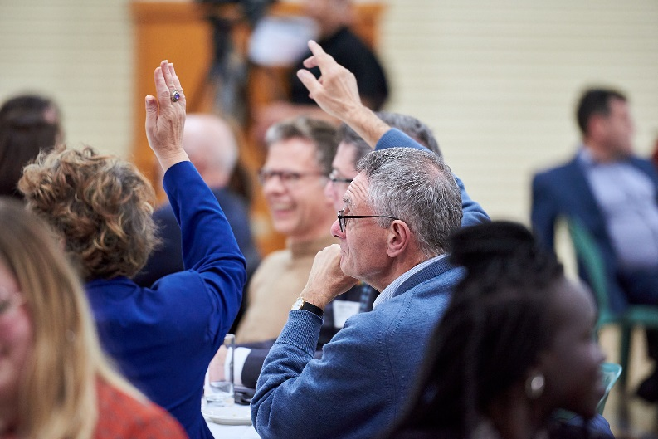

.

## Community cohesion and inclusion

For participants, community not only implied inclusion but a context in which people go on to find a sense of connectedness, belonging and support. Participants envisioned neighbourhoods that provided not only social but also economic support to the isolated and disadvantaged in the community. Youth engagement featured prominently in feedback, where people underlined the need to gain the insights of young people to develop a better community. There was shared appreciation for the opportunity for dialogue as a community and participants recommended holding more talks and including more residents in these conversations.

In 2030, everyone in the Inner South-east will be able to…

*‘… have a sense of belonging or connection with their local community, through vibrant and purposeful open spaces and environment, connected communities, services, formal and informal networks and social prescribing that allow people to be identified when they need help or who can offer help to others.’*

*‘… create connections with youth, remove the stigma and separation between generations.*

*Include youth in these forums, don't have them separate.’*

*‘… have access to secure work, education and housing in a connected local community.’*

*‘… increase opportunities for participation: formal and informal at neighbourhood level, whether through schools, sporting clubs, neighbourhood activity groups. Encouragement of support, volunteering opportunities, outreach support to local elderly, disabled …’*

*‘… let all elements of our communities to talk and find collective solutions.’*

*In 2030, everyone in the Inner South-east will be able to…*

*‘…have reasonable/affordable access to community care.’*

*‘… access mental health facilities easier, with less stigma and have appropriate respectful and respectable housing.’*

*‘… fund more youth workers to work with people impacted by mental health and substance misuse.’*

## Community health and wellbeing

Health and wellbeing related to creating more widespread access to services and social infrastructure. Participants stated a desire for more affordable access to health-related services, including mental-health and community care options. Part of the challenge to creating better access was linked to providing more open space within neighbourhoods, as well as more equitable transport to link these places.

## Open space and environment

The desire for more equal access to open spaces related not only to quantity but also to location (being near homes and places of work, and as well as quality spaces) with more open spaces exhibiting elements of sustainability and indigenous influence. The theme of open space was also connected to creating a sense of community within neighbourhoods and to health, particularly through providing more community gardens and equitable access to food. Additionally, participants also demonstrated a desire for greater environmental and sustainability standards to be demonstrated and maintained in the built environment.

*In 2030, everyone in the Inner South-east will be able to…*

*‘… live in well-designed suburbs that encourage connectivity of its community members and be able to enjoy open spaces and good public schools.’*

*‘… enjoy open space that caters for diverse abilities and interests, restores indigenous natural environments and is part of water-sensitive urban design.’*

*‘… access safe open spaces which facilitate physical activity and fresh fruit and vegetable gardens.’*

*‘… access open spaces easily; and have a community hub so no one feels isolated or alone.’*

*‘… add some new pocket parks using road space of school grounds and reallocate some open space in parks from ovals and car parks to bush gardens/small urban forests.’*

## Economy, industry and jobs

The idea of a local economy that provided greater employment access and increased options for working close to home resonated with many participants. Again, beyond the idea of providing adequate employment that kept up with the rising costs of living, the theme of local economy was linked to the idea of walkable neighbourhoods, in which more residents enjoy equitable employment that was located nearby to their other activities and provided the opportunity to build community while offering a means of support for those that needed it. Some participants recommended using creative aspects of the sharing economy such as   
co-working and job-sharing to achieve this objective.

*In 2030, everyone in the Inner South-east will be able to…*

*‘… have a sustainable community which provides for the social economic needs of its members through collaboration and support.’*

*‘… access employment across generations.’*

*‘… support local business to grow here, support people to love here.’*

*‘… create job opportunities including those in traineeships (paid) for those who struggle to find work e.g. mental health issues, school kids not doing well at school …’*

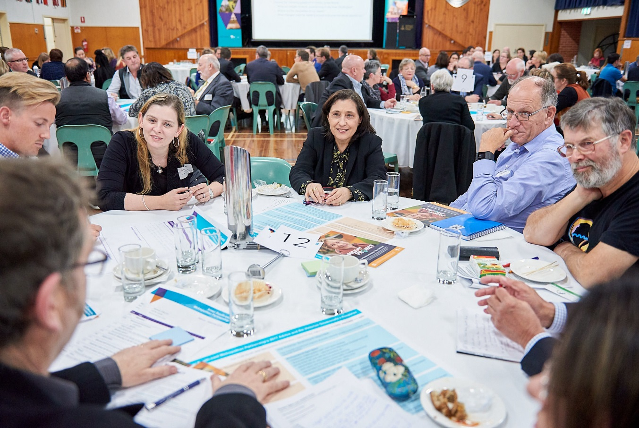

## Access to education

Although educational quality was often mentioned in vision statements, so too was fairer access to such education. Achieving equity between the private and public systems in the region was an important factor for participants, with better support for the state education system being cited as a way forward.

*In 2030, everyone in the Inner South-east will be able to…*

*‘… enrol children in local state schools, thus ensuring a more fair and equitable society’*

*‘… have private schools (which are) more compassionate to low income families.’*

*‘… stop the flight of middle classes out of public education by letting successful public school brands like McKinnon college fly! i.e. consider other campuses, mentoring etc. to open up access services people pay a lot (in home prices premiums) to get into.’*

*‘… allow/encourage childcare and aged care facilities to work together scheduling activities where children and elders get to enjoy each other's company and learn from each other.’*

The participants provided many ideas for the ‘*first step for this to happen’.* The recurring suggestions were:

* Change government legislation and increase funding to provide affordable and social housing. Examples are creating a social housing strategy and create inclusionary zoning.
* Increase public participation opportunities particularly at a local/neighbourhood level. Solutions to big challenges such as population growth need to be community driven.
* Improve the quality and quantity of government schools in the region.
* Review the public transport routes people use and increase the coverage of bus services to connect people to local services. This could be through a smaller shuttle bus system.
* Support employment options ‘close to home’ and flexible working options.
* Put effort into the social design of open spaces to ensure they are places people can come and connect with others.

Evaluation

Participants were asked to evaluate the success of the Assembly by answering the question: ‘*How satisfied are you with the opportunities provided tonight to share and discuss the priorities for your region?*’, with possible responses ranging from ‘very dissatisfied’ to ‘very satisfied’. They were then asked to provide general feedback comments.

The overall feedback for the assembly was positive, with 69 and 22 per cent of respondents stating that they were satisfied or very satisfied with the opportunities provided at the assembly.

*‘Would love more time to talk about and conceive of solutions.’*

*‘Difficult to concentrate … because of time limits.’*

*‘Focus was on discussions rather than ideas. We should have generated more ideas and then selected ideas. Concern whether learnings will lead to change.’*

Participants appreciated the event’s format and organisation. They were enthusiastic to continue future conversations and particularly appreciated the roles of the table facilitators and scribes when it came to managing time and focusing the conversations.

*‘It is definitely a worthwhile forum and allows a wide perspective on issues. It makes you feel valued and listened to and I particularly like that there is now also a focus on youth. It's good to see the engagement.’*

*‘Table facilitators and scribe was a great idea. It really helped to keep the conversation focused and everyone was asked to contribute.’*

*‘Well set up, planned and orchestrated. Perfect pitch and perfect pace. Table chairing and scribing excellent.’*

*‘Well organised and consultative. Great sense of our ideas and opinions valued.’*

There was also a sense of progression and improvement in feedback.

‘I now have a greater appreciation of the issues of this region.’

‘The conversations are becoming more focused and pragmatic. People seem to be showing a greater awareness of financial constraints on their ideal solutions.’

At the same time, the assembly’s broad regional scope and the event’s time constraints made it difficult for some participants to feel satisfied that the solutions would eventuate from broad-ranging discussions. Several participants stated their preferences for more discussion time and actively seeking more ideas and solutions to bring about change.

Providing the right levels of scale and focus in a regional discussion forum proved to be a challenge for some respondents, who indicated their desire for more specific discussions.

This contrasted with the advice of other participants, who preferred more strategic discussions. Future assemblies might therefore benefit from different tables to cater simultaneously for continued strategic and thematic discussions as well as solutions that are more focused and ‘place-based’.

*‘The advice from the assembly should be strategic, and not "locality specific" e.g. if I get six of my friends coming, we will dominate the discussion and impose our views, which is not desirable. As such, staying away from "place‑based solutions" is better.’*

Respondents suggested diversifying the range of participants to improve future assemblies. Attendees viewed the Metropolitan Partnerships Youth Forum as a very positive initiative to do this. Meanwhile, other groups, such as working parents, were also noted as being underrepresented. To address this, participants suggested different engagement times, including weekends, where longer and more extensive conversations could also take place.

*‘Concerned the group is an older demographic. Was pleased there was a young persons' session.’*

On the other hand, suggestions for improvement also included providing better background information for participants to inform their table discussions at future assemblies.

*‘I would have provided an issues/statistics card for each table related to the issue for discussion which may have assisted in focusing the discussion.’*

*‘The sessions should be more exhaustive, preferably over one day.’*

*‘Would be better over a longer period of time. A Saturday all day with multiple table changes.’*

*Setting the context with the right amount of information was an important factor raised by participants. On the one hand, participants appreciated the unique insights about the region and its often unseen challenges, which were provided by the facilitators and youth.*

*‘… insights into the country (profile) and thoughts of young people were thought provoking.’*

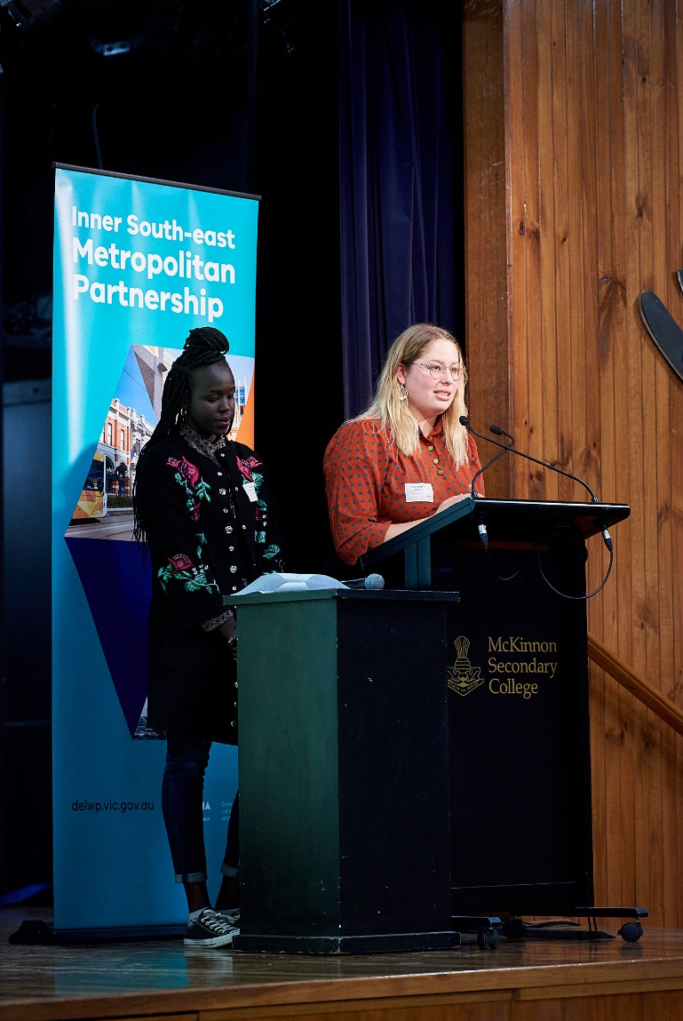

1. Graphs have been calculated for the people who attended the Assembly and do not include demographics of people who completed questions in the registration form but did not attend the Assembly.
2. Participants could choose more than one option.
3. Many participants did not provide their suburb.