delwp.vic.gov.au

Metropolitan Partnerships – Northern region

|  |
| --- |
| The 2017 Northern Assembly  Summary Report |

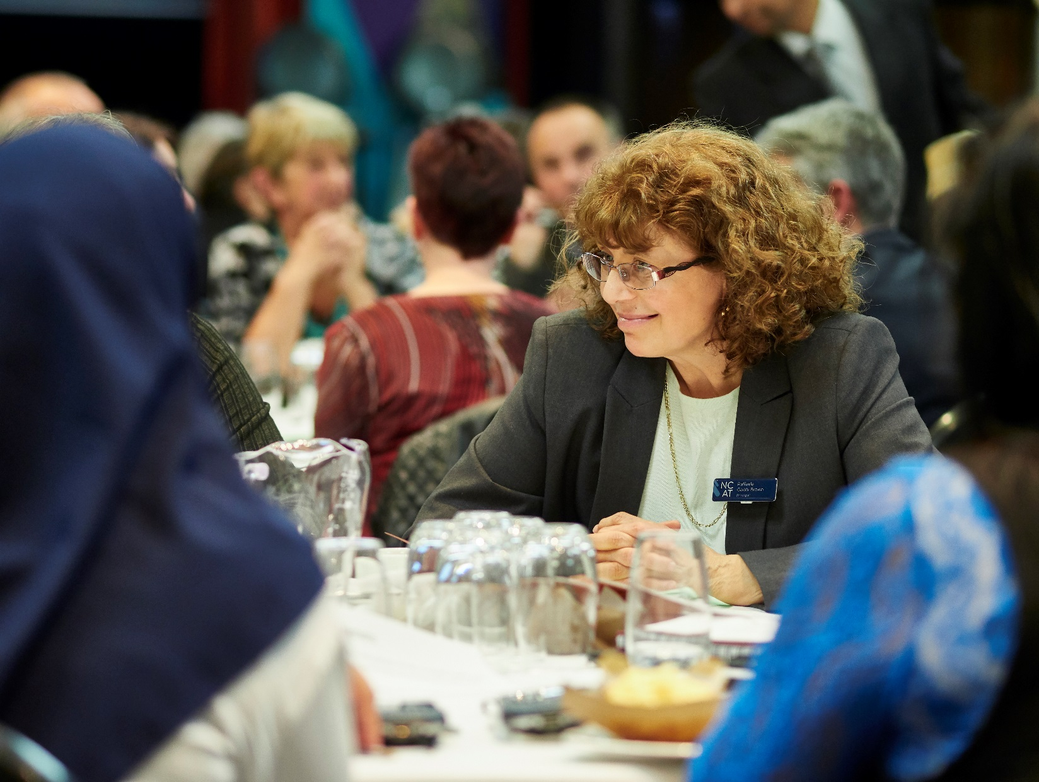

|  |  |
| --- | --- |
|  |  |



|  |  |  |  |
| --- | --- | --- | --- |
|  |  |  |  |

|  |
| --- |
| © The State of Victoria Department of Environment, Land, Water and Planning 2017  LogoThis work is licensed under a Creative Commons Attribution 4.0 International licence. You are free to re-use the work under that licence, on the condition that you credit the State of Victoria as author. The licence does not apply to any images, photographs or branding, including the Victorian Coat of Arms, the Victorian Government logo and the Department of Environment, Land, Water and Planning (DELWP) logo. To view a copy of this licence, visit <http://creativecommons.org/licenses/by/4.0/>  ISBN 978-1-76047-812-4 (Print)  ISBN 978-1-76047-813-1 (pdf/online)  Disclaimer  This publication may be of assistance to you but the State of Victoria and its employees do not guarantee that the publication is without flaw of any kind or is wholly appropriate for your particular purposes and therefore disclaims all liability for any error, loss or other consequence which may arise from you relying on any information in this publication.  Accessibility  If you would like to receive this publication in an alternative format, please telephone the DELWP Customer Service Centre on 136186, email [customer.service@delwp.vic.gov.au](mailto:customer.service@delwp.vic.gov.au), or via the National Relay Service on 133 677 [www.relayservice.com.au](http://www.relayservice.com.au). This document is also available on the internet at [www.delwp.vic.gov.au](http://www.delwp.vic.gov.au). |

**This report has been prepared by Capire and DELWP and is an independent account of the discussions at the assembly.**

Unless otherwise stated, all feedback documented by Capire Consulting Group and any person(s) acting on our behalf is written and/or recorded during our program/consultation activities.

Capire staff and associates take great care while transcribing participant feedback but unfortunately cannot guarantee the accuracy of all notes. We are however confident that we capture the full range of ideas, concerns and views expressed during our consultation activities.

Unless otherwise noted, the views expressed in our work represent those of the participants and not necessarily those of our consultants or our clients.

Executive Summary

An Assembly was held by the Northern Metropolitan Partnership on Wednesday 25 October 2017, bringing together community members, businesses, mayors and councillors to determine the key priorities for the Northern region.

The outcomes of the Assembly will be used by the Metropolitan Partnership to inform its independent advice to government on priorities for the region.

One hundred and ninety-five people participated in discussion; 172 attendees and 23 table hosts. Attendees included 15 mayors and councillors from the six local governments in the region, four State Ministers, seven local Members of Parliament and the Premier of Victoria.

The focus of the night was to hear feedback and ideas from the community through three activities:

* Review and evaluate the Partnership’s initial thinking on priorities for the Northern region
* Develop and pitch ideas for how these priorities can be achieved
* Evaluate action statements by all participants on the night.

To increase transparency and provide live results, individual handsets were given to every participant to take part in the evaluation polls.   
  
On the night participants agreed that the top priority for the region was ‘*residents of our region will have greater employment opportunities, close to home, and accessible by a well-connected transport system’.*

Overall participants agreed that all ten priorities presented by the Partnership were key priorities for the Northern region.

The issues participants also wanted to see included in the priorities were: preparing for the digital economy; increasing the supply of affordable and social housing; supporting older age groups and their growing needs; and crime prevention and addressing homelessness.

Twenty action statements to address the priorities were developed and evaluated. Participants believed the top three high priority actions were:

* Deliver smart cities deal for Melbourne's north. Aggregate assets. Create opportunities for new industries, jobs, life learning, affordable housing and transport
* Require all new housing developments to include a percentage of social (5%) and affordable (10%) housing
* Prevention of harmful gambling from $400 million to $200 million by reducing cash outlet availability, amount able to withdraw, and opening hours of gambling facilities.

Of the themes discussed at the assembly, participants thought that the topics of Social Welfare and Young People, and Infrastructure and Transport were the highest priorities for their region.

Contents

Executive Summary 1

The Metropolitan Partnerships 3

The 2017 Northern Assembly 4

Who took part in the conversation? 5

The Partnership’s priority statements 6

Activity 1 – Reviewing the priorities for the region 7

Activity 2 – How do we achieve the priorities? 8

Activity 3 – Evaluating action statements 11

Key findings 14

Appendix A – List of action statements and votes 15

The Metropolitan Partnerships

The Metropolitan Partnerships are a new and coordinated way for communities to advise government on what matters in their region.

The Victorian Government wants to better understand and respond to the needs of Melbourne’s communities. Six Metropolitan Partnerships across Melbourne have been created because the government recognises that local communities are best placed to advise on issues and priorities for their region.

Each Partnership is made up of eight community and business representatives with varied backgrounds, experiences and networks, the CEO of every local government in that region and a Deputy Secretary from the Victorian State Government.

Working closely with their communities, the Partnerships will identify opportunities for driving improved social, economic and environmental outcomes and advise the government on actions that can make a real difference to the liveability and prosperity of their metropolitan region.

The Partnerships will strengthen relationships and facilitate stronger collaboration across the three tiers of government, businesses and communities. They will also enable the government to respond in a more coordinated and targeted manner to deliver better outcomes for the community.

More information on the six Metropolitan Partnerships can be found at suburbandevelopment.vic.gov.au

## The Northern Partnership

The Northern Partnership members are:

* Terry Larkins, Chair
* Helen Coleman, Deputy Chair
* Meghan Hopper, Member
* Carmel Guerra, Member
* Phillip Bain, Member
* Mark Maskiell, Member
* Esme Bamblett, Member
* Sue Davies, Member
* Bob McQuillen, RDA Committee Member
* Domenic Isola, CEO, Hume City Council
* Simon Overland, CEO, Whittlesea City Council
* Mark Stoermer, CEO, Nillumbik Shire Council
* Sue Wilkinson, CEO, Darebin City Council
* Simon McMillan, CEO, Banyule City Council
* Nerina Di Lorenzo, CEO, Moreland City Council
* David Turnbull, CEO, Mitchell Shire Council
* Andrew Crisp, Victorian Government representative

Find out more about the Northern Metropolitan Partnership members at: <https://www.suburbandevelopment.vic.gov.au/partnerships/metropolitan-partnerships/northern-partnership>

## The Northern Region

The Northern region is a diverse and vibrant region with inner city cultural hubs and growing outer suburbs. The region includes the local government areas of Darebin, Moreland, Banyule, Nillumbik, Whittlesea, Hume and Mitchell. The region has a population of over 957,000, or about 20 per cent of Melbourne’s total population.

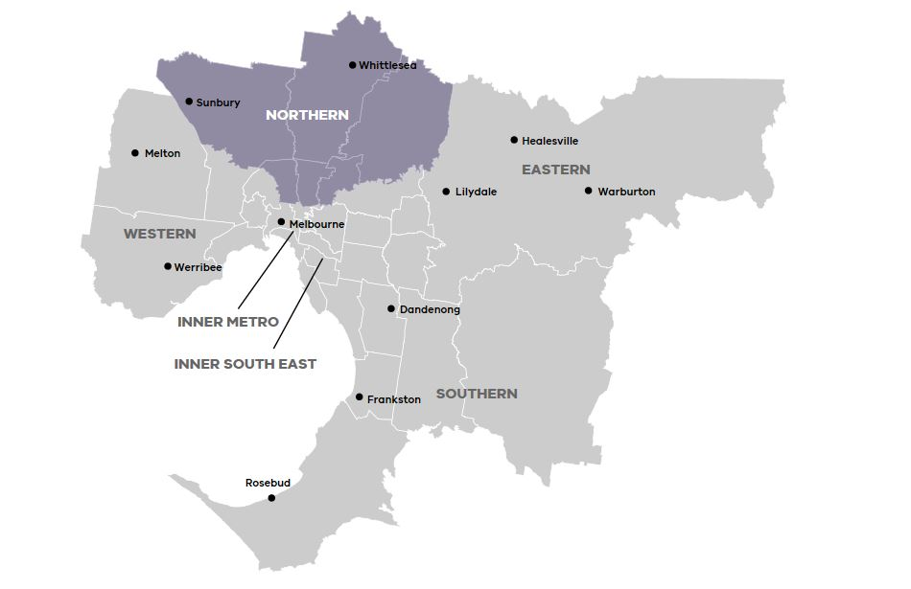

Read more about the Northern Metropolitan region at: <https://www.suburbandevelopment.vic.gov.au/regions/northern-region>

The 2017 Northern Assembly

On Wednesday 25 October 2017, 195 community members, businesses, mayors and councillors came together to help determine the key priorities for the Northern region.

The Metropolitan Assemblies are part of a commitment to give Victorians the opportunity to influence decisions and shape the future of their communities.

The assemblies have been initiated as an opportunity for the community to come together and have their say on issues that matter to them and the priorities they have for their communities.

There were several ways people could take part in the conversation, including answering pre-engagement questions online at engage.vic.gov.au and attending the Assembly.

## What happened on the night

The focus of the night was to hear feedback and ideas from community members and included three activities.

### Activity 1 – Reviewing the priorities for the region

Informed by the pre-engagement results and other community engagement initiatives conducted by local government, Partnership members developed ten priority statements for the region.

Participants were split across 23 tables and asked to consider whether the statements highlighted the right priorities for the region and advise what might be missing. The top messages from the conversation were recorded and participants were invited to declare whether they agree or disagree that each statement was a key priority for the region through their individual handsets.

### Activity 2 – Developing action statements

Participants moved to a second table to discuss topics they are passionate about. Topics of interest were indicated by participants when registering for the Assembly, and the number of tables allocated to each topic reflected the volume of interest.

Participants were asked to create an action statement to highlight how the priorities for each topic could be achieved and pitch it to the table for discussion. The table voted for their favourite action statement using sticky dots.

The table then agreed on one action statement to submit to all Assembly participants for evaluation.

### Activity 3 – Voting on action statements

Each table’s action statement was presented to the room. Participants were asked to consider each statement and respond through their handsets to the question - *what positive impact will this action have on communities across the North?*

## Limitations

As with all community engagement processes, there are limitations associated with the Assembly that should be acknowledged. They include:

* Assembly participants were not necessarily a representative sample of the Northern region’s population. The results from the night are a good indication of sentiment and ideas in the region, but are not a statistically valid reflection of the views of the entire eastern community
* Due to multiple registration processes, demographic information was not collected for all participants
* Not all participants chose to take part in all polls. All results have been converted into percentages to reduce the impact of this
* Participants had a varied understanding of the issues in the region and possible solutions
* Some participants were allocated to themed tables but chose to move to other discussions on the night
* Some actions identified did not always reflect the topics discussed. This was in part due to the cross pollination of issues emerging across the themes discussed
* Table hosts have taken care to record participant feedback. However, we cannot guarantee the accuracy or inclusion of all comments. We are confident that the range of ideas, concerns and views reflect the comments made at the sessions.

Who took part in the conversation?

Between 14 August and 18 October 2017, a page dedicated to the Northern region was live on engage.vic.gov.au. The site was visited by 1,578 people with 226 people completing the pre-engagement questions.

Participants’ key demographic attributes are as follows:

* There were more females (60 per cent) in attendance than males (40 per cent)
* Almost a third of participants were between 45 and 54 years of age
* Over half of the participants live in the region, and over a third work in the region
* The Cities of Darebin and Nillumbik had the most participants.

Figures 1 to 3 show the participants age, suburb they live in and relationship to the region.

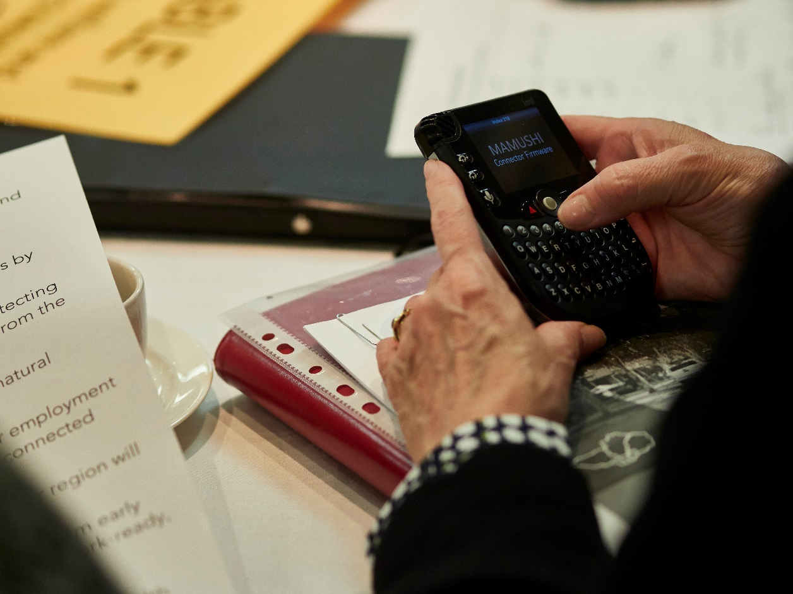

**Figure 1: Council areas in which participants reside (n=102)**

**Figure 3: Age range of Assembly participants (n=105)**

**Figure 2: Participants’ relationship to the region (n=201)**

The Partnership’s priority statements

**Statement #1:** Our young people will feel connected, healthy and respected and our communities will embrace arts, culture and linguistic diversity.

**Statement #2:** Our region will be a leader in environmental responsibilities, committing to zero greenhouse gas emissions by 2050.

**Statement #3:** Our region will strike a balance between protecting our precious natural assets and keeping communities safe from the impacts of natural disasters.

**Statement #4:** Our community will be connected to our natural environment through recreational trails.

**Statement #5:** Residents of our region will have greater employment opportunities, close to home, and accessible by a well-connected transport system.

**Statement #6:** Improved transport connections within our region will ease congestion on the roads and public transport.

**Statement #7:** A seamless approach to lifelong learning from early childhood to retirement years, resulting in a more skilled, work-ready, resilient and connected community.

**Statement #8:** Improved health and wellbeing within our communities through increased access to affordable clinical health and community services that cater to our culturally diverse community.

**Statement #9:** Mental health services and family violence response services are easy to access throughout our region.

**Statement #10:** Housing in the region is affordable, balances development with protection of green wedges, demonstrates quality design, and maintains the distinct character of our neighbourhoods.

Activity 1 – Reviewing the priorities for the region

Overall participants agreed that ten of the priority statements were key priorities for the north.

Table hosts noted the following key messages from the discussion:

* Apply an equity lens over the whole plan as equity is absent in current priority statements
* The disparity between the inner and north of the region needs to be acknowledged and addressed, there are different challenges in established and growing areas
* Improving transport connections across the region is integral to meeting other priorities
* Creating and supporting jobs in the region (particularly the outer areas) for all ages is crucial, and will assist to achieve many of the social priorities
* The North’s cultural diversity should be celebrated and CALD communities supported.

Table 1: Polling results responding to the statement - this is a key priority for the region.

Legend: 1= Strongly Disagree, 3=Neutral, 5= Strongly Agree.

Participants felt that several topics were not addressed in the priority statements. They were:

* Preparing for the digital economy
* Increasing the supply of affordable and social housing
* Supporting older age groups and their growing needs
* Crime prevention and addressing homelessness.

Table 1 illustrates that participants agreed that ‘*residents of our region will have greater employment opportunities, close to home, and accessible by a well-connected transport system’* was the top priority for the region.

|  |  |  |  |
| --- | --- | --- | --- |
| Topic | Priority statement | Average score | |
| **Economy, Jobs and Industry** | Residents of our region will have greater employment opportunities, close to home, and accessible by a well-connected transport system. | **4.74** |
| **Transport and Infrastructure** | Improved transport connections within our region will ease congestion on the roads and public transport. | **4.56** |
| **Education and Training** | A seamless approach to lifelong learning from early childhood to retirement years, resulting in a more skilled, work-ready, resilient and connected community. | **4.41** |
| **Health** | Mental health services and family violence response services are easy to access throughout our region. | **4.38** |
| **Health, Social Welfare and young people** | Improved health and wellbeing within our communities through increased access to affordable clinical health and community services that cater to our culturally diverse community. | **4.35** |
| **Housing** | Housing in the region is affordable, balances development with protection of green wedges, demonstrates quality design, and maintains the distinct character of our neighbourhoods. | **4.27** |
| **Social welfare and young people** | Our young people will feel connected, healthy and respected and our communities will embrace arts, culture and linguistic diversity. | **4.04** |
| **Environment** | Our region will be a leader in environmental responsibilities, committing to zero greenhouse gas emissions by 2050. | **3.89** |
| **Environment** | Our community will be connected to our natural environment through recreational trails. | **3.74** |
| **Environment** | Our region will strike a balance between protecting our precious natural assets and keeping communities safe from the impacts of natural disasters. | **3.67** |

Activity 2 – How do we achieve the priorities?

Actions statements pitched by participants on the night are summarised and organised by topic in Table 2. The most supported ideas are bolded. These ideas were submitted for evaluation. The other ideas have been summarised into a few key statements. All ideas pitched on the night are included in Table 4 in the Appendix.

Table 2: Action statements by topic

|  |
| --- |
| **Infrastructure and Transport (discussed at four tables)** |
| * Deliver a smart cities deal for Melbourne's north; aggregate assets, create opportunities for new industries, jobs, life learning, affordable housing and transport. * Prioritise public transport and active transport over private single user cars: faster, safer and more frequent. * Every school has active transport plans in place with ride and walk to school programs funded, and safe route signage installed. * Significantly invest in an arterial road upgrade package for the north and build it right. * Plan for more effective public transport delivery e.g. use real time data, explore innovative travel modes, integration of different modes of transport. * Engage key stakeholders to better understand freight requirements and preferred corridors of travel. * Combine multiple public transport tracking apps into one. * Extend railway lines and provide dedicated bus and tram lanes. * Include independent expert urban planners, community and politicians in solving local transport problems. * Design train stations that are also community activity hubs. * Promote public transport use through behavioural change campaigns. * Explore the role cross region transport plays in encouraging industry and developing activity centres. * Build connected, separated and safe bicycle infrastructure to encourage more commuting for trips 15kms and under. |
| **Economy (discussed at three tables)** |
| * Establish a food and beverage precinct or cluster next to Melbourne Market including an incubator for start-up businesses. * Expand early years services as they result in better school outcomes. This could take the form of more kinder hours. * Provide improved health, wellbeing and education services to our most disadvantaged through a pilot program. * Involve community leaders in decision making processes that effect their community. * Develop industry clusters to support emerging growth industries e.g. technology hubs. * Work with the region's performing arts community to grow this industry. * Improve public transport and road connections to improve access to local businesses and employment opportunities. * Encourage apprenticeships, traineeships and mentoring programs. |
| **Environment (discussed at three tables)** |
| * Invest in the restoration and protection of creeks, parks and waterways. * Empower the community and businesses to discontinue the use of fossil fuels and clean up the electricity grid. Roll out renewables big time. * Showcase and mainstream approaches to community renewables and energy efficiency, positioning the north as an innovation zone. * Reimagine waste systems to decrease landfill. * Enforce environmental targets on residential development, and advocate for stronger provisions in the state planning guidelines to protect existing natural assets. * Increase development of rail infrastructure to reduce emissions. * Make standalone battery solar-power systems more affordable. * Educate residents about disposing of plastic bags and rubbish appropriately. * Involve TAFE students in constructing and repairing recreational trails along rivers and creeks in the North. * Protect green spaces by taking a holistic approach to open space management. * Implement the Northern Trails Strategy throughout the North to take pressure off roads, promote healthy lifestyles and boost ecotourism * Form a renewable energy cluster in the North to increase employment and enhance innovation. |
| **Education and Training (discussed at three tables)** |
| * Reorienting the education and training system to meet the needs of the emerging knowledge economy and the jobs of the future. * Turn around the Australian childhood development census in the northern suburbs to maximise longer term benefits to the north. * Formally recognise the Northern College of Arts and Technology as a regional resource and fund industry standard arts facility. * Develop partnerships between universities, schools and specialist education services to provide more engaging and targeted learning opportunities for young people. * Create a youth hub that provides training, job search and education opportunities for young people. * Ensure investment in the region is directed towards supporting new and existing training and employment opportunities. |
| **Social Welfare and Young People (discussed at three tables)** |
| * Prevention from harmful gambling; take it from $400 million to $200 million by reducing cash outlet availability, the amount a person is able to withdraw, and opening hours of gambling facilities. * Youth have a voice by developing a youth regional partnership. * Establish an independent taskforce to implement previous recommendations on liveability in the north. * Reactivate "federation white papers" to improve service delivery for health, and social programs. * Provide more recreational and social activities for young people that are affordable and accessible. * Build platforms for community engagement with established community organisations, local schools and community groups. Encourage people from different communities to share stories and expertise. * Support overseas migrants and refugees to have their qualifications recognised in Australia to improve their employability. * Provide social and community areas in new and repurposed developments. * Create strategies around supporting youth offenders and reducing family violence. * Expand connectivity between services such as Headspace and community hubs. * Provide diversity awareness training covering areas including gender, cultural, socio-economic, LGBTQI+ issues. * Work towards early provision of social infrastructure. * A youth employment institute that links with creating a healthy community. * Establish a centre of excellence at the Aborigines Advancement League that will provide an Aboriginal cultural experience for the northern region. * Initiate Australia's first trial of the Universal Basic Income in the region. |
| **Health (discussed at three tables)** |
| * Increase funding for councils as well as community and health services for prevention. * Community led Uber for older people and people with disabilities to access health and recreational opportunities. * Build an open and accessible simulator that helps to attract, plan and deliver the required health services as the population grows and changes. * Work in partnership with existing health service providers including council’s, BKI, Northern Health, GPs, pharmacists, Community Health Centres and NGOs. * Embrace current research and be innovative in providing healthy environments and adequate health services. * Improve access to health and wellbeing services for vulnerable and disadvantaged members of the community. * Host inclusive, cross cultural gatherings to raise awareness of social and mental issues (including family violence). * Increase physical activity and mental wellbeing by providing safe cycling and walking routes and increasing access to natural green spaces. * Invest in green infrastructure such as urban cooling and shading to reduce heat impacts on health. * Provide a co-working space in Mernda to reduce the stress associated with long commute times. * Develop an integrated health and community services hub. |
| **Housing (discussed at one table)** |
| * Require all new housing developments to include a percentage of social (5%) and affordable (10%) housing. * Increase planning controls to ensure new housing reflects the unique character of local areas. * Set measurable targets for affordability of housing and use targets to shape local planning and investment decisions. * Convert carparking areas at train stations to affordable housing. * Balance housing development with green wedge protection and infrastructure provision. * Make 20-minute neighbourhoods a reality by rejuvenating activity centres and linking with public transport. |

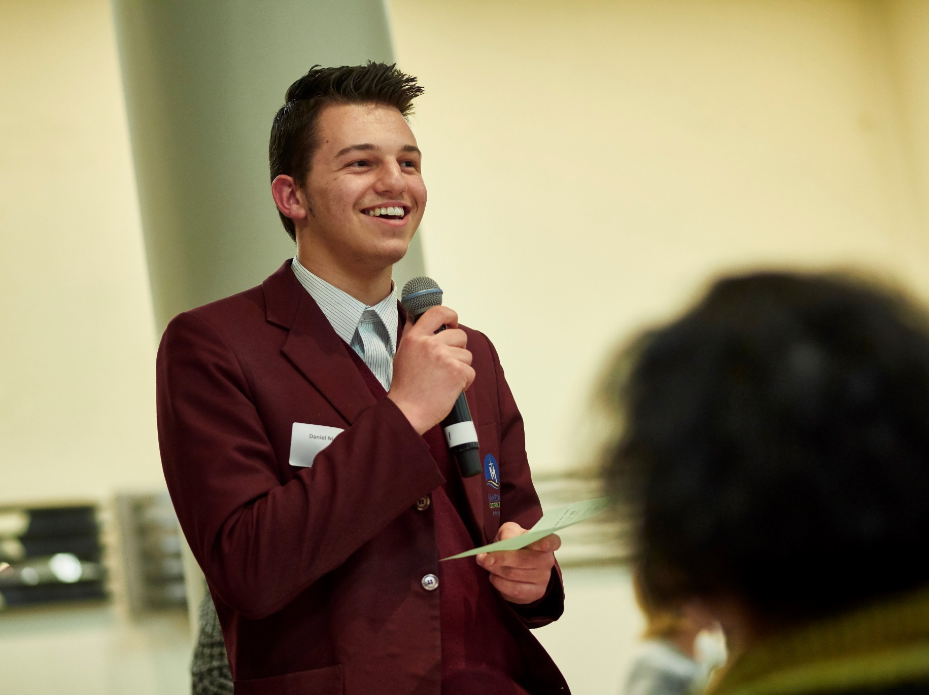

Activity 3 – Evaluating action statements

Participants’ evaluations of the action statements are illustrated in Table 3. Participants believed the top three important actions were:

* Deliver a smart cities deal for Melbourne's north, aggregate assets, create opportunities for new industries, jobs, life learning, affordable housing and transport
* Require all new housing developments to include a percentage of social (5 per cent) and affordable (10 per cent) housing
* Prevention from harmful gambling; take it from $400 million to $200 million by reducing cash outlet availability, the amount a person can withdraw, and opening hours of gambling facilities.

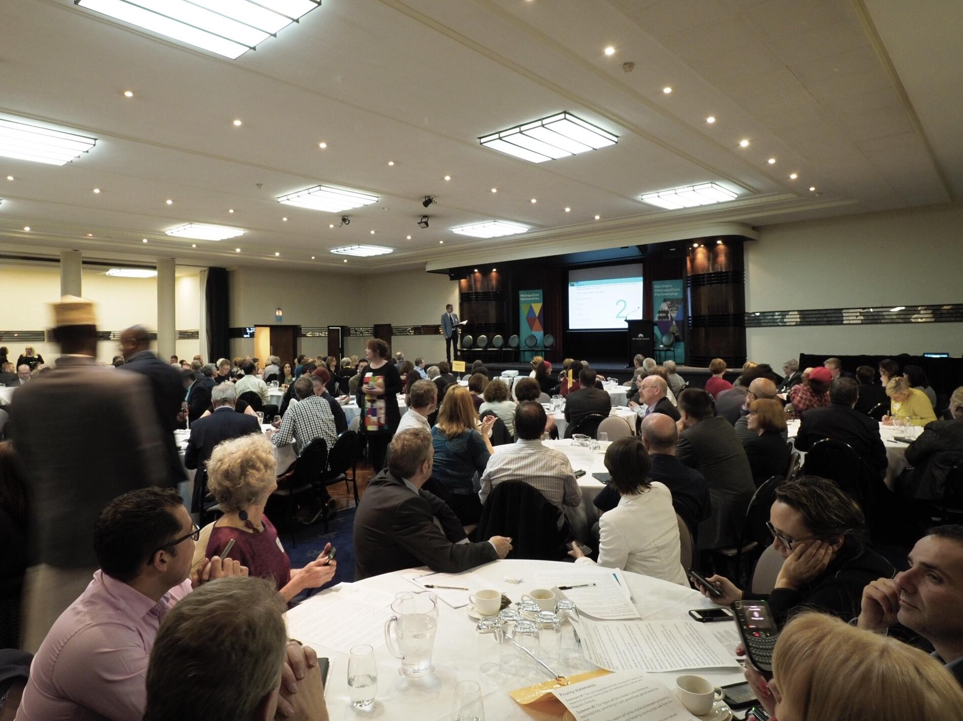

Transport and Infrastructure consistently polled high in both priorities and actions. Overall, participants believed 18 of the 20 action statements would have a medium to high positive impact on communicates across the North.

Participants consistently agreed on the level of importance of all the actions. There was no significant split of responses to investigate.

Table 3: Polling results for the action statements.

Legend: 1= Not a priority, 3= Medium priority, 5= Essential.

|  |  |  |
| --- | --- | --- |
| Topic | Action statement | Average priority |
| Transport and infrastructure | Deliver smart cities deal for Melbourne's north. Aggregate assets. Create opportunities for new industries, jobs, life learning, affordable housing and transport. | 4.51 |
| Housing | Require all new housing developments to include a percentage of social (5%) and affordable (10%) housing. | 4.44 |
| Social welfare and young people | Prevention from harmful gambling from $400 million to $200 million by reducing cash outlet availability, amount able to withdraw, and opening hours of gambling facilities. | 4.43 |
| Health | Increase funding for councils and community and health services for prevention. | 4.38 |
| Transport and infrastructure | Prioritise public transport and active transport over private single user cars: faster, safer and more frequent. | 4.36 |
| Education and training | Reorienting the education and training system to meet the needs of the emerging knowledge economy and the jobs of the future. | 4.21 |
| Economy | Establish a food and beverage precinct or cluster next to Melbourne Market including an incubator for start-up businesses. | 4.19 |
| Social welfare and young people | Expand early years services as they result in better school outcomes. This could take the form of more kinder hours. | 4.04 |
| Environment | Invest in the restoration and protection of creeks, parks and waterways. | 4.04 |
| Social welfare and young people | Community led Uber for older people and people with disabilities to access health and recreational opportunities. | 4.03 |
| Environment | Empower the community and businesses to get off fossil fuels and clean up the electricity grid. Roll out renewables big time. | 4.00 |
| Social welfare and young people | Turn around the Australian childhood development census in the northern suburbs to maximise longer term benefits to the north. | 4.00 |
| Health | Provide improved health, wellbeing and education services to our most disadvantaged through a pilot program. | 3.99 |
| Transport and infrastructure | Every school has active transport plans in place with ride and walk to school programs funded, and safe route signage installed. | 3.95 |
| Environment | Showcase and mainstream approaches to community renewables and energy efficiency. Positioning the north as an innovation zone. | 3.92 |
| Social welfare and young people | Youth having a voice by developing a youth regional partnership. | 3.88 |
| Transport and infrastructure | Significant investment in an arterial road upgrade package for the north and build it right. | 3.86 |
| Social welfare and young people | Establish an independent taskforce to implement previous recommendations on liveability in the north. | 3.57 |
| Education and training | Formally recognise the Northern College of Arts and Technology as a regional resource and fund industry standard arts facility. | 3.49 |
| Health | Build an open and accessible simulator that helps to attract, plan and deliver the required health services as the population grows and changes. | 3.21 |

Key findings

The Assembly participants’ contributions and ideas provide Partnership members with good insight to the key priorities for the region.

The Partnership’s key take-aways are:

* Overall, participants agreed that the priorities presented by the Partnership were key priorities for the North
* The issues participants wanted to see included in the priorities were: preparing for the digital economy; increasing the supply of affordable and social housing; supporting older age groups and their changing needs; and crime prevention and addressing homelessness
* The most consistent key message from participants during activity one was that the priorities did not link more employment opportunities with the social benefits they would create
* The topics of Social Welfare and Young People and Infrastructure and Transport were both high priorities for the regions, and associated actions were evaluated as medium to high impact for the region.

The Partnership will take on board the ideas from the Assembly while it formulates its independent advice that will be submitted to Government later this year.

**Terry Larkins, Chair of the Northern Metropolitan Partnership**

Appendix A – List of action statements and votes

Table 4: All action statements put forward by participants, their votes, and themes.

| **Action statement** | **Votes** | **Theme** |
| --- | --- | --- |
| Undertake a pilot program to improve access to health and wellbeing services for our vulnerable and disadvantaged members of our community. | 10 | Social welfare and young people |
| Food processing, manufacturing, distribution, innovation and incubation hub on the land adjacent to Melbourne Wholesale Market, creating new jobs for Melbourne north. | 8 | Economy |
| Time to empower people and business getting off fossil fuels and clean up the electricity and roll out renewables big time! | 6 | Environment |
| Formally recognise the Northern College of the Arts and Technology as a regional resource that meets the training needs of the North and the arts facilities, so it can enhance its offerings and provide industry standard facilities. | 6 | Education and training |
| Increase funding for Councils, health and community services for prevention. | 6 | Health |
| Prevent harm from gambling and have annual regional gambling losses from $400 million to $200 million by: 1) reducing cash out to $200, 2) reducing EGM opening hours to 12 hours a day and 3) introducing $1 maximum bet. | 5 | Social welfare and young people |
| Establish a food and beverage precinct/cluster next to Melbourne Wholesale Market, including an incubator for food start-up businesses | 5 | Economy |
| Every school has an active transport plan in place with ride and walk to school programs funded and safe rout signage installed. Increasing active transport, decreasing cars on road, decreasing emissions, decreasing congestion and time in cars, increasing timeliness of public transport, increase time off road with families, increase health benefits and decrease economic losses. | 5 | Transport and infrastructure |
| Community led "Uber for older people" people with disability to access health and recreational opportunities. | 5 | Social welfare and young people |
| Application of an "equity" lens to all priorities selected by the partnership. Systematic roll out of equity awareness training covering gender equity, cultural, socio-economic, LGBTQI+. In order "walk our talk", then expand to whole community. | 4 | Social welfare and young people |
| Showcase and mainstream approaches to community renewable and energy efficiency positioning the North as an innovation zone for community climate action. | 4 | Environment |
| The rivers and creeks give our area its character, so I would like them to be protected and restored. | 4 | Environment |
| Tackle climate change by protecting native forests in East Gippsland and central highlands, forming the Great Forest National Park and Emerald Link. These are the most carbon dense in the world and the mountain ash one hour from here are the source of our drinking water. Also form renewable energy cluster in the north for employment and innovation. | 4 | Environment |
| Protecting and enhancing our Green Wedge will provide eco-system services to the whole of the region, protect our future by providing carbon sink, provide employment by developing renewables. | 4 | Environment |
| Redevelopment of Broadmeadow’s train service with safe, attractive, reliable, frequent, and acts as a community and activity hub for Melbourne's north. | 4 | Transport and infrastructure |
| Get on with construction of all roads that meet arterial category. Listen to local Councils who understand their local issues! Build it once and build it properly. Stop all the interim works. | 4 | Transport and infrastructure |
| Promote attitudinal change to encourage use of public transport by quarterly free travel day with increased frequency on these days. Employers reward employees who use public transport incentives from local businesses e.g. Free fries, free use of swimming pool on presentation of ticket. | 4 | Transport and infrastructure |
| Housing in the region is affordable, balances development with protection of green wedges demonstrates quality design and maintains the distinct character of our neighbourhoods. | 4 | Housing |
| English language training for the diverse community of the Northern Region to assist the community to engage and connect with each other. Partnership with Council, BKI, Northern Health, Community health and NGOs. | 4 | Social welfare and young people |
| Create paths to schools that children can walk and ride independently to increase well-being and social connections. | 4 | Social welfare and young people |
| Legislate that every new housing development include a percentage of social (5 per cent) and affordable (10 per cent) housing. In partnership with NGOs, community housing providers, Councils and developers. | 4 | Housing |
| Extend and electrify Upfield rail to Craigieburn and build a rain line from Epping to Lockerbie/Wallan and integrate buses. | 4 | Transport and infrastructure |
| Youth having a voice by developing a youth regional partnership. | 4 | Social welfare and young people |
| Early intense and consistent integration, 1) with Youth who are first time arrivals to the Justice System and 2) absolute synergy in the way we share our information and strategy regarding youth offending and family violence. | 4 | Social welfare and young people |
| A strategically integrated education and training system focussed on maximising benefits from the knowledge economy linked to the north delivering employment and measured against that aim | 4 | Education and training |
| Turn around the Australian Early Development census in the outer northern suburbs | 4 | Social welfare and young people |
| More job opportunities for young people, concentrating on multicultural. Job fairs in Hume main areas (shopping and community centres) for the youth. | 3 | Social welfare and young people |
| Reimagining consumer-driven, rethinking waste system to significantly decrease waste to landfill to zero. Streamline what can be across Councils, e.g. 1) invest in waste to energy plant 2) and other organic recycling facility like composting 3) changing attitudes towards buying and focus on waste recycle. | 3 | Environment |
| Encourage residents to develop 20-minute neighbourhood groups to include environmental improvements as part of their proposals. | 3 | Environment |
| To invest in technology and on road infrastructure to ensure reliable travel times for on road public transport, to boost reliance on road based public transport. | 3 | Transport and infrastructure |
| Northern arterial road. | 3 | Transport and infrastructure |
| Involve independent expert urban planners as well as community and politicians in solving local transport problems. | 3 | Transport and infrastructure |
| Services aren't ready for the growing populations. I would build a simulator that predicts needs and attracts services to areas of need. | 3 | Social welfare and young people |
| Increase public health initiatives to prevent illness and promote well-being, partnered with free or low-cost actions through GPs and pharmacists, not just through Community Health Centres. | 3 | Social welfare and young people |
| Develop an integrated health and community services hub in the Craigieburn Town Centre to support the current population and future population of Craigieburn and the emerging suburbs to the north. Two services hubs should include broad range of primary health and community services, working in an innovative, integrated approach which is client focussed. | 3 | Social welfare and young people |
| Promote linkages between education, local employment and industry. Funding of specialist educational facilities that link education with local employment sectors. | 3 | Education and training |
| To meet our environmental targets, focus on residential development, open spaces and transport infrastructure. Creating well insulated draft proofed dwellings will contribute to the need in increased electricity and gas. This coupled with greening infrastructure in vast open spaces, nature strip and parklands. Increase and development of rail infrastructure reduces emissions. | 2 | Environment |
| Initiate Australia's first trial of the Universal Basic Income in the region with the lowest socio-economic suburbs. | 2 | Economy |
| Create the Merri Creek Regional Parklands from the Yarra to Wallan and fund its existence and development. | 2 | Environment |
| Implement Northern Trails Strategy throughout the North to take pressure off roads, promote healthy lifestyles and promote ecotourism. | 2 | Transport and infrastructure |
| Reduce pokies machines. Victorian loses = $2.6 billion per year. That's $7 million per day. It leads to domestic violence and other social issues. | 2 | Economy |
| Combine the JVBN program with suitable youth mentoring programs. This will create a positive experience for the workers engaged with JVBN programs. | 2 | Education and training |
| One app tracks my train, another tracks my tram, and another (sometimes) tracks my bus. "The one app" makes me safer, encourage more transport option, can pay for itself. | 2 | Transport and infrastructure |
| An arterial road improvement package for the North like the recently announced Western Package. A base transport network to move people and connect communities. | 2 | Transport and infrastructure |
| From my opinion, the houses are not affordable for the new arrivals of refugees, especially for those who have children at school and have no work. I think government should build more affordable houses. | 2 | Housing |
| Victorian Gov. support the Northern Councils and work with Federal Government to obtain a 'city deal' for Melbourne's North. | 2 | Transport and infrastructure |
| If possible more buses in peak time and connected with trains. | 2 | Transport and infrastructure |
| That investment in health services is not based on hospital beds, planning includes local primary services, buildings and finances to run them. | 2 | Health |
| Increased local training opportunities in health and aged care areas for local students for local jobs. | 2 | Social welfare and young people |
| Work to understand the systems that support health, wellbeing, education, transport, employment, housing, disadvantage, equity in opportunities and equality in outcomes. Address one through the others. | 2 | Social welfare and young people |
| Bring local, state and federal government together with NFP and developers to provide social, affordable and accessible housing options reflective of local area. | 2 | Housing |
| Convert large suburb train parking to medium density affordable housing, massive increases in bus access to stations. | 2 | Housing |
| Support overseas migrants and refugees to have their qualifications recognised as a priority in improving their employability within the northern region. Reduce pokie machines in the North to the number in Nillumbik! | 2 | Education and training |
| Establish a centre of excellence at the Aborigines Advancement League that will provide a Aboriginal cultural experience for the northern region. | 1 | Social welfare and young people |
| Affordability of stand-alone battery solar-power (domestic) bulk buying through Council. | 1 | Environment |
| Re-educating residents about disposing of plastic bags and rubbish appropriately. Eradicating use of plastic bags. | 1 | Environment |
| Possibility of using skills of young people in TAFE and Tech schools to construct and repair recreational trails along rivers and creeks in the North. Involve students in repairing historical sites, i.e. Carome Homestead. | 1 | Education and training |
| A commitment to an agreed percentage of green space in any ongoing development and maintenance of existing parks, bush reserves in current built up areas. | 1 | Environment |
| My idea is that Environmental biodiversity and health is protected by local government and state government planning roles and policy to protect and enhance open spaces and waterways. No exceptions for freeways. More than lip service will be paid to the Yarra River Protection Act. More Rangers for parks. | 1 | Environment |
| Waterways are the arteries of our communities, green, trees, biodiverse, bike trails, protected from stormwater and accessible to all. | 1 | Environment |
| Our region will (somehow) create more numerous and effective local bike paths. | 1 | Transport and infrastructure |
| Money allocated to arterial roads within Hume Council which are owned by the state. | 1 | Transport and infrastructure |
| Undertake a pilot program that tests an integrated service delivery model to improve access to the services communities need. | 1 | Transport and infrastructure |
| Access to real time data and information to allow for transport planning at regional, local and individual levels. | 1 | Transport and infrastructure |
| Engage and collaborate with key stakeholders in the regions to understand typical freight requirements and preferred corridors of travel. | 1 | Transport and infrastructure |
| Create a multicourt sporting facility at Yarrambat to support youth and general community of the area. | 1 | Social welfare and young people |
| Map existing transport options and explore innovative connections paths across the region to ease congestion. | 1 | Transport and infrastructure |
| Put health at the centre of all decision making, considering equity of health opportunity. | 1 | Health |
| Empower youth and raise awareness of social and mental issues (including family violence), by hosting inclusive gatherings that are across cultural and religious boundaries. | 1 | Social welfare and young people |
| Make a fully interconnected walk and bike city that enables people to travel safely without being near cars and traffic. | 1 | Transport and infrastructure |
| Victorian Government supports and works with the Federal Government to pursue a "City deal" for Melbourne's North. | 1 | Transport and infrastructure |
| Health and wellbeing services across the care continuum, build on existing partnerships to ensure equitable access regardless of where in the region a resident lives. | 1 | Health |
| Local planning controls need to be tighter so that housing reflects the unique character of each area. Local resident views need to carry greater weight at VCAT. | 1 | Housing |
| Set measurable targets for affordability of housing (sale and renting) across income quartiles and use those measures to shape local planning and investment decisions. Use population projections to also shape future decisions. | 1 | Housing |
| Free bus to schools. Free public transport for working people on way to work. Better and bigger public parking at all train stations, especially new built. | 1 | Transport and infrastructure |
| New bus routes need to be implemented in new housing estates to connect residents with employment, education, shops and services. | 1 | Transport and infrastructure |
| "Northern Suburb City Deal" to leverage State, Federal and Local government funding for a broad strategy to co-ordinate and action plan for transport, job growth, housing and resilient communities. | 1 | Transport and infrastructure |
| Build platforms for community engagement with credible established Islamic organisations and local schools and community groups. (I.e.. Have schools invite people from Muslim community groups during cultural diversity week). | 1 | Social welfare and young people |
| Social and community areas in new and repurposed developments - small or large all with covered open areas, with seating water and green areas. | 1 | Social welfare and young people |
| Provide strategic employment close to transport through blended skills based training by aligning industry with key education providers. Industry and education hubs, side by side. | 1 | Education and training |
| Reactivate "federation white papers" to improve service delivery for health, education social programs (including housing). | 0 | Social welfare and young people |
| That the partnership explores further ways to capture the input of young people, acknowledging that the 20-34 age bracket is the largest in the region but only 14 responded to the survey. | 0 | Social welfare and young people |
| More recreational and social activities for young people on the weekends and holidays that are affordable and accessible. | 0 | Social welfare and young people |
| Expand connectivity between services such as Headspace and community hubs. Improve connectivity between communities, share these services and expertise. | 0 | Social welfare and young people |
| Early provision of social infrastructure, for example, services and building social capital and communities alongside physical infrastructure. Social infrastructure needs should inform physical infrastructure, not the other way around. | 0 | Social welfare and young people |
| A youth employment institute that links with creating a healthy community. | 0 | Social welfare and young people |
| Establish interdepartmental taskforce that would ensure advancing liveability in Melbourne outer suburbs that have been identified in various parliamentary/VAGO reports resulting in a integrated 20 year strategic place for the North, that embraces AISI heritage in the North. | 0 | Social welfare and young people |
| Waterways enhanced and improved - naturalisation, regional parklands, network of open space - North and West | 0 | Environment |
| Reinvigorate creeks and waterways in the Hume region. Return them to their natural state rather than concrete drains. | 0 | Environment |
| A holistic approach to open space management and acquisition of land, so we can have a network of green space. In: (waterways, green wedges, reserves) new developments/subdivisions | 0 | Environment |
| That we re-invent the Green Wedge concept to preserve and promote this unique and valuable resource, through a marketing, communicative community focussed projects. Greater Melbourne ownership. It's an amazing resource, yet fragile, misunderstood and disappearing. It is under huge threat from planned Yarra Valley. | 0 | Environment |
| Ensure stronger provisions in the state planning guidelines to protect existing natural assets, trees (hollows) waterways, including the hydrology and vegetation classes. | 0 | Environment |
| Social disintegration (productions of volunteer mobile apps). Gambling among CALD communities (providing awareness and proactive approach). Involving African community leaders in resolving African issues. | 0 | Social welfare and young people |
| Develop industry clusters to research and enable and support emerging growth industries. Particular focus should be on industries where the Northern Melbourne region enjoy some comparative advantage. | 0 | Economy |
| Through the Northern Metro Partnership governments works with the region's performing arts community on requirements to grow this already substantial northern industry. | 0 | Economy |
| Action two options for the ring road extensions not one (options B and D). | 0 | Transport and infrastructure |
| Strategic planning at the regional level that promote the jobs of the future and is outcome focussed and builds diversity and resilience. | 0 | Economy |
| Comprehensively review and reset the public transport connections, integration and frequencies across the region to improve access to services, facilities, shops and employment. | 0 | Transport and infrastructure |
| Northern Metro Partners, as a collaborative, commit to all contracts investing 5-10% into jobs for young people, e.g. Apprenticeships and traineeships. | 0 | Economy |
| 1) The Melbourne North Councils to advocate and deliver an economic incubator/hub for food and beverage. 2) Develop a digital hub for Melbourne education and smart business. 3) State and Federal Government to deliver a city deal, transport, education and economy. | 0 | Economy |
| Focus on attracting leading technology organisations to create the technology hub of Melbourne "Silicon Valley of Australia". | 0 | Economy |
| Improve road and transport for the area including Yan Yean Road area to enable our regional areas better travel. | 0 | Transport and infrastructure |
| Build food and beverage innovation centre next to Melbourne Market, $500k for business case, $45 million to develop it. | 0 | Economy |
| Disadvantage communities require more support and educate them, especially assistance with language. | 0 | Education and training |
| My idea is to better connect refugee youth who arrive in the region to live through better education and community support programs. | 0 | Social welfare and young people |
| Duplicate and extend the Upfield line to Roxburgh Park to improve connectivity and relieve pressure on Craigieburn line. | 0 | Transport and infrastructure |
| Seek a 'city deal' for Melbourne's North from the Federal Government. | 0 | Transport and infrastructure |
| Provide a Northern Region arterial road package that includes upgrades to North East Link, Craigieburn Road and Manningham Road. | 0 | Transport and infrastructure |
| Bring capacity projects for cross-regional and sub-regional transport connections that support industry and innovation and provide for strong activity centres development. | 0 | Transport and infrastructure |
| Deliver smart cities deal for Melbourne north. Aggregate assets, create opportunities for new industries, jobs, life learning and affordable housing. | 0 | Transport and infrastructure |
| Allocate payroll tax to company 'reward and recognition' program that is audited annually and money still is spent but is spent on people that will invest in the region. | 0 | Transport and infrastructure |
| I think the government should build and provide affordable houses for the new arrivals. | 0 | Transport and infrastructure |
| Developing partnerships between universities, schools, specialist education services to engage young people and build skills for the future, innovation and technology. | 0 | Education and training |
| Serious trades, technical and arts education starting at Year 10, so many young people can gain skills to contribute to their employment and business throughout northern region. | 0 | Education and training |
| Create youth support, training, job opportunity and education hub. Affordable housing. | 0 | Education and training |
| Develop and implement a long term, integrated regional growth strategy which brings together plans to create the jobs of the future, infrastructure and community development. Social and physical delivery, not just land use. | 0 | Education and training |
| The north is home to a fully integrated education and skills sector. | 0 | Education and training |
| An integrated and industry focussed education and skills sector | 0 | Education and training |
| Not only should we have state based local content requirements, we should have a certain percentage as regional content requirements, including apprenticeships etc. | 0 | Education and training |
| Leveraging existing and new training and employment opportunities from investment in the region. | 0 | Education and training |
| That our design for new communities embraces the evidence about what communities need to be healthy. | 0 | Health |
| Increase physical activity by providing safe cycling routes to increase health and mental wellbeing. Address barriers. | 0 | Transport and infrastructure |
| Invest in green infrastructure for health and well-being and urban cooling and shading. | 0 | Environment |
| Walk score contour maps available online to focus development in place of most need. | 0 | Transport and infrastructure |
| We are time poor and stressed, co-working space in Mernda to reduce the commute and give us time back to ourselves. | 0 | Social welfare and young people |
| Construction of a hospital to the north of Craigieburn. This will service the growth areas of Hume, Whittlesea and Mitchell. | 0 | Health |
| Access to green natural spaces, improved physical and mental health. Increase parks and tree canopies and safe areas to walk, run and engage with the environment. | 0 | Environment |
| There would be more money for health if people had to pay a small amount. Money for Dianella to expand. Boom gates for car park. | 0 | Social welfare and young people |
| Examine retooling of manufacturing to support ageing sectors i.e. Health and disability. Promotion of employment options in health to schools. University and sector partnership to develop strategies for health opportunities. | 0 | Social welfare and young people |
| Commitment to a healthy environment, access to rural areas, proven aid to promote mental health and wellness. | 0 | Social welfare and young people |
| Invest in infrastructure: build, enhance and extend public transport, especially train lines and bus routes including bus lanes to cater for growth. Free buses for school age kids, car parking and buses at and to train stations, funding solution. | 0 | Transport and infrastructure |
| Dedicated bus and tram lanes, and priority measures as well as integrated train lines. | 0 | Transport and infrastructure |
| Easy allocation or commitment of growth area infrastructure funding. | 0 | Transport and infrastructure |
| Faster, more frequent, safe public transport, e.g. New York, Paris and London style metro. | 0 | Transport and infrastructure |
| Make the 20-minute neighbourhoods real by rejuvenating activity centres through a joint investment plan between state and local governments and the private sector and building transport links around these. | 0 | Transport and infrastructure |
| Increased bus services, build more bus only lanes and priority measures at intersections. Provide more car parking as bus hubs, introduction of an express bus, improve transport mode connections. | 0 | Transport and infrastructure |
| Build connected, separated and safe bicycle infrastructure to encourage more community for trips 15kms and under. Support local community to make connected and fast roads, safe and slower so that children can play and connect in their local communities. | 0 | Transport and infrastructure |
| Build Eltham North Railway Station and initiate bus services in the north and rural areas where none exist. Increase train parking at all stations. | 0 | Transport and infrastructure |
| Interlinks on/off road (north/south and east west) paths to improve active transport options. | 0 | Transport and infrastructure |
| Develop "alternative" education programs which recognise community vulnerabilities, build youth and leadership, and are robustly linked to sustained employment outcomes. | 0 | Social welfare and young people |
| We need northern Councils to join up and collaborate to deliver affordable, high quality cultural competence training focussed on supporting vulnerable families for municipal staff and local service community providers. | 0 | Social welfare and young people |
| Develop a system that shares information respectfully about CHN through all universal access services from birth to end of 2nd School. Vulnerability, Disability, all CHN. | 0 | Social welfare and young people |