delwp.vic.gov.au

Metropolitan Partnerships – Southern region

|  |
| --- |
| The 2017 Southern Assembly  Summary Report |

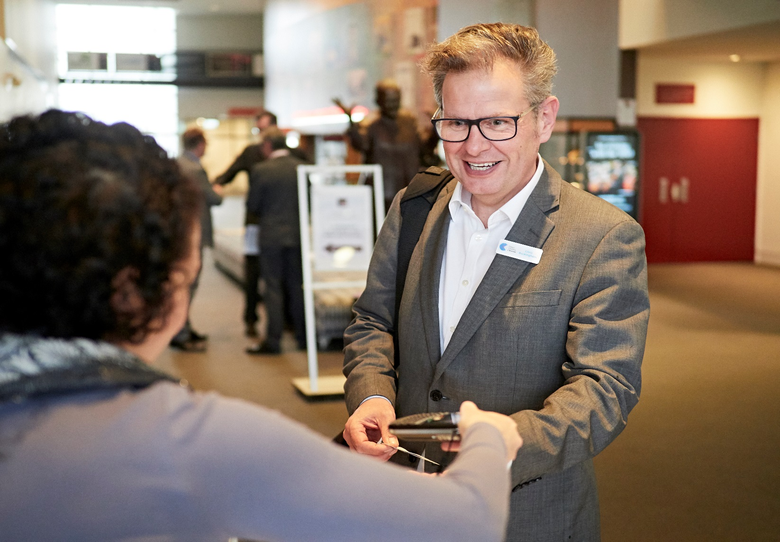

|  |  |
| --- | --- |
|  |  |



|  |  |  |  |
| --- | --- | --- | --- |
|  |  |  |  |

|  |
| --- |
| © The State of Victoria Department of Environment, Land, Water and Planning 2017  LogoThis work is licensed under a Creative Commons Attribution 4.0 International licence. You are free to re-use the work under that licence, on the condition that you credit the State of Victoria as author. The licence does not apply to any images, photographs or branding, including the Victorian Coat of Arms, the Victorian Government logo and the Department of Environment, Land, Water and Planning (DELWP) logo. To view a copy of this licence, visit <http://creativecommons.org/licenses/by/4.0/>  ISBN 978-1-76047-810-0 (print)  ISBN 978-1-76047-811-7 (pdf)  Disclaimer  This publication may be of assistance to you but the State of Victoria and its employees do not guarantee that the publication is without flaw of any kind or is wholly appropriate for your particular purposes and therefore disclaims all liability for any error, loss or other consequence which may arise from you relying on any information in this publication.  Accessibility  If you would like to receive this publication in an alternative format, please telephone the DELWP Customer Service Centre on 136186, email [customer.service@delwp.vic.gov.au](mailto:customer.service@delwp.vic.gov.au), or via the National Relay Service on 133 677 [www.relayservice.com.au](http://www.relayservice.com.au). This document is also available on the internet at [www.delwp.vic.gov.au](http://www.delwp.vic.gov.au). |

**This report has been prepared by Capire and DELWP and is an independent account of the discussions at the assembly.**

Unless otherwise stated, all feedback documented by Capire Consulting Group and any person(s) acting on our behalf is written and/or recorded during our program/consultation activities.

Capire staff and associates take great care while transcribing participant feedback but unfortunately cannot guarantee the accuracy of all notes. We are however confident that we capture the full range of ideas, concerns and views expressed during our consultation activities.

Unless otherwise noted, the views expressed in our work represent those of the participants and not necessarily those of our consultants or our clients.

Executive Summary

An Assembly was held by the Southern Metropolitan Partnership on Wednesday 11 October 2017, bringing together community members, businesses, mayors and councillors to determine the key priorities for the Southern region.

The outcomes of the Assembly will be used by the Metropolitan Partnership to inform its independent advice to government on priorities for the region.

One hundred and thirty-six people participated in discussion; 117 attendees and 19 table hosts. Attendees included 18 mayors and councillors from the six local governments in the region, three State Ministers and two Members of Parliament.

The focus of the night was to hear feedback and ideas from the community through three activities:

* Review and evaluate the Partnership’s initial thinking on priorities for the Southern region
* Develop and pitch ideas for how these priorities can be achieved
* Evaluate action statements by all participants on the night.

To increase transparency and provide live results, individual handsets were given to every participant to take part in the evaluation polls.

On the night participants agreed that the top priority for the region was ‘*our neighbourhoods will be better connected to employment, education, recreation and services with upgraded roads and higher frequency public transport’.*

The priorities presented on the night were considered almost right, with participants also requesting to include issues such as alcohol and drug dependency and community safety.

Fifteen action statements to address the priorities were developed and evaluated. Participants believed the top three high priority actions were:

* Operationalise an intermodal inland port in Dandenong powered by an alternate waste treatment facility from the six councils in the South
* Divert existing recycled water from Carrum to use for agriculture and preserve the green wedge, provide food security and replenish the environment
* Review the bus network to accommodate for growth and change to bring it up to a recognised service stand for all in the region.

The results indicate that Infrastructure and Transport, and the Environment are key intervention points for the Southern region. They were high priority topics and had actions that participants felt were important to achieving better outcomes for the whole region.

In contrast, participants were less likely to think that social welfare actions would have a high impact on the communities of the Southern region.

Contents

Executive Summary 1

The Metropolitan Partnerships 3

The 2017 Southern Assembly 4

Who took part in the conversation? 5

The Partnership’s priority statements 6

Activity 1 – Reviewing the priorities for the region 7

Activity 2 – How do we achieve the priorities? 8

Activity 3 – Evaluating action statements 10

Key findings 12

Appendix A – List of action statements and votes 13

The Metropolitan Partnerships

The Metropolitan Partnerships are a new and coordinated way for communities to advise government on what matters in their region.

The Victorian Government wants to better understand and respond to the needs of Melbourne’s communities. Six Metropolitan Partnerships across Melbourne have been created because the government recognises that local communities are best placed to advise on issues and priorities for their region.

Each Partnership is made up of eight community and business representatives with varied backgrounds, experiences and networks, the CEO of every local government in that region and a Deputy Secretary from the Victorian State Government.

Working closely with their communities, the Partnerships will identify opportunities for driving improved social, economic and environmental outcomes and advise the government on actions that can make a real difference to the liveability and prosperity of their metropolitan region.

The Partnerships will strengthen relationships and facilitate stronger collaboration across the three tiers of government, businesses and communities. They will also enable the government to respond in a more coordinated and targeted manner to deliver better outcomes for the community.

More information on the six Metropolitan Partnerships can be found at suburbandevelopment.vic.gov.au

## The Southern Partnership

The Southern Partnership members are:

* Elizabeth Deveny, Chair
* Andrew Simmons, Deputy Chair
* Andrew Cornwall, Member
* Vicki MacDermid, Member
* Shabnam Safa, Member
* Jillian Walsh, Member
* Andrew Gardiner, Member
* Jacqueline Galloway, Member
* Gary McQuillan, CEO, Cardinia Shire Council
* Mike Tyler, CEO, Casey City Council
* John Nevins, CEO, Kingston City Council
* Dennis Hovenden, CEO, Frankston City Council
* John Bennie, CEO, Greater Dandenong City Council
* Carl Cowie, CEO, Mornington Peninsula Shire Council
* Jenny Atta, Victorian Government representative

Find out more about the Southern Metropolitan Partnership members at: <https://www.suburbandevelopment.vic.gov.au/partnerships/metropolitan-partnerships/southern-partnership>

Read more about the Southern Metropolitan region at: <https://www.suburbandevelopment.vic.gov.au/regions/southern-region>

## The Southern Region

The Southern metropolitan region is a diverse and vibrant area that includes the coastal local government areas of Kingston, Frankston, and Mornington Peninsula. It also includes the inland regional economic centre of Greater Dandenong, and the outer suburban growth areas of Cardinia and Casey. It has the largest population of the six Melbourne regions at over 1 million people, or about 22 per cent of Melbourne’s total population.

The 2017 Southern Assembly

On Wednesday 11 October 2017, 136 community members, businesses, councillors and mayors came together to help determine the key priorities for the Southern region.

The Metropolitan Assemblies are part of a commitment to give Victorians the opportunity to influence decisions and shape the future of their communities.

The assemblies have been initiated as an opportunity for the community to come together and have their say on issues that matter to them and the priorities they have for their communities.

There were several ways people could take part in the conversation, including answering pre-engagement questions online at engage.vic.gov.au and attending the Assembly.

## What happened on the night

The focus of the night was to hear feedback and ideas from community members and included three activities.

### Activity 1 – Reviewing the priorities for the region

Informed with the pre-engagement results and other community engagement initiatives conducted by local government, Partnership members developed nine priority statements for the region.

Participants were split across 19 tables and asked to consider whether the statements highlighted the right priorities for the region and advise what might be missing. The top messages from the conversation were recorded and participants were invited to declare whether they agree or disagree that each statement was a key priority for the region through their individual handsets.

### Activity 2 – Developing action statements

Participants moved to a second table to discuss topics they are passionate about. Topics of interest were indicated by participants when registering for the Assembly, and the number of tables allocated to each topic reflected the volume of interest.

Participants were asked to create an action statement to highlight how the priorities for each topic could be achieved and pitch it to the table for discussion. The table voted for their favourite action statement using sticky dots.

The table then agreed on one action statement to submit to all Assembly participants for evaluation.

### Activity 3 – Voting on action statements

Each table’s action statement was presented to the room. Participants were asked to consider each statement and respond through their handsets to the question - *what positive impact will this action have on communities across the South?*

## Limitations

As with all community engagement processes, there are limitations associated with the Assembly that should be acknowledged. They include:

* Assembly participants were not necessarily a representative sample of the Southern region’s population. The results from the night are a good indication of sentiment and ideas in the region, but are not a statistically valid reflection of the views of the entire eastern community
* Due to multiple registration processes, demographic information was not collected for all participants
* Not all participants chose to take part in all polls. All results have been converted into percentages to reduce the impact of this
* Participants had a varied understanding of the issues in the region and possible solutions
* Some participants were allocated to theme tables but chose to move to other discussions on the night
* Some actions identified did not always reflect the topics discussed. This was in part due to the cross pollination of issues emerging cross the themes discussed
* Table hosts have taken care to record participant feedback. However, we cannot guarantee the accuracy or inclusion of all comments. We are confident that the range of ideas, concerns and views reflect the comments made at the sessions.

Who took part in the conversation?

Between 14 August and 11 October 2017, a page dedicated to the Southern region was live on engage.vic.gov.au. The site was visited by 1,067 people with 72 people completing the pre-engagement questions.

Participants’ key demographic attributes are as follows:

* There were more males in attendance than females
* Most participants were between 55 and 64 years of age
* Almost half of the participants live in the region, and a third work in the region
* Nine participants spoke English as a second language and two participants had a disability.

Figures 1 to 3 show the participants age, suburb they live in and relationship to the region.

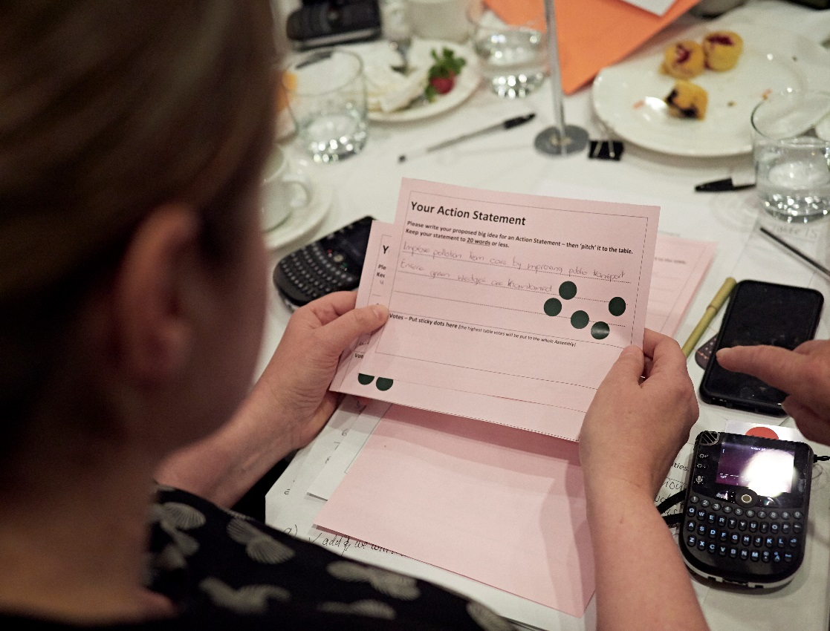

**Figure 3: Age range of Assembly participants (n=102)**

**Figure 2: Participants’ relationship to the region (n=162)**

**Figure 1: Council areas in which participants reside (n=69)**

The Partnership’s priority statements

**Statement #1:** Our communities will have greater access to health services so that everyone can get the right care at the right time and in the right place.

**Statement #2:** Our communities will overcome obesity and smoking through targeted support across the region.

**Statement #3:** Our young people will be engaged and stay in school with better access to local employment, skills and training.

**Statement #4:** Our visitor and regional economy will be boosted by new regional infrastructure projects.

**Statement #5:** Families and children will be better engaged and supported by our communities.

**Statement #6:** Our neighbourhoods will be better connected to employment, education, recreation and services with upgraded roads and higher frequency public transport.

**Statement #7:** Our businesses and workplaces will be socially responsible and family friendly to support our communities.

**Statement #8:** Our region will have increased availability and access to affordable housing which is well located and safe for all.

**Statement #9:** Our natural environment will be protected and accessible for all of our community to enjoy.

Activity 1 – Reviewing the priorities for the region

Overall, participants agreed that seven of the nine priorities presented by the Partnership were key priorities for the Southern region. However, on average, participants polled neutral for two of the priorities:

* Our businesses and workplaces will be socially responsible and family friendly to support our communities
* Our communities will overcome obesity and smoking through targeted support across the region.

Table hosts noted the following key messages from the discussion:

* It is very important to encourage job creation in the South-east reducing the number of people who must travel into the city
* Community resources need to be better leveraged to ensure awareness of programs, information needs to be shared effectively via a range of methods
* There is a need to create more connections between education and industry to support young people transitioning to jobs
* Infrastructure must keep up with population growth, this affects access to education, work and services, in turn affecting equity in the South
* Protecting the natural environment underpins all the priorities.

Several tables wanted to see statement two expanded to include drug and alcohol dependency. Participants also felt inclusion for all ages and people with a disability was missing from the priorities. One table wanted to see the priorities address safety in the South.

Table 1 illustrates that participants agreed the key priority for the region was ‘*Our neighbourhoods will be better connected to employment, education, recreation and services with upgraded roads and higher frequency public transport’.*

Table 1: Polling results responding to the statement - this is a key priority for the region.

Legend: 1= Strongly Disagree, 3=Neutral, 5= Strongly Agree.

|  |  |  |
| --- | --- | --- |
| Topic | Priority statement | Average score |
| **Infrastructure and Transport** | Our neighbourhoods will be better connected to employment, education, recreation and services with upgraded roads and higher frequency public transport. | **4.57** |
| **Environment** | Our natural environment will be protected and accessible for all of our community to enjoy. | **4.41** |
| **Education and Training** | Our young people will be engaged and stay in school with better access to local employment, skills and training. | **4.25** |
| **Housing** | Our region will have increased availability and access to affordable housing which is well located and safe for all. | **4.19** |
| **Health** | Our communities will have greater access to health services so that everyone can get the right care at the right time and in the right place. | **4.16** |
| **Economy, Industry and Jobs** | Our visitor and regional economy will be boosted by new regional infrastructure projects. | **3.91** |
| **Social Welfare** | Families and children will be better engaged and supported by our communities. | **3.83** |
| **Economy, Industry and Job, Social Welfare** | Our businesses and workplaces will be socially responsible and family friendly to support our communities. | **3.39** |
| **Health, Social Welfare** | Our communities will overcome obesity and smoking through targeted support across the region. | **3.16** |

Activity 2 – How do we achieve the priorities?

Actions statements pitched by participants on the night are summarised and organised by topic in Table 2. The most supported ideas are bolded. These ideas were submitted for evaluation. The other ideas have been summarised into a few key statements. All ideas pitched on the night are included in Table 4 in the Appendix.

Table 2: Action statements by topic

|  |
| --- |
| **Economy, industry and jobs (discussed at three tables)** |
| * Reprioritise development of economically advanced and technical industries into the Southern economy. * Two regional transport strategies that integrate land use and economic development taking into account urban design and connectivity plan. * Identify and secure land and give planning approvals to build a new airport south east of Melbourne. * Build a Class A Water Irrigation scheme for agricultural, food and fibre farms, to retain local food production, retain agribusiness, skilled jobs and related tourism. * Ensure that new and existing housing estates have sufficient infrastructure (educating, transport, hospitals etc) upon completion of housing construction. * Create socially responsible workplaces by: * changing working hours for some industries and conducting engagement to understand what a socially responsible workplace means * becoming a leader in providing the workforce solution for the NAIS and showcasing inclusion project. |
| **Infrastructure and Transport (discussed at three tables)** |
| * Divert existing recycled water from Carrum to use for agriculture and preserve the green wedge, provide food security and replenish the environment. * More responsive public transport across the Southern region. * Review the bus network to accommodate for growth and change to bring it up to a recognised service standard for all in the region. * Build dedicated rail infrastructure for freight from port of Melbourne to activity centres (Dandenong). * Investigate passenger ferry transport infrastructure in Port Phillip Bay (similar to Sydney ferries). * Establish a committee of specialists to review key infrastructure projects focusing on road links between activity zones. * Innovative planning and policy to meet the needs of today’s prospective and current homeowners including sustainable qualities for intergenerational youth, singles and small families for example, co-housing, tiny houses, granny flats. |
| **Environment (discussed at three tables)** |
| * Operationalise an intermodal inland port in Dandenong powered by an alternate waste treatment facility from the six councils in the South. * A real time environmental data centre to support conservation planning and community ownership. * Localised planning statement green wedge management plan for example, not included is Southern Metropolitan Planning Scheme. * Consolidate waste management, processing and treatment in the South-east with protection from encroachment with a suitable transport corridor to minimise cost of transport. * Improve the capacity of Landcare groups and landowners to create strategic bio-links that promote bio diversity to the community. * Ensure adequate protection is forced as planning and development needs increase pressure so that open areas are not compromised. |
| **Housing (discussed at three tables)** |
| * Affordable housing is important to ensure links to work because access to jobs defines income which then defines affordability. * Campaign for community to accept affordable housing in all forms as part of all communities across the State. * Axe stamp duty on personal homes or attach additional cost to renovating to encourage moving over renovations so entry level houses remain available and increase availability by improving movement. * Ensure that every new development has five per cent public housing in every development to spread disadvantaged evenly across the city and endure a continuing growth supply. |
| **Education and Training (discussed at three tables)** |
| * Significantly invest in early childhood education 0 to 3 with a specific focus on building lifelong learning for children and adults. * Action research on years 5-9 to identify what the gaps are regarding engagement and flexible learning options. Need to create behaviour change to get kids back into education. * Create training and educational opportunities that create resilience, so they are responsive to the industry needs and adapt to provide for a changing employment environment. * Provide modular, affordable, accessible training locally at libraries, shopping centres and council WIFI zones that is recognised by training procedures, TAFEs, employees across the region. * Seek deeper engagement from youth about how they wish to learn and where they wish to learn to inform pathways and educational options. * Significantly invest in early childhood programs with a specific focus on building a culture of life-long learning in both children and adults. Casey and Cardinia libraries would happily pilot a regional approach with local schools. |
| **Social Welfare (discussed at two tables)** |
| * To overcome obesity in young people, organise activities that engage families in physical activities. * Dealing with crime and safety through a combination of harsher penalties and better diversion programs for young offenders. * Increase tax on the wealthy to fund improved services for all. * Strengthen protective factors in families e.g. inclusion in community. * Create a network of integrated service and community hubs in neighbourhoods across the region, connected to share innovation/ideas, focus on early intervention. * Combat social isolation by building a network of recreation and social activities which can be used by health professionals to refer patients. Build in follow up with those who do not attend. |
| **Health (discussed at two tables)** |
| * Targeted place based networks that address the drivers of poor health outcomes and social isolation |
| * Pilot a community-focused information exchange that connects people to existing services including food, shelter and health care to increase equity. |
| * Enable people to exercise choice and control over their own health and wellbeing. Health promoting environments and behaviours are re-incentivised, enabling communities to act to promote and protect their health and wellbeing (nutrition, exercise, connection to community). |
| * Improve capacity of mental health and counselling services (addiction, etc.) and ensure wide community knowledge of their availability. |
| * Develop a region wide alliance to support a joined-up approach addressing health issues. |
| * Reform the health system to establish core activities rather than delivering a range of services for all. |

Activity 3 – Evaluating action statements

Participants’ evaluations of the action statements are illustrated in Table 3. Participants believed the top three important actions were:

* Operationalise an intermodal inland port in Dandenong powered by an alternate waste treatment facility from the six councils in the South
* Divert existing recycled water from Carrum to use for agriculture and preserve the green wedge, provide food security and replenish the environment
* Review bus network to accommodate for growth and change to bring it up to a recognised service standard for all in the region.

The themes for both the top priorities and actions were Infrastructure and Transport, and Environment. In contrast participants were less likely to think the social welfare actions would have a high impact on communities of the South.

Overall, participants believed 12 of the 14 action statements would have a medium to high positive impact on communities across the South. Participants were more likely to respond unsure or low impact for the two social welfare related actions.

Participants largely agreed on the importance of action statements for the Southern region. However, two actions split participants more than others. They were:

* Dealing with crime and safety through a combination of harsher penalties and better diversion programs for young offenders
* To overcome obesity in young people, organise activities that engage families in physical activities.

When reviewing participant voting patterns, several demographic factors were observed including:

* Women were more likely to be unsure about the impact of dealing with crime and safety through harsher penalties and diversion programs and people 45-54 were more likely to think this action would have a low impact
* Males were more likely to think organising activities that engage families in physical activities would have a medium impact on communities, whereas women were more likely to think this would have a low impact
* Participants who live and work in the City of Casey were more likely to think the second statement above would have a high impact on communities in the South.

Table 3: Polling results for the action statements.

Legend: 1= Not a priority, 3= Medium priority, 5= Essential.

|  |  |  |
| --- | --- | --- |
| Topic | Action statement | Average priority |
| **Environment** | Operationalise an intermodal inland port in Dandenong powered by an alternate waste treatment facility from the six councils in the South. | **4.33** |
| **Infrastructure and transport** | Divert existing recycled water from Carrum to use for agriculture and preserve the green wedge, provide food security and replenish the environment. | **4.25** |
| **Infrastructure and transport** | Review the bus network to accommodate for growth and change to bring it up to a recognised service standard for all in the region. | **4.14** |
| **Economy, industry & jobs** | Reprioritise development of economically advanced and technical industries into the Southern economy. | **4.03** |
| **Infrastructure and transport** | More responsive public transport across the Southern region. | **4.01** |
| **Education and training** | Significantly invest in early childhood education 0 to 3 with a specific focus on building lifelong learning for children and adults. | **3.77** |
| **Education and training** | Action research on years 5-9 to identify what the gaps are regarding engagement and flexible learning options. Need to create behaviour change to get kids back into education. | **3.74** |
| **Housing** | Affordable housing is important to ensure links to work because access to jobs defines income which then defines affordability. | **3.70** |
| **Health** | Targeted place based networks that address the drivers of poor health outcomes and social isolation. | **3.63** |
| **Economy, industry & jobs** | Two regional transport strategies that integrate land use and economic development taking into account urban design and connectivity plan. | **3.61** |
| **Housing** | Campaign for community to accept affordable housing in all forms as part of all communities across the State. | **3.60** |
| **Health** | Pilot a community-focused information exchange that connects people to existing services including food, shelter and health care to increase equity. | **3.46** |
| **Environment** | A real time environmental data centre to support conservation planning and community ownership. | **3.41** |

Key findings

The Assembly participants’ contributions and ideas provide Partnership members with good insight to the key priorities for the region.

The key take-away messages for the Partnership are:

* Overall participants agreed that the priorities presented by the Partnership were key priorities for the South
* The issues participants also wanted to see included in the priorities were addressing alcohol and drug dependency, being inclusive for all ages and abilities and community safety
* The most consistent key messages from participants during activity one was the importance of encouraging jobs in the south and matching population growth with infrastructure
* The themes Infrastructure and Transport, and Environment were both high priorities for the regions, and their actions evaluated as medium to high impact for communities in the region. Two out of the three top actions called for more transport options.

The Partnership will take on board the ideas from the Assembly while it formulates its independent advice that will be submitted to Government later this year.

**Elizabeth Deveny, Chair of the Southern Metropolitan Partnership**

Appendix A – List of action statements and votes

Table 4: All action statements put forward by participants, their votes and themes.

| Action statement | Votes | Theme |
| --- | --- | --- |
| Reprioritise development of economically complex industries in the south region | 10 | Economy, Industry and jobs |
| Regional transport strategy integrated to land and economic development. Connectivity - urban design - future planning | 10 | Economy, Industry and jobs |
| Direct existing recycled water from Carrum to use for agriculture and preserve the green wedge, provide food security and replenish the environment and keep green wedge green. | 9 | Environment |
| Operationalise an intermodal inland port in Dandenong powered by an alternative waste treatment facility from our six councils. | 8 | Environment |
| Improve public transport infrastructure, more frequent, more responsive to need across the region. | 8 | Transport |
| Request funding for review of transport to enable more efficient reliable connectivity and reduce road traffic and parking congestion. | 7 | Transport |
| Changing working hours for various industries (not just reducing but defining by job role, company, industry) | 6 | Economy, Industry and jobs |
| Corporate social responsibility and employing youth, foster family recognised, sustainability recognised. | 6 | Social welfare |
| Secure and identify land and give planning approvals to build a new airport south east of Melbourne. | 5 | Economy, Industry and jobs |
| Build a Class A Water Irrigation schemes to agricultural food + fibre farms, to retain local food production, retain agribusiness, skilled jobs and related tourism | 4 | Economy, Industry and jobs |
| Affordable housing is important to link to work because access to jobs defines income which defines affordability. Links to work | 3 | Infrastructure |
| Free public transport to youth and welfare dependant | 3 | Transport |
| In order to overcome obesity and smoking particularly in young people it is important to organised facilities like activities for physical activity like sport and more get together facilities. | 3 | Social welfare |
| Improve how and when you can get a train, before you duplicate and electrify a rail line. Build the connection to be able to commute | 2 | Economy, Industry and jobs |
| The southwest to become a leader in providing the workforce solution for the NAIS and showcasing inclusion project - Sarges Cottage farm in Frankston to become Australia's most inclusive farm - national attraction | 2 | Economy, Industry and jobs |
| Engagement strategy to ensure that all workplaces socially responsible "what does this mean" | 2 | Economy, Industry and jobs |
| Safety people main concern, people not safe in own homes, people afraid to walk around streets day and night. Harder penalties needed for those committing crime. Diversity program for the youth. | 2 | Social welfare |
| Increase tax on the wealthy to fund improved services for all | 2 | Social welfare |
| Rather than adhoc reaction to problems planning schemes should be developed into long term action plans that encompass large infrastructure/transport future needs and consider inappropriate infrastructure that doesn’t account for social planning. | 2 | Economy, Industry and jobs |
| Ensuring that new and existing housing estates have sufficient infrastructure (educating, transport, hospitals etc) | 1 | Economy, Industry and jobs |
| That the state government maintain current public housing stock. That the stock be extended to meet the needs of people struggling to find suitable permanent housing | 1 | Infrastructure |
| Axe stamp duty on personal homes or attach addental cost to renovating to encourage moving over renovations so entry level houses remaining available and you increase the availability by improving movement | 1 | Infrastructure |
| We need to innovative planning and policy to meet the needs of today’s prospective and current homeowners including sustainable qualities for intergenerational youth, singles and small families. (co-housing, tiny houses, granny flats) | 1 | Infrastructure |
| Ensure that every new development has 5% public housing in every development to spread disadvantaged evenly across city and endure a continuing growth supply | 1 | Infrastructure |
| Develop a region wide alliance, and collaborate to support a joined-up approach to identifying and addressing health issues. | 1 | Health |
| Dedicated rail infrastructure for freight from port of Melbourne to activity centres (Dandenong). | 1 | Transport |
| Express buses/ responsive better linking of public transport that is more frequent. | 1 | Transport |
| Passenger ferry transport infrastructure in Port Phillip Bay (similar to Sydney ferries) | 1 | Transport |
| Industry should be totally responsible for environment protection by careful disposal of used water (e.g. car wash company) and bar food industry to recycle food waste and households to dispose of food waste into green bins for richer compost. Trucks moving along busy roads create air pollution and jeopardise pedestrian safety. | 1 | Environment |
| Provide new high frequency Smart Bus services connecting the regional hubs, and reserve corridors now for future mass transit services. | 1 | Transport |
| Electrification and duplication of story point Frankston Line, stage 2 extensions of that line | 0 | Economy, Industry and jobs |
| Action research on years 5-9 what are the gaps re engagement flexible learning options. Need to create behaviour change to get kids back into education | 0 | Education and training |
| Create training and educational opportunities that create resilience, are responsive to the industry needs and adapt to provide for a changing employment environment | 0 | Education and training |
| To encourage / facilitate wide variety of educational training organisation to have a presence | 0 | Education and training |
| Community and businesses are encouraged to participate in their young people in education | 0 | Education and training |
| Flexible model that allows use and access to facilities and training | 0 | Education and training |
| Ensure education and triaging are aligned to industry needs and growing industries and employment sectors | 0 | Education and training |
| Provide modular affordable accessible training locally, libraries, shopping centres, council WIFI zones that is recognised by training procedures, TAFES, employees across the region | 0 | Education and training |
| Make real time digital data on the health of the environment at the local level available to community. Government invests in a new capability environmental digital/data centre | 0 | Environment |
| Develop an accessible real-time info and build community ownership and purport integrated regional environmental management | 0 | Environment |
| Focus on beach - walking trail along length of beach from Portsea - Blackrock - elevated above sand and plants | 0 | Environment |
| To train the natural environment instead of offsetting it and include wildlife in the planning process | 0 | Environment |
| Consolidate waste management, proc processing / treatment in the SE with a protection from encroachment with a suitable transport corridor to minimise cost of transport | 0 | Environment |
| Ensure adequate protection is forced as planning / development needs increased pressure e.g. permeable % opened areas are not compromised | 0 | Environment |
| Localised planning statement green wedge management plan i.e. not included is Southern Metropolitan Planning Scheme | 0 | Environment |
| Develop and find a navigation system for basic service information across the region which is consistently accessible | 0 | Health |
| Pilot a community focused information change which connects people to existing services including food, shelter and health care to increase social equity | 0 | Health |
| Establish a succinct and consistent health service that takes the service to the people / community | 0 | Health |
| Access to quality local education and employment training programs for everyone, including apprenticeships and on the job training. | 0 | Education and training |
| Improve the c capacity of land core groups and landowners to create strategic bio-links that promote bio diversity to the community |  | Environment |
| Exercise choice and control over their own health and wellbeing. Health promoting environments and behaviours are reincentivised, enabling communities to act to promote and protect their health and wellbeing (nutrition, exercise, connection to community). |  | Health |
| Unravelling the cause of acute presentations at health providers. |  | Health |
| Strengthen protective factors in families e.g. inclusion in community. |  | Health |
| Reform the health system to establish core activities rather than delivering a range of services for all (scatter gun approach) |  | Health |
| Improve capacity of mental health and counselling services (addiction, etc) and ensure wide community knowledge of their availability. |  | Health |
| Targeted place based approaches that address the drivers of poor health outcomes in areas of particular need with an emphasis on promoting social inclusion in engaging in health risk behaviours in those areas. For example, build networks that combat social isolation and create integrated services. |  | Health |
| Network of integrated service and community hubs in neighbourhoods across the region- connected to share innovation/ideas, focus on early intervention and focus areas for everyone of social industry |  | Health |
| Suicide support, inclusion and participation. Engagement in hubs, schools, work. Promise shared resources across local areas |  | Health |
| Combatting social isolation- building a network of recreation and social activities which can be used by health professionals to refer patients. Build in follow up with those who don’t attend. |  | Health |
| Hop on, hop off bus to link tourist key place attractions. |  | Transport |
| Demand response to buses to hot springs and eagle chairlift. |  | Transport |
| Electrification of railway line to Baxter |  | Transport |
| Specifically target specialised industries of the future and provide affordable incentives to encourage related entities that will support and develop these to become national leading and attract the digital nomads |  | Economy, Industry and jobs |
| Significantly invest in early childhood programs with a specific focus on building a culture of life long learnings in both children and adults. (key performance measurement point NAPLAN). Casey and Cardinia libraries would happily pilot a regional approach with local schools. |  | Education and training |
| Seek deeper engagement from youth about how they wish to learn and where they wish to learn to inform pathway and educational options. |  | Education and training |
| Invest deeply in early childhood and the first 1000 days. |  | Social welfare |
| Establish a committee of specialists to review key infrastructure projects focusing on road links between activity zones. |  | Transport |
| Electrify Frankston rail line to Baxter, or at least Langwarrin. Greater access to health services education and jobs for residents on train line. |  | Health |
| Improve public transport systems grow and assist the community. |  | Transport |
| Transport problem: Local, state and federal governments should work as one and to think long term which may be more costly initially but more cost effective in the end with concentration on giving over future generations a better life. Tram from safety beach to Sorrento. |  | Transport |
| Community buses regulated 'car share' system to provide a de-facto public transport solution (extra fee for driver). |  | Transport |
| We need a fresh review of public transport services in our outer metropolitan regions. To better service community needs. |  | Transport |